Ex:1a **Installing Virtual Box**

**Date:**

Aim: To install virtual box on windows.

Step 1 – Download VirtualBox

You can download VirtualBox from the official [Oracle VirtualBox website](https://www.virtualbox.org/). VirtualBox can be installed in Linux based operating systems such as Ubuntu, centOS etc., MacOS and Windows. [Download Windows version](https://www.virtualbox.org/wiki/Downloads) from here as I will be using Windows 10 to install VirtualBox.

[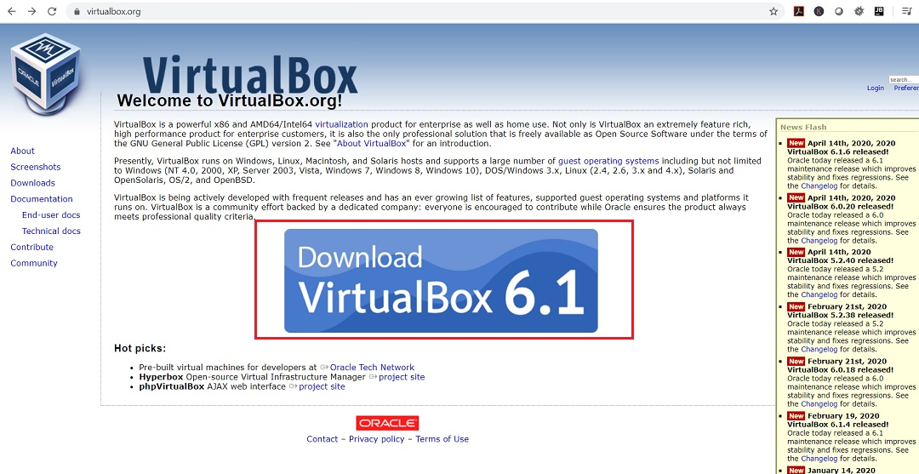](https://www.shaileshjha.com/how-to-install-oracle-vm-virtualbox-5-in-windows-10/virtualbox-web-page/)

VirtualBox Web Page

The file size of VirtualBox installer for Windows is around 101 MB.

Step 2 – Start the Installation process

The file downloaded will have the file name format like VirtualBox-VersionNumber-BuildNumber-Win.exe. Something like this: VirtualBox-6.1.6-137129-Win.exe. Double click on the installer to launch the setup Wizard. Click on Next to continue.

[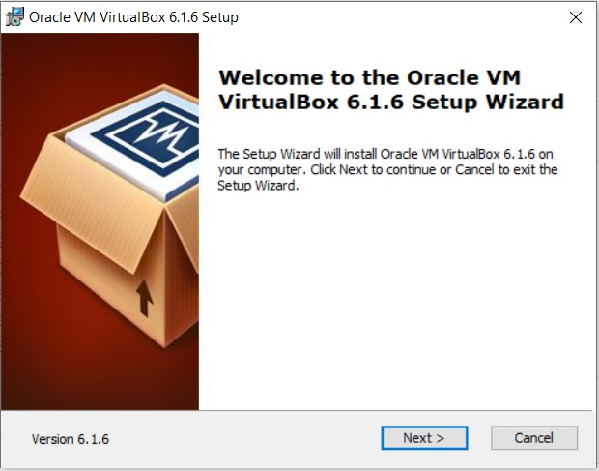](https://www.shaileshjha.com/how-to-install-oracle-vm-virtualbox-5-in-windows-10/virtualbox-installation-setup-wizard/)

VirtualBox Installation – Setup Wizard

Step 3 – Custom setup dialog box

You will see custom setup dialog box. There is not much to choose from. You can accept the default and click next.

If you wish to change the installation directory, you van change it by clicking on the browse button and selecting the new directory and clicking OK. Normally I leave it as the default as the whole installation process does not take much space on your hard drive.

[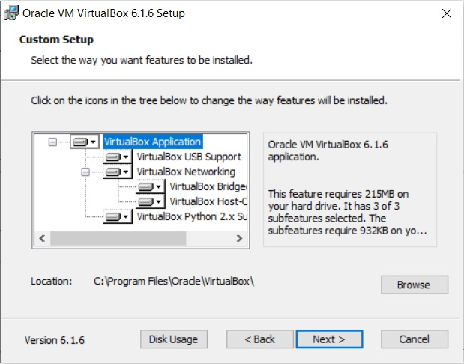](https://www.shaileshjha.com/how-to-install-oracle-vm-virtualbox-5-in-windows-10/virtualbox-installation-custom-setup-dialog-box-screenshot-6/)

VirtualBox Installation – Custom setup dialog box screenshot

Step 4 – Custom setup dialog box – Feature to install

In this dialog box you can choose which features to install. As you can see, there is not much to choose. You can accept the default and click next. Normally I uncheck Create a shortcut in the quick launch bar and register file association.

[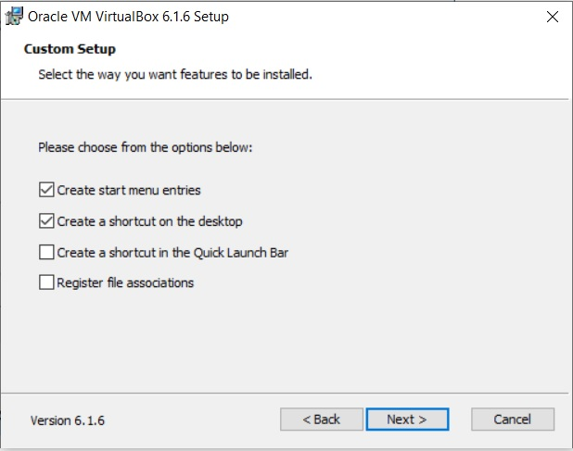](https://www.shaileshjha.com/how-to-install-oracle-vm-virtualbox-5-in-windows-10/virtualbox-installation-custom-setup-select-feature-to-install/)

VirtualBox Installation – Custom Setup – Select feature to Install

Step 5 – Network Interface setup

This dialog box warns you about setting up a Network Interface. what this means that VirtualBox will install network interfaces that will interact with the installed virtual machines and the host operating system which in our case is windows. This will temporarily disconnect you from the internet but that OK, nothing to worry.

[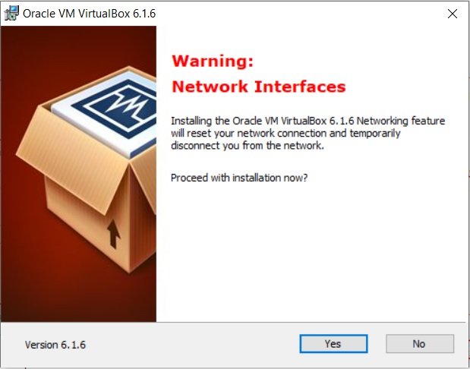](https://www.shaileshjha.com/how-to-install-oracle-vm-virtualbox-5-in-windows-10/virtualbox-installation-network-interface-warning/)

VirtualBox Installation – Network Interface warning

Step 6 – Ready to Install

You will see ready to install dialog box.

[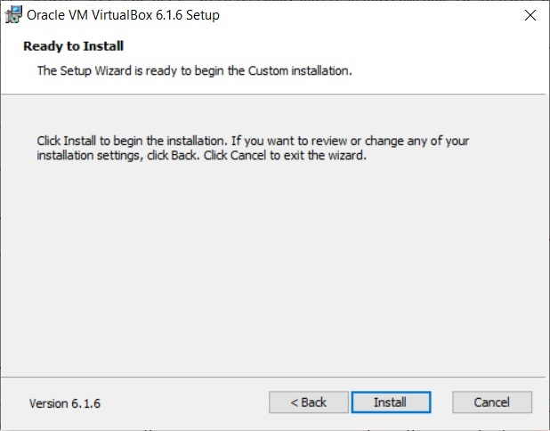](https://www.shaileshjha.com/how-to-install-oracle-vm-virtualbox-5-in-windows-10/virtualbox-installation-ready-to-install-4/)

VirtualBox Installation – Ready to Install

Step 7 – Installation begins

After clicking install, you will mostly probably see User access control confirmation dialog box from Windows OS. This is a security feature in Windows that wants to confirm if the application should be allowed to proceed with the installation process. Click Yes to continue and you will see that the installation process will begin. Wait for the installation to complete.

If you see Windows User Account Control Warning, click yes to accept and continue.

[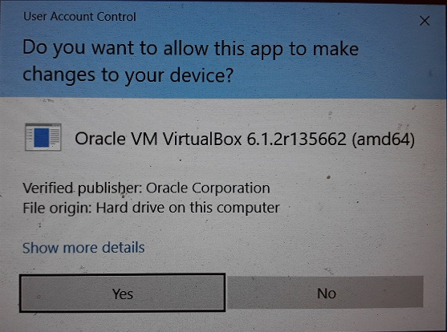](https://www.shaileshjha.com/how-to-install-oracle-vm-virtualbox-5-in-windows-10/virtualbox-installation-windows-user-account-control-warning-screenshot-2/)

VirtualBox Installation – Windows User Account Control warning screenshot

[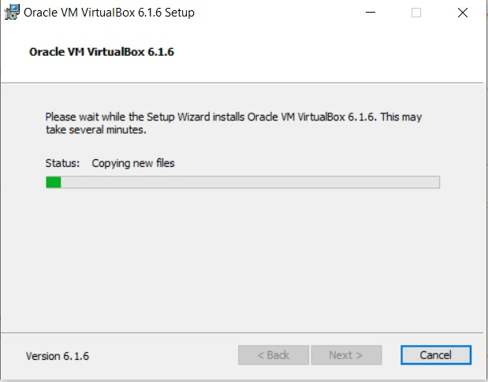](https://www.shaileshjha.com/how-to-install-oracle-vm-virtualbox-5-in-windows-10/virtualbox-installation-in-progress/)

VirtualBox Installation in Progress

Step 8 – Installation Completes

After the installation completes, you will see installation completion dialog box. Click finish. If you leave Start Oracle VM VirtualBox after installation checked, VirtualBox will launch automatically. If you uncheck it, you will have to launch Virtualbox manually. Its not big deal anyways. Click finish to exit installation.

[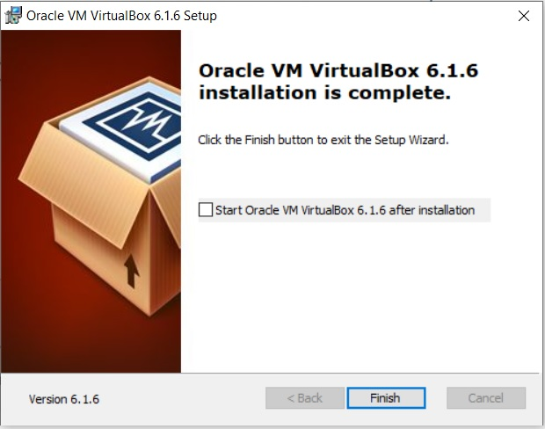](https://www.shaileshjha.com/how-to-install-oracle-vm-virtualbox-5-in-windows-10/virtualbox-installation-complete/)

VirtualBox Installation complete

Step 9 – Launch VirtualBox application

Your newly installed VirtualBox is ready to go. You can search for VirtualBox in windows search in taskbar. You will see the VirtaulBox Icon on top. Click that to open VirtualBox.

[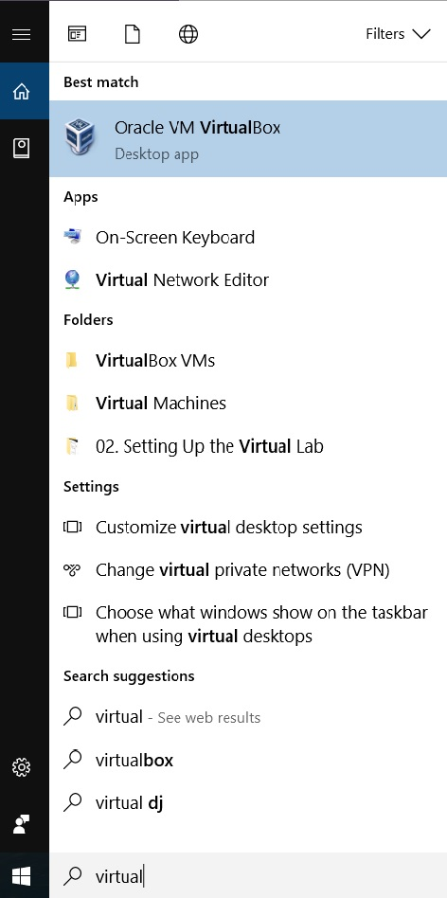](https://www.shaileshjha.com/how-to-install-oracle-vm-virtualbox-5-in-windows-10/virtualbox-windows-start-menu-search-screenshot/)

VirtualBox Windows start menu search screenshot

[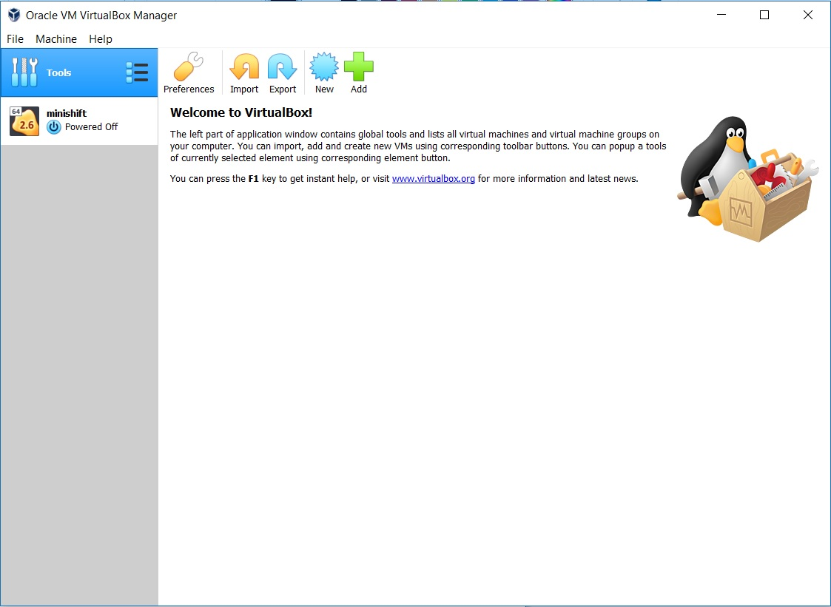](https://www.shaileshjha.com/how-to-install-oracle-vm-virtualbox-5-in-windows-10/oracle-vm-virtualbox-manager/)

Oracle VM VirtualBox Manager

Step 10 – Install VirtualBox Extension pack

After the installation of VirtualBox is complete, please install VirtualBox Extension pack which will enable support for USB 2.0 and USB 3.0 devices, VirtualBox RDP, disk encryption, NVMe and PXE boot for Intel cards.

VirtualBox Extension pack can be downloaded from [here](https://www.virtualbox.org/wiki/Downloads). Look for extension pack on the page, click on all supported platform to start the download process. The name of the file will be something like **Oracle\_VM\_VirtualBox\_Extension\_Pack-6.1.6.vbox-extpack** and around 10.5 MB in size.

[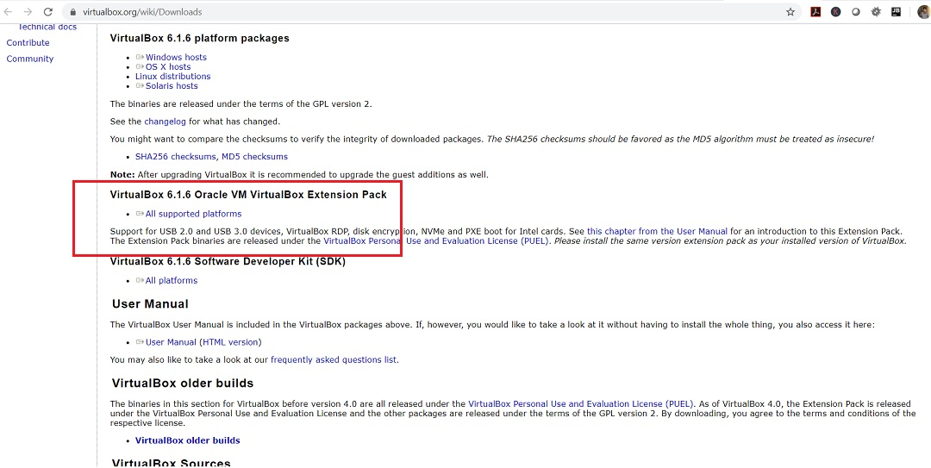](https://www.shaileshjha.com/how-to-install-oracle-vm-virtualbox-5-in-windows-10/virtualbox-download-extension-pack/)

VirtualBox – Download Extension Pack

To install extensions pack, open VirtualBox, go to **File -> Preference -> Extensions -> Add new package (click on the + sign and browse to the downloaded file)** and click Install.

[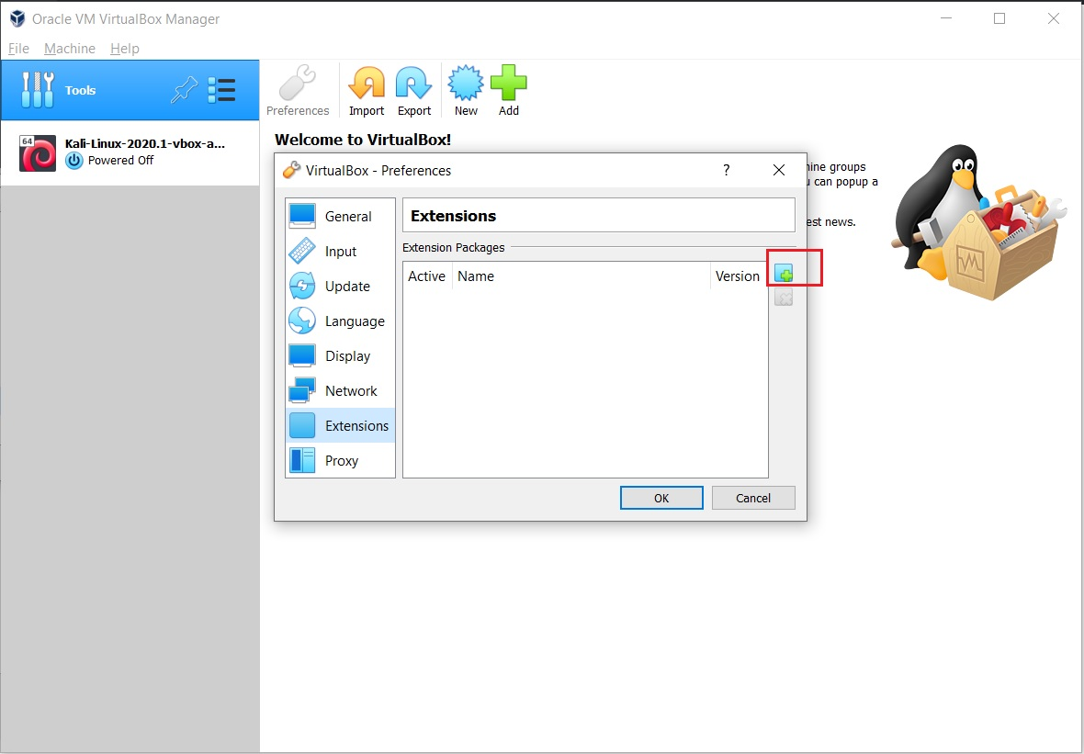](https://www.shaileshjha.com/how-to-install-oracle-vm-virtualbox-5-in-windows-10/virtualbox-preference-extensions/)

VirtualBox – Preference – Extensions

Installation will start, wait for the process to complete.

[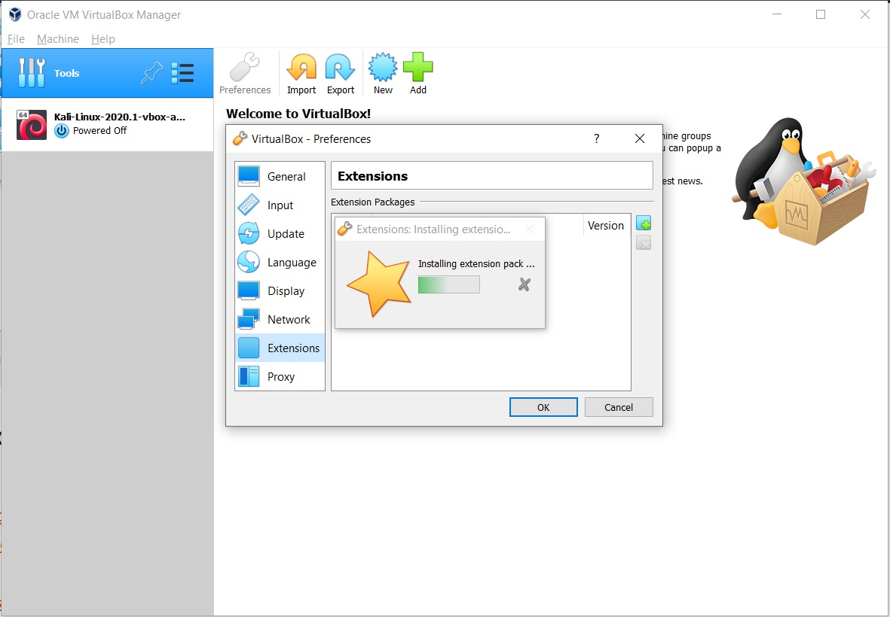](https://www.shaileshjha.com/how-to-install-oracle-vm-virtualbox-5-in-windows-10/virtualbox-extension-pack-installation-in-progress/)

VirtualBox Extension Pack installation in progress

You will see installation complete message. Click on OK to exit.

[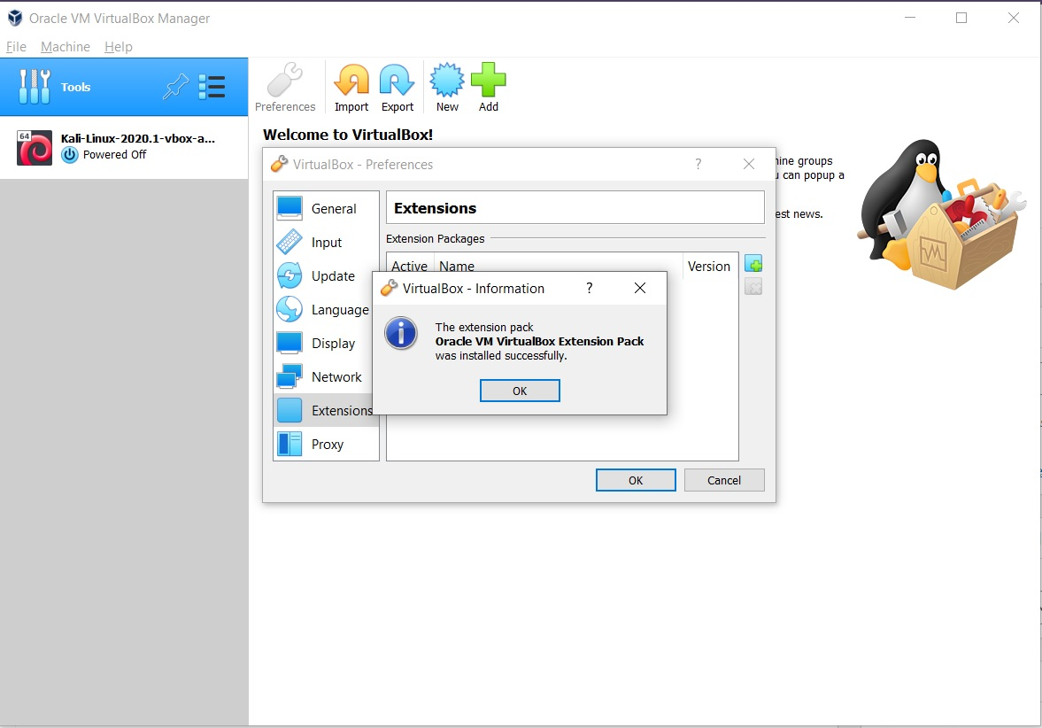](https://www.shaileshjha.com/how-to-install-oracle-vm-virtualbox-5-in-windows-10/virtualbox-extension-pack-installation-success-message/)

VirtualBox Extension pack Installation – success message

Result:

Thus the virtualbox is installed on windows.

# Ex.No 1b **Install Ubuntu-16.04 LTS on Virtual Box (Desktop version)**

Date:

Aim: To install Ubuntu on virtual box.

1. Download the .iso image for Ubuntu-16.04-desktop version.





2. Open Oracle Virtual Box and click on **“New”.**

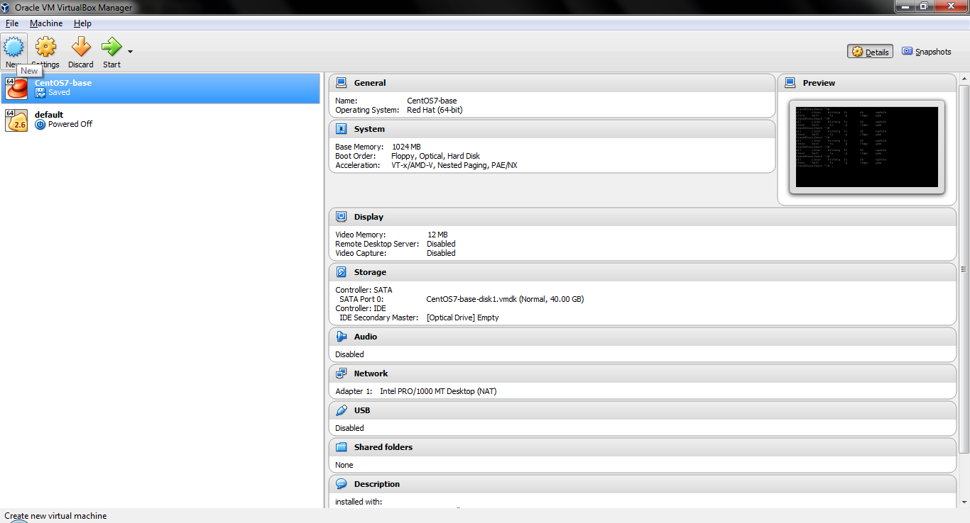

3. Enter the Name for your VM. Then select **Type**as **Linux** and **Version**as **Ubuntu (64-bit)**from the drop-down. Click **“Next”**.

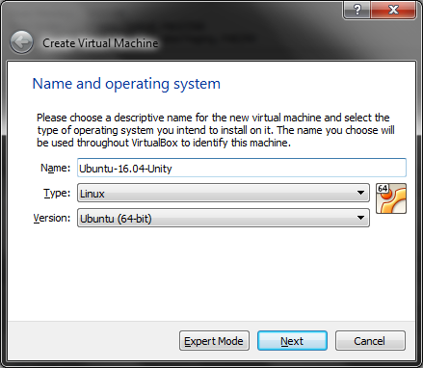

4. Allocate **RAM**as per your usage. **1024 MB** is the recommended memory size. (Using the recommended RAM here)

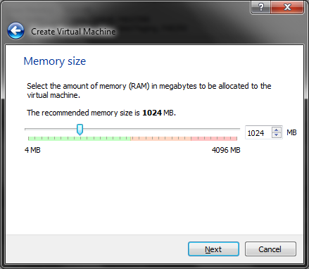

5. Select **“Create a virtual hard disk now”** as we are installing Ubuntu on Virtual Box for first time.

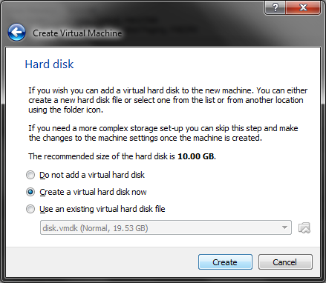

6. Select **“VDI(Virtual Box Disk Image)”** as the type for your Virtual Hard Disk file.

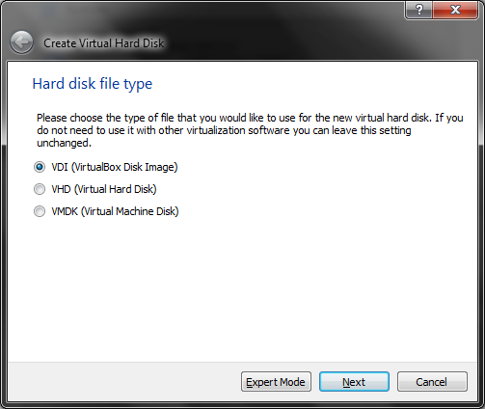

7. Select **“Dynamically Allocated”** as we don’t want to keep restriction on the virtual hard disk file size.

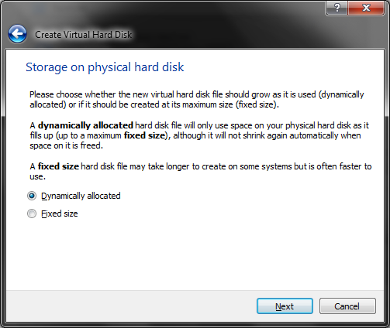

8. Enter the **name**for the **Virtual Hard Disk file.** (we can also leave it as default name same as VM name).

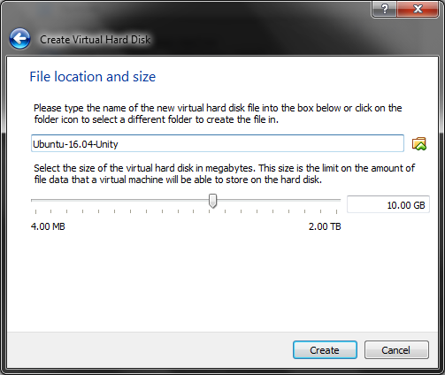

9. Your VM will now be created with the above configuration. (Visible on the left panel of Virtual Box).

Select the VM and click on **“Start”.**

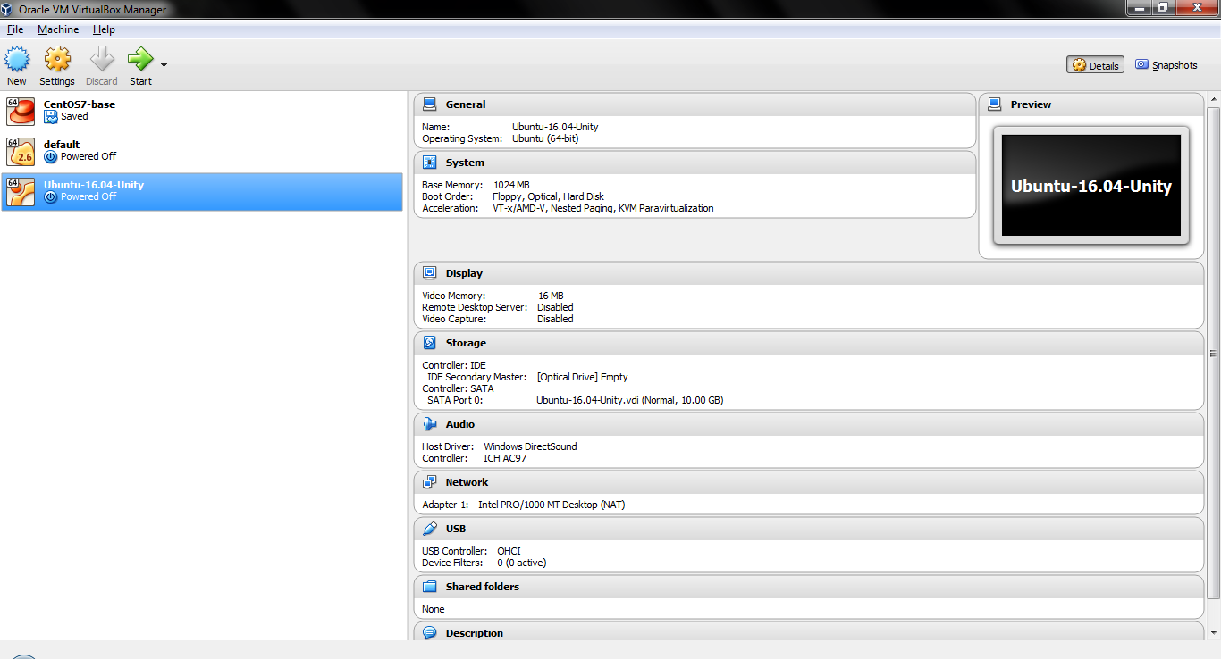

10. Now click on the icon as highlighted below.

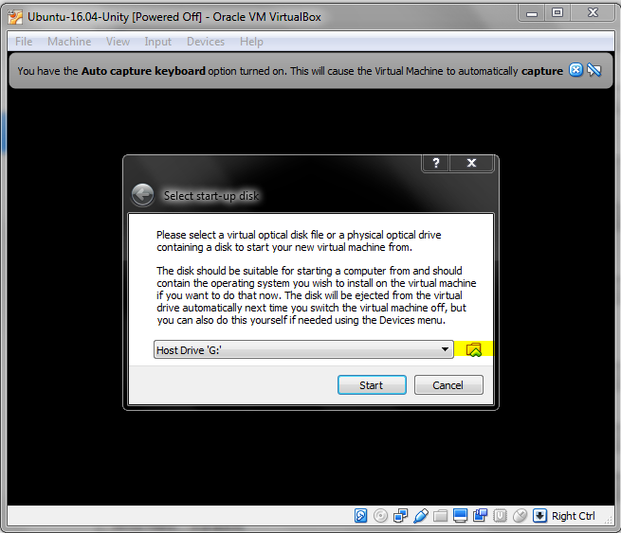

11. Go to the path of your **Ubuntu-16.04-desktop-amd64.iso** image and select it. Click **“Open”.**

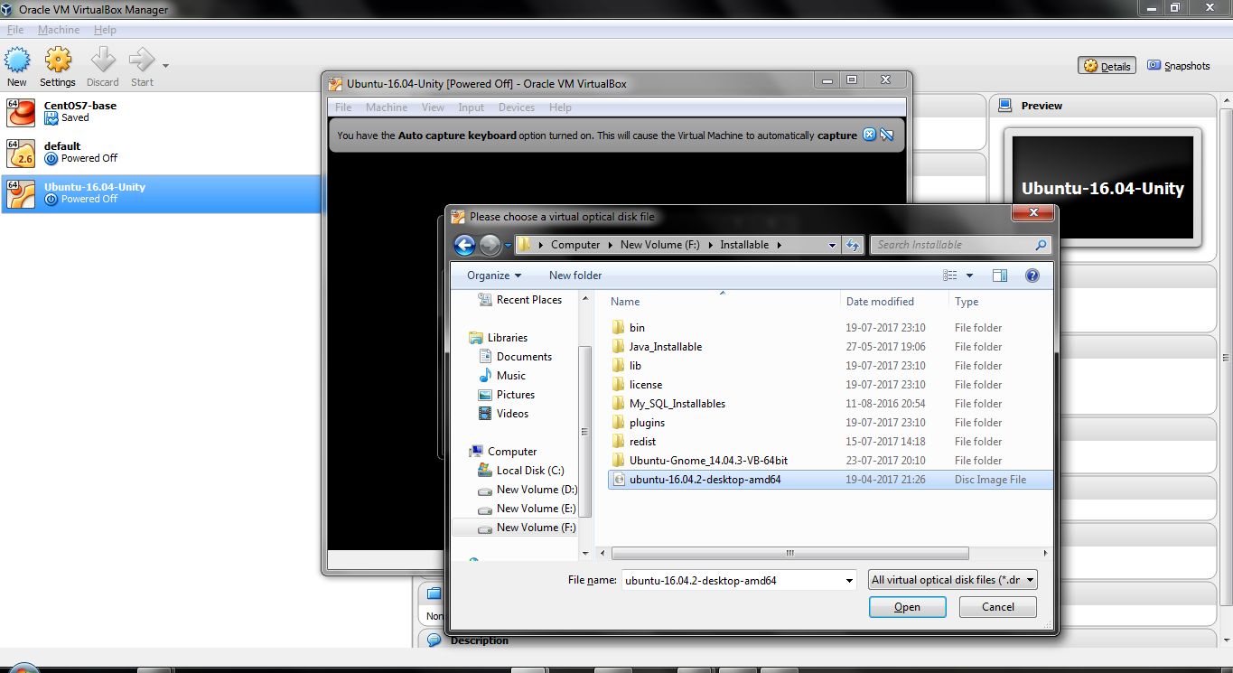

12. Now Ubuntu will boot up and ask for Installation details. Click on **“Install Ubuntu”.**

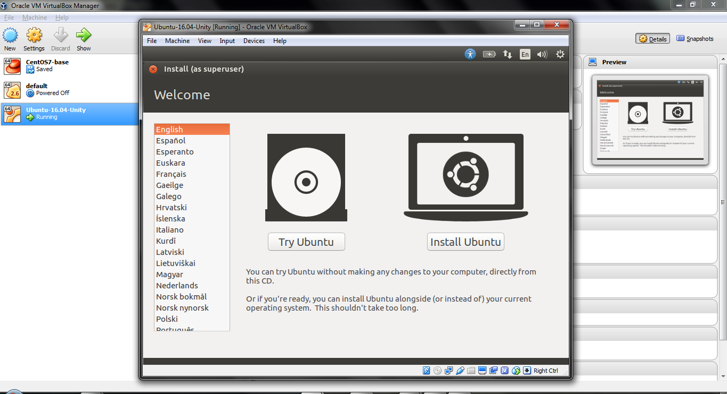

13. Don’t select the checkbox as we don’t want to install any 3rd party software while Ubuntu Installation.

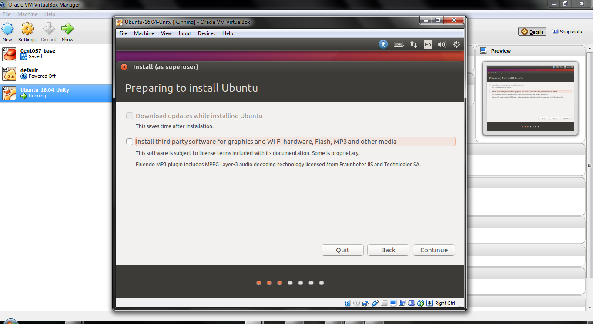

14. As we are making Ubuntu VM for the 1st time on our Virtual Box, we will select the 1st option i.e. **“Erase disk and install Ubuntu”**.

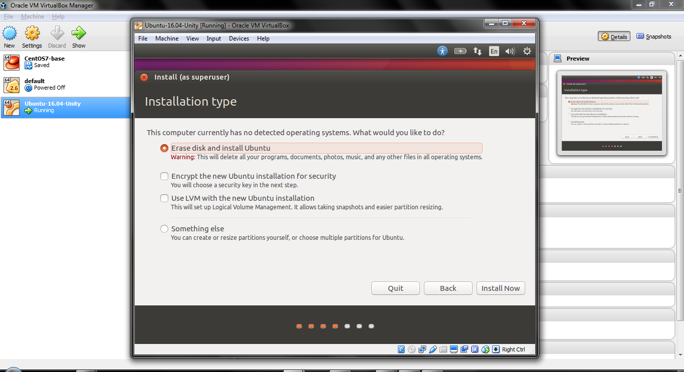

15. Select your location for time zone settings. I am selecting **India (Kolkata)** as my region.

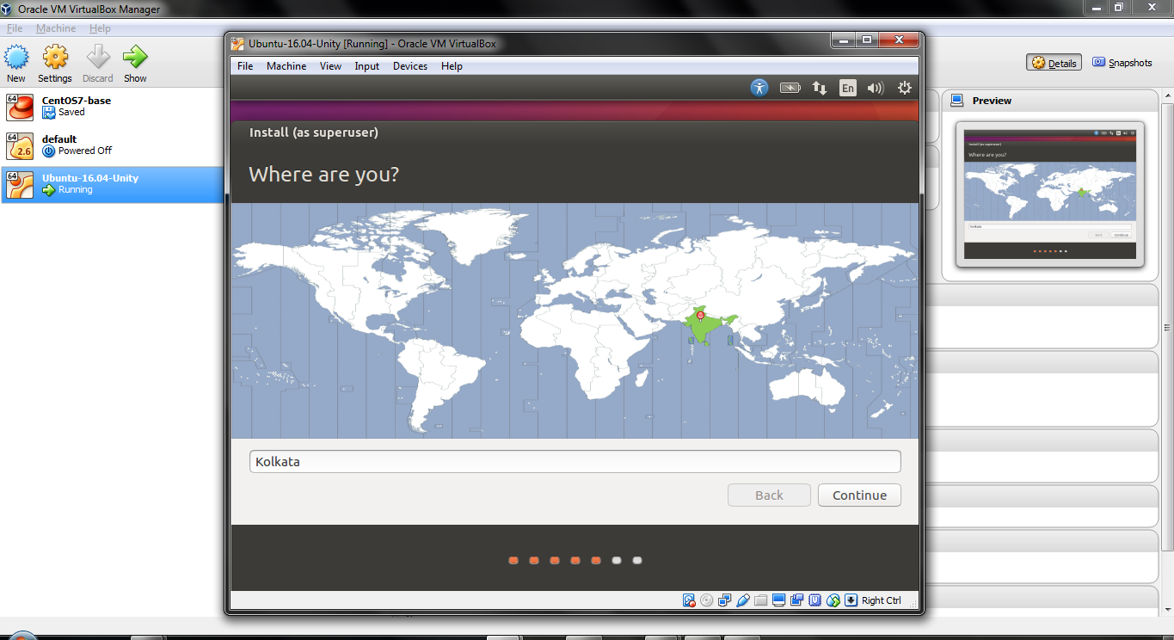

16. Select your keyboard layout. I am selecting as **“English (US)”** as per my usability.

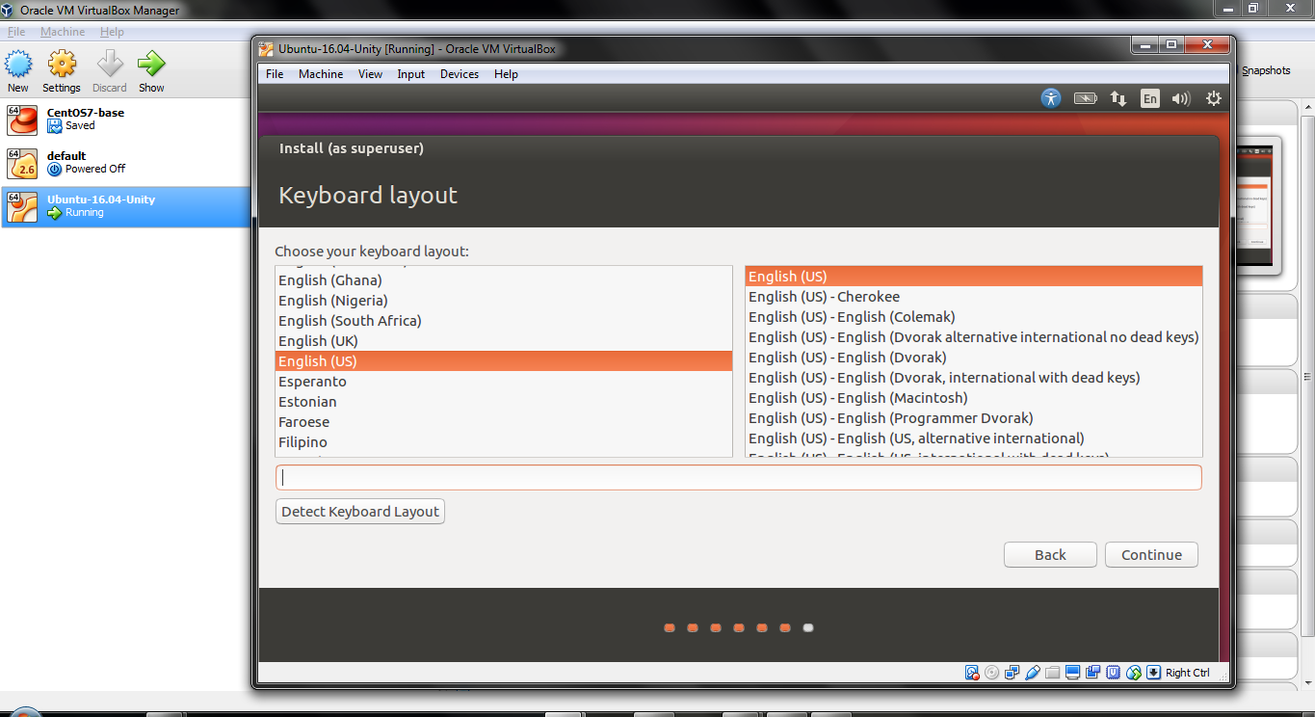

17. Fill in the below fields for Name, Username, Password and Computer’s Name.

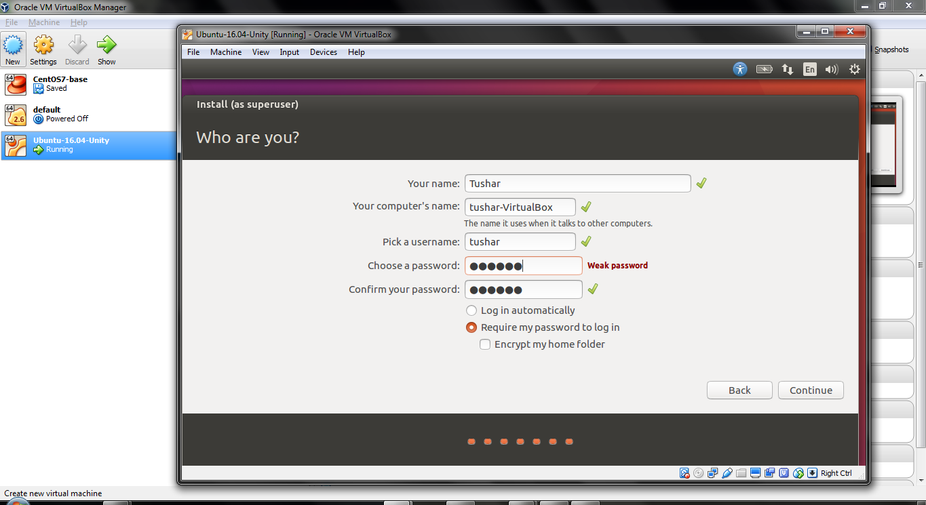

18. Wait for the Installation to complete.

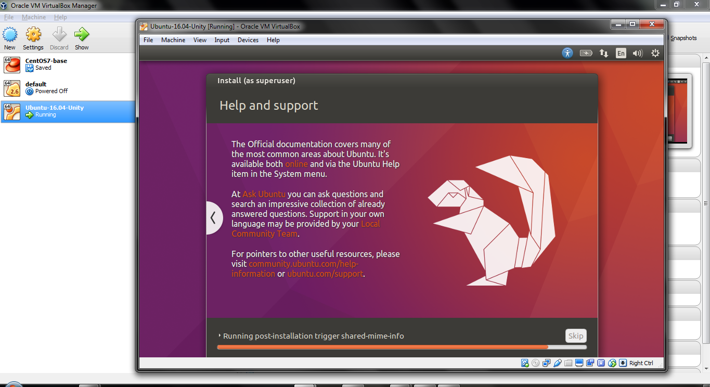

19. Enter your **password** for logging into the Ubuntu-16.04 VM Desktop.

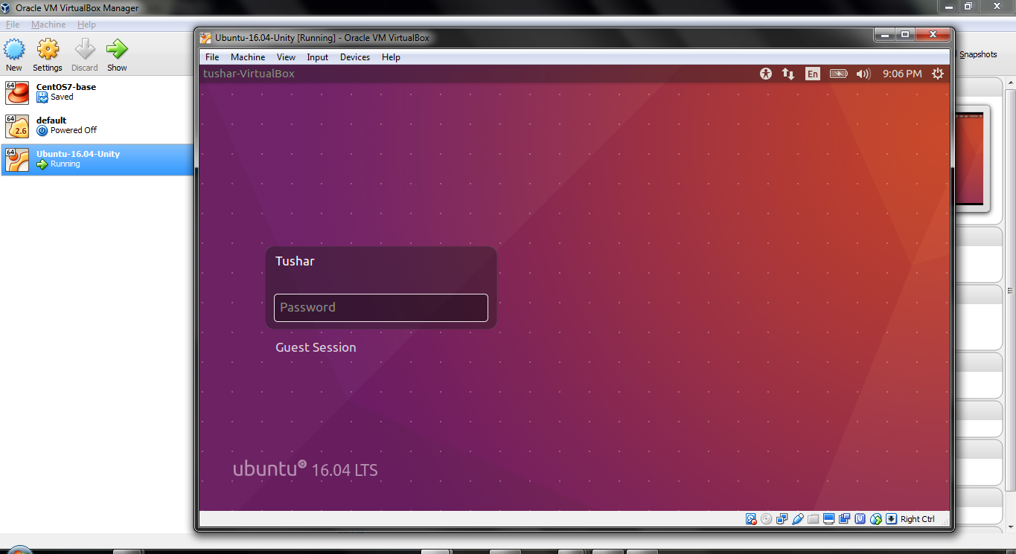

# Ubuntu 16.04 LTS is now running on your Oracle Virtual Box.



Result:

Thus the Ubuntu desktop version is installed successfully on virtual box.

**Ex:No 2 Installing GCC C compiler in Ubuntu OS and execute simple programs**

Date:

**Objective**

The objective is to install GCC the C compiler on Ubuntu 18.04 Bionic Beaver

**Operating System and Software Versions**

* **Operating System:** - Ubuntu 18.04 Bionic Beaver

**Requirements**

Privileged access to your Ubuntu System as root or via sudo command is required.

**Conventions**

* **#** - requires given [linux commands](https://linuxconfig.org/linux-commands" \t "_blank) to be executed with root privileges either directly as a root user or by use of sudo command
* **$** - requires given [linux commands](https://linuxconfig.org/linux-commands" \t "_blank) to be executed as a regular non-privileged user

**Other Versions of this Tutorial**

[Ubuntu 20.04 (Focal Fossa)](https://linuxconfig.org/how-to-install-gcc-the-c-compiler-on-ubuntu-20-04-lts-focal-fossa-linux)

**Instructions**

**Install GCC**

The following [linux command](https://linuxconfig.org/linux-commands" \t "_blank) will install gcc compiler on on Ubuntu 18.04 Bionic Beaver. [Open up terminal](https://linuxconfig.org/how-to-open-a-terminal-on-ubuntu-bionic-beaver-18-04-linux) and enter:

$ sudo apt install gcc

### Install build-essential

Another way to install gcc compiler is to install it as part of build-essential package. build-essential package will also install additional libraries as well as g++ compiler. In most cases or if unsure this is exactly what you need:

$ sudo apt install build-essential

### Check GCC version

Confirm your installation by checking for GCC version:

$ gcc --version

gcc (Ubuntu 7.2.0-18ubuntu2) 7.2.0

Copyright (C) 2017 Free Software Foundation, Inc.

This is free software; see the source for copying conditions. There is NO

warranty; not even for MERCHANTABILITY or FITNESS FOR A PARTICULAR PURPOSE.

### C Hello World

Compile a simple C "Hello World" code:

#include <stdio.h>

int main()

{

printf("Hello, World!");

return 0;

}

Save the above code within hello.c file, compile and execute it:

$ gcc -o hello hello.c

$ ./hello

Hello, World!

Result:

Thus the gcc compiler is installed and the required binaries have been configured and finally we have executed programs using C compiler.

**Ex: No 3 Installing and Creating Application in GAE**

**Date:**

**Aim:** Install Google App Engine. Create hello world app and other simple web applications using python/java

**Sign up for Google App Engine**

You need to first sign up for the Google App Engine Account. This is easy and is a breeze in case you already have a Google Account (Gmail, Apps, etc) in which case it is best that you use that straight away. Go to [http://appengine.google.com](http://appengine.google.com/) and simply login with your account. Even if you do not have an account, you can sign up for a Google Account, a link for which is provided on the page.

Whether you already have a Google Account or have signed up for a new one, do login first. Once you are logged in, you will be presented with a list of applications that you are currently running on the Google App Engine under the account which we logged in with. Google provides a total of 10 applications that you can deploy under a single account. Please be aware that as of this date, there is no way to delete an application and use that slot for another application — so use with care.

Here is a screen shot of my account page at the Google App Engine after login:

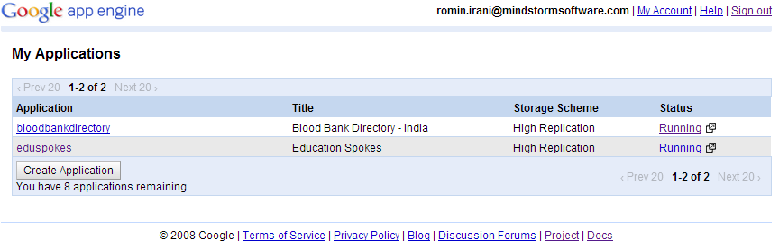

It shows that I have 4 applications registered on Google App Engine and have 6 more to go. You might have no applications listed if you are logging in for the first time and/or have not created any application.

**Note:** If you are**registering your 1st application**, the process is as follows:

1. Click on **Create an Application**.

2. Once you have selected a name, then you will be prompted for **your Mobile Number**. Enter your mobile number (with country code, etc).

3. Google will **send you a SMS** with an code. You will be prompted on the next screen to enter the code that you received on SMS. Enter that to confirm the process.

**This is only required for registering your 1st application and once the SMS verification process is complete, you will not be prompted again when you create your 2nd application and so on.**

**Registering your Application**

Cool, let’s create an application then but before that we must tell your application to show its ID. So let us talk about Identity first.

**Identity, Identity, Identity….**

Yes, everyone needs to show an ID. And the same applies to your application too that is hosted in the cloud.

Let me explain that a little. As you know Google App Engine is a PaaS (Platform as a Service), which means that you can develop and deploy your application (following some specification) into their infrastructure (in the cloud). Now what this means is that while it would be nice for you to get an application name of your choice, it is not feasible in a hosted environment where you are sharing all resources with other applications too.

By default, your application needs to be unique within this so called name space:

**YOUR\_APPLICATION\_ID.appspot.com**

where **YOUR\_APPLICATION\_ID** can be any name that you wish for your application, that has not already been taken by someone else. So before you start with an application in mind, it pays to plan it out a little first and that includes what name you would like for your application and then registering it as quickly as possible so that you have it.

**Note:** Please keep in mind that what I am discussing here is the basic facilities provided by Google. It is perfectly possible for you to purchase a domain name and then point it to the URL where your application is hosted in the Google App Engine cloud. But we will not discuss all that know and will keep the discussion to what is provided straight of the bat.

OK. So you have thought of the application name and wish to register it. So since we are going to write a**“Hello World”** sort of an application — we should go ahead and create an application identifier first.

Let us actually do that before moving on. Assuming that you are logged in as described earlier, click on the Create An Application button. This will bring up a page as shown below:

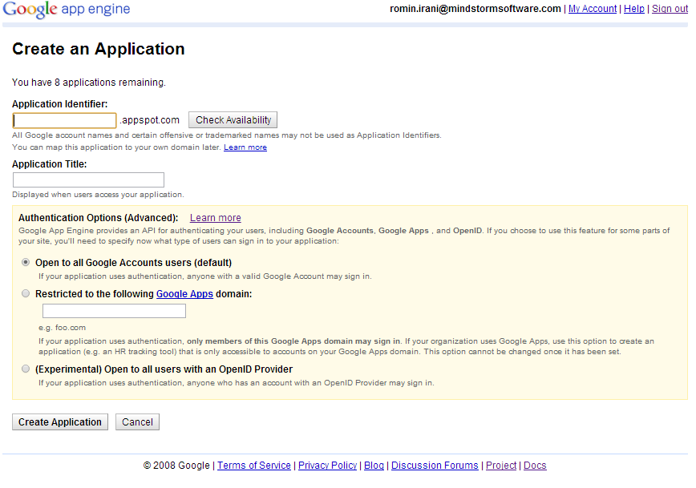

This page will allow you to select an **Application Identifier** that we have been talking about. Go ahead. Try out a few names like myhelloworld, myfirstapp, etc and see which one is available. Give any string for the Application Title and go with the default options for the Account options (we can skip it for now). Click on the Save button. If all is well, the application identifier will be created and your first application is registered. Congratulations! But we have a lot to do including writing the application.

Please make sure that you note down your Application Identifier since this will be used later on to verify your entire setup. OK, let me not scare you — you can always go back to the Google AppEngine account and see the applications listed :-)

Do check out the excellent monitoring portal that Google App Engine provides to view/monitor a number of things about your application. Just click on the registered application in the application list and you will be lead to the portal where you can check the logs/quotas and configure several other stuff. As this blog develops, I will cover more of this but for now, just browse around and familiarize yourself.

**Downloading, Installing and setting up the Eclipse IDE for GAEJ**

We will need the following software to be present on your development machine. I am assuming that you are comfortable with downloading and setting up of the software from public sites.

1. **Java Development Kit 1.6.x or Java Development 1.7.x**: Please ensure that the JDK version is setup appropriately on your machine. **Do note that you should setup the Java Development Kit and not the Java Runtime Environment (JRE). The JDK is required for compilation of your JSP files, should you use them in your Web Application Project.**
2. **Eclipse 3.8 / 4.2 / 4.3**: Choose any Eclipse IDE version that you want. I am using the Eclipse 3.8 Juno Release.
3. **GAEJ Plug-in**: Go to the following page: <https://developers.google.com/eclipse/docs/getting_started>. This page contains links to the GAEJ plugin for Eclipse download/installation. I list below the update site URL for the GAEJ Eclipse plugin from that page:

* **Eclipse 4.3 (Kepler)**http://dl.google.com/eclipse/plugin/4.3
* **Eclipse 3.8 / 4.2 (Juno)**http://dl.google.com/eclipse/plugin/4.2
* **Eclipse 3.7 (Indigo)**http://dl.google.com/eclipse/plugin/3.7

1. Depending on the version of Eclipse that you have, I reproduce from the Google site the links for installing the plugin depending on the version of Eclipse that you have. Please follow the instructions on the page, it is straightforward and I do not wish to replicate it here.

* [Google Plugin for Eclipse 4.3 (Kepler)](https://developers.google.com/eclipse/docs/install-eclipse-4.3)
* [Google Plugin for Eclipse 3.8/4.2 (Juno)](https://developers.google.com/eclipse/docs/install-eclipse-4.2).
* [Google Plugin for Eclipse 3.7 (Indigo)](https://developers.google.com/eclipse/docs/install-eclipse-3.7).

Once you have finished the setup and restarted your Eclipse IDE, you should see the following Google Icon in the toolbar of the Eclipse IDE. Click on that and you will see the different options as listed below:

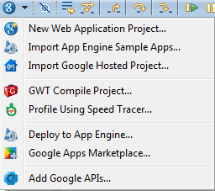

If not, please refer to the troubleshooting options that are described in each of the above links.

**Writing our first GAEJ application**

So far we have signed up for Google App Engine, registered our Application Id and setup the GAEJ plug-in for Eclipse. We are ready to write our application now. The Gods always tell us to start any new thing on an auspicious note by crying out “Hello World” and we shall stick to the tradition.

As we shall see things unfold, GAEJ plug-in for Eclipse makes things very simple. It does all the hard work after we give it some inputs and then it generates an entire web application for us along with sample servlet that pretty much does just that i.e. says “Hello World”. What we will be writing no code, you say? Yes. All this code is generated for us and is pretty much a template that we can take and put our application logic in there.

So let us move forward and generate our first project now (steps along with explanation follow):

1. Launch your Eclipse (if not started).

2. Either click on **File → New → Other** or press **Ctrl-N** to create a new project. Select **Google**and then **Web Application project**. Alternately, you could also click on the **New Web Application Project** Icon [part of GAEJ Eclipse Plugin] in the Toolbar:

3. This will bring up a New Web Application Project page as shown below:

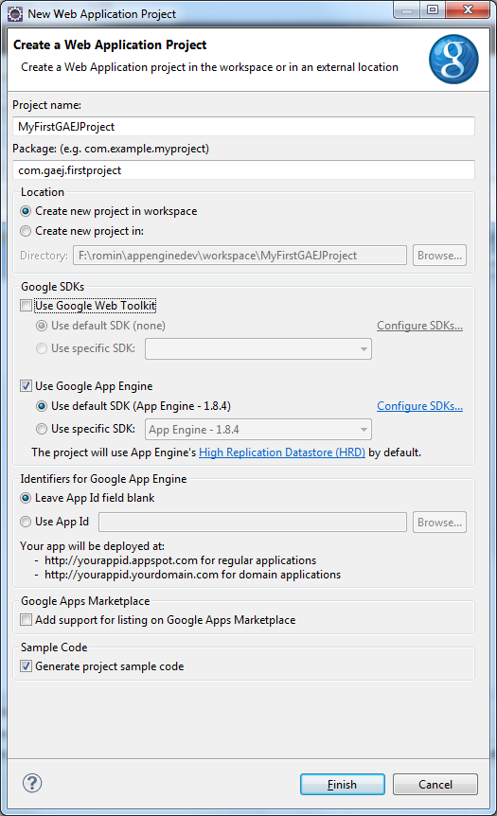

Enter the details as given below:

\* **Project Name** : **MyFirstGAEJProject**. You can select any name that you like.

\* **Package**: **com.gaej.firstproject**. You can select any name that you like. I will go with this and use it for the rest of the blog post, so it is advisable to stick to this one for now.

\* **Deselect**the **Use Google Web Toolkit**option.

4. Click on **Finish**. This will generate an entire project for you which is ready to be deployed.

5. But before that, let us look at the files that have been generated. I reproduce for you the screen from my Package Explorer as shown below:

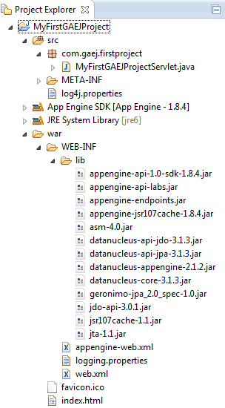

6. If you are familiar with Java Web applications, this should be straightforward stuff with directories like WEB-INF, WEB-INF\classes, WEB-INF\lib, etc. But let us cover it in brief:

* **src**: This contains the source files. You will find that it has generated a sample file name **MyFirstGAEJProjectSerlvet.java** for you. It has been created as per the package hierarchy that you selected. You can keep all your source files over here as you develop more.
* **war**: This is the war file structure i.e. Web Application Archive. This if you recollect will be deployed into the Servlet Container of the App Engine that will eventually host your Java Web Application. In this directory, you have the following:
* **WEB-INFlib**: All appropriate JAR files that provide the Java SDK libraries along with Google Java APIs for the App Engine have been linked correctly into the project **build path** and the necessary JAR files are also present in the **WEB-INF\lib** folder
* **index.html** : This is the first page served. You can actually customize it to any that you want. All your additional**html files/resources** could go in here.
* **logging.properties:** If you are familiar with Java logging, you should be able to make sense of this file and tweak your logging preferences over here.
* **web.xml** : This is a standard web application configuration file. You will find the **Servlet**entries present here for the sample servlet that is generated for us.
* **appengine-web.xml** : This is a Google App Engine specific configuration file. And the main element here of interest to us is the application element that will contain the**Application ID** of the application that we registered for Google and which will be pointing to a hosted version of this WAR. We will set this up at the time of deploying the application, which we will cover later.

7. **MyFirstGAEJProjectServlet** : Let us cover this in brief, which can also act as a refresher for writing and setting up a servlet configuration in case you are little rusty (happens to the best of us!).

The servlet code is straightforward as shown below[Omitting package and import declarations]:

public void doGet(HttpServletRequest req, HttpServletResponse resp) throws IOException {  
resp.setContentType("text/plain");  
resp.getWriter().println("Hello, world");  
}  
}

It extends the **javax.servlet.http.HttpServlet** class and implements the **GET**method. You could parse out the request parameters if needed (in this case there are none of interest). All that the servlet does is to **get a handle to the response stream** and then mention its content type and send across the text **Hello World** to the client.

Now, we need to set the servlet url and its java class in the **web.xml** configuration file. Open up the **web.xml**file and you will find the appropriate entries as shown below:

<servlet>  
<servlet-name>MyFirstGAEJProject</servlet-name>  
<servlet-class>com.gaej.firstproject.MyFirstGAEJProjectServlet</servlet-class>  
</servlet>  
<servlet-mapping>  
<servlet-name>MyFirstGAEJProject</servlet-name>  
<url-pattern>/myfirstgaejproject</url-pattern>  
</servlet-mapping>

And finally, if you open **index.html**, you will find a link that references the servlet as shown below:

<td><a href="myfirstgaejproject"/>MyFirstGAEJProject</td>

so that when the**index.html**page is served, you will see a **Hyperlink** named **MyFirstGAEJProject** and on **clicking**it will **invoke the MyFirsGAEProject servlet** implemented in **com.gaej.firstproject.MyFirstGAEJProjectServlet** which will then**print out Hello World**.

**Testing it locally**

GAEJ Eclipse plug-in ships with a local server, where you can deploy your application and test it out. Ensure that port **8888**is free on your machine and that no other web server is running on it.

To test the application, all you need to do is the following:

1. Select the project and then Run As → Web Application

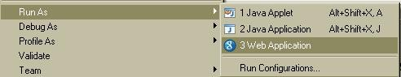

2. This will compile/deploy your application the local server and the server will be started on port 8888. You will see the server starting in the console window as shown below:

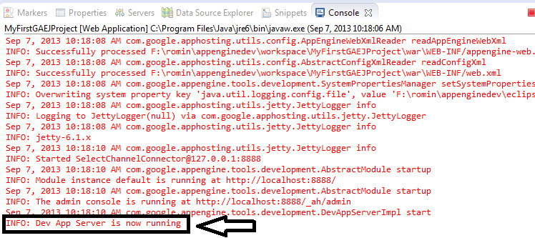

3. If all is well, you will get the message that the server is running at [http://localhost:8888](http://localhost:8888/) as shown above.

4. Once that notification is shown, launch your browser and navigate to the url : [http://localhost:8888.](http://localhost:8888./) This will bring up a default JSP page that is generated for you with the servlet URL in it as shown below:

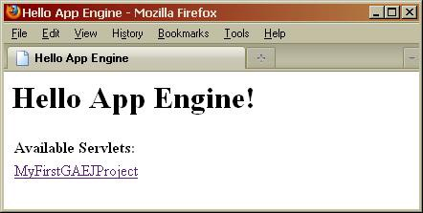

5. Click on the link and you will see your servlet getting invoked and telling you “Hello World”.

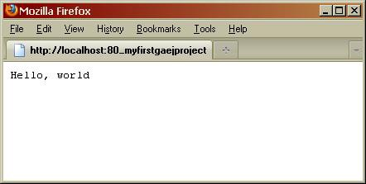

Now that things work, we need to deploy this application into the Google App Engine infrastructure. So lets go to that.

**Deploying it into the Cloud**

First ensure that you are logged in to your Google Account via which you signed up for Google App Engine earlier. In Eclipse, you will find on the bottom right of the screen, a **“Sign in to Google”** … button present as shown below:



Click on that, it will bring up the standard Google Account login. Provide your username and password. Google will also ask for permission to allow access, please go ahead and give it all the permission.

Once logged in successfully, you will see your **user id** shown at the bottom right of the screen instead of the “Sign in to Google…” button.

To deploy the application in the cloud, simply click on the **Deploy App Engine Project Icon** available in Toolbar[part of GAEJ Eclipse Plugin].

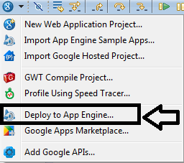

This will bring up a dialog where you will need to provide your Google Account credentials (username and password). **Do not click on Deploy** yet.

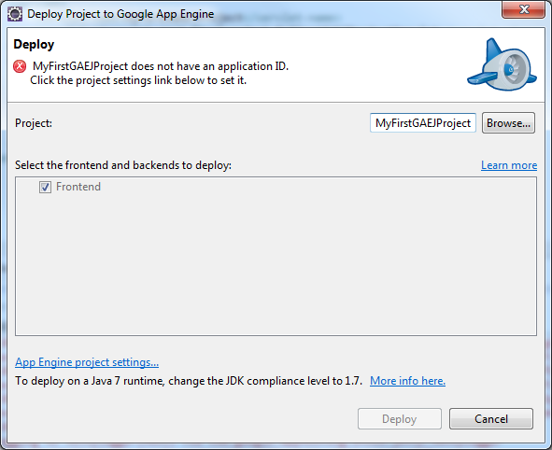

The dialog says that it **does not have an application ID.**What this means is that AppEngine needs to know under which of your 10 applications shown the application be hosted under. So you have to provide the name here.

Click on the **App Engine Project settings** link in the above dialog. This will bring up a properties page as shown where you need to entire the **Application ID**. Remember the Application ID that we discussed earlier and you registered one for you. Well that is the Application Id that you need enter over here. Enter that and click OK as shown below [Remember to enter your Application ID before clicking OK]:

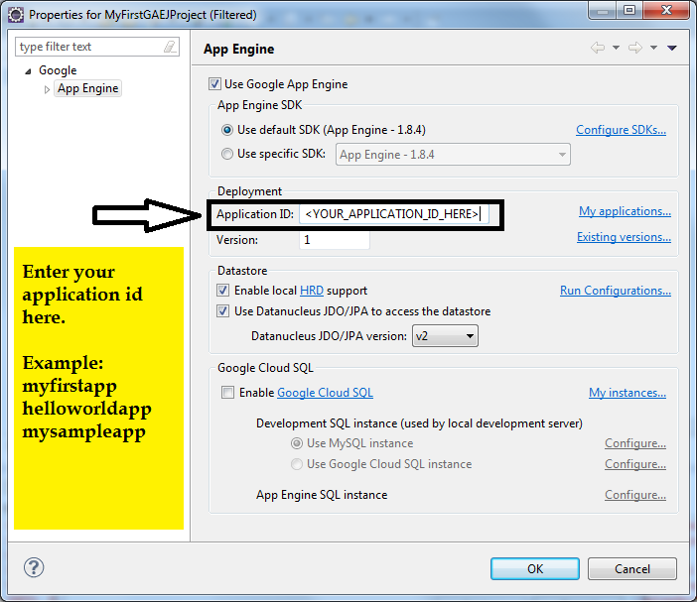

This will lead you back to the Deploy Project to Google App Engine dialog box. Now simply click Deploy. This will connect to Google App Engine and deploy your application and register it with the Application Id that you used. A snapshot of the Progress dialog on my machine is shown below:

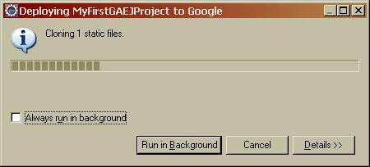

You will a lot of activity in your Console bar (a snapshot is shown) and at the end of it you should see a message saying that the application is available.

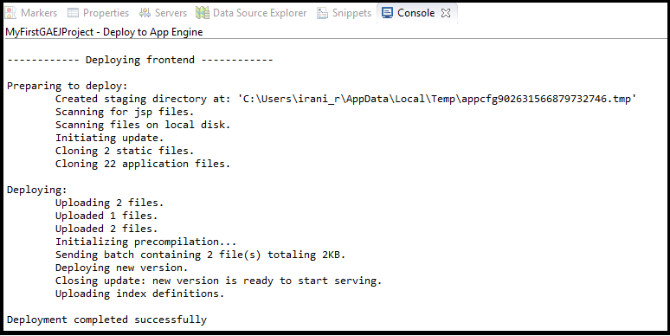

You can deploy your application several times as you make changes. There is a certain quota limit to how many times you can deploy it in a day and you can read that up but for the moment, you can rest assured that the number is quite huge.

**Congratulations!** You now have your own application hosted on the Google App Engine. It is already available to the world and that is what we will verify in the next section.

**Testing the hosted/online version of our application**

Your application is available under the url :[**http://YOUR\_APPLICATION\_ID.appspot.com**.](http://your_application_id.appspot.com./) So if you **Application ID** is **myapp**, the url is [**http://myapp.appspot.com**.](http://myapp.appspot.com./) Go ahead and access your URL. :-)

Technically it is even possible to have different versions running, but for the purposes of this article we will limit it to the latest version that you deploy and which is available under the url that I have mentioned above.

**Next Steps**

So we have ended our mini journey for now in which we did the following:

* Registered for Google App Engine
* Registered our first application
* Setup the Developer Environment for developing and deploying GAEJ Java applications
* Used the Google Eclipse Plug-in to develop our first GAEJ application
* Tested and deployed our first GAEJ application

Result:

Thus the Google App Engine is installed and a sample application is launched using Google App Engine Launcher.

**Ex No: 4(a) CloudSim Installation**

**Date:**

**AIM:**

To install CloudSim in Windows.

**Procedure:**

Step 1: Setting up the Prerequisites

1. First of all we need to download the CloudSim and latest version of the Java Development Toolkit (JDK). These can be found here:

[CloudSim 3.0.3](https://adf.ly/t2jfl)

[JDK latest version for Windows](https://adf.ly/szMZ3)

2. CloudSim requires a working JRE, so install the JDK.

3. Now its time to install the CloudSim. Unpack the downloaded 'CloudSim-3.0.3.tar.gz' or 'CloudSim-3.0.3.zip' (let the name of the unpacked folder be 'cloudsim-3.0.3'). As you can see there is no executable file inside the folder so there is no special program to install the CloudSim. Later if you want to remove the CloudSim, then remove the whole 'cloudsim-3.0.3' directory.

Step 2: Setting up the Environment

Now comes the critical part, the most important part of the CloudSim setup is the setting up the paths to different classes and jar files correctly or you won't be able to run your programs efficiently.

1. The first path to be set is the 'Path' variable which will contain the location of executable java files such as 'javac' and 'java' and will be used by the CloudSim while compiling and running a CloudSim or Java program.

2. The second path to be set is the 'CLASSPATH' variable which will contain the location of the class files and will be used by the CloudSim while executing an application. So we have to set three consecutive values first one for location of JDK executables, second one is the location of jar files provided in the CloudSim and is used exclusively by the CloudSim applications and third one is the location where we have stored our programs.

To set the paths go to the properties of 'My Computer' —> 'Advanced system settings' —>'Advanced' tab —> 'Environment Variables...' —> under the 'System variables' —> 'New...' —> in the popped up box set the 'Variable name' and 'Variable Value' as shown and click 'OK'.

|  |  |  |
| --- | --- | --- |
|  | Variable name | Variable value |
| 1 | Path | C:\Program Files\Java\jdk1.8.0\_11\bin; |
| 2 | CLASSPATH | C:\Program Files\Java\jdk1.8.0\_11\bin; C:\Users\michael\Desktop\cloudsim-3.0.3\jars\\*; C:\Users\michael\Desktop\cloudsim-3.0.3\examples; |

Note: We have to close all the opened command prompt windows, if any.  
  
  
Step 3: Testing the Setup (Compiling and Executing a CloudSim Application)  
  
Finally now we can test whether our installation is successful or not. CloudSim includes some test example programs in the 'CloudSim\examples\gridsim\' folder that we can use to test our setup.

1. Compiling a CloudSim program: If you have followed this DIY then compiling a CloudSim program is pretty straightforward; the basic syntax for compilation is just similar to that of Java programs i.e. javac filename.java or javac file\_location\filename.java. Let us compile the Example2.java included in 'CloudSim\examples\gridsim\example02\' folder. We will now run the following command in a new command prompt

|  |  |
| --- | --- |
| 1 | javac C:\Users\Dhyan\Desktop\cloudsim-3.0.3\examples\org\cloudbus\cloudsim\examples\CloudSimExample1.java |

2. Running the compiled program: The syntax for running a compiled CloudSim program is similar to that of running a program in Java i.e. java filename. In our case we have to type (see image 1)

|  |  |
| --- | --- |
| 1 | java org.cloudbus.cloudsim.examples.CloudSimExample1 |

**RESULT:**

A Study on CloudSim and its execution was successful.

**Ex No: 4(b) Creation of Data Center with one Host and one Cloudlet**

**Date:**

**AIM:**

To create a datacenter with one host and run one cloudlet on it.

**Algorithm:**

1.Initialize the CloudSim library.

2. Create Data Centers

3.Create Broker

4. Add the VMs to the VM List

5. Create one host and one Cloudlet

6. Starts the simulation

**PROGRAM:**

import java.text.DecimalFormat;

import java.util.ArrayList;

import java.util.Calendar;

import java.util.LinkedList;

import java.util.List;

import org.cloudbus.cloudsim.Cloudlet;

import org.cloudbus.cloudsim.CloudletSchedulerTimeShared;

import org.cloudbus.cloudsim.Datacenter;

import org.cloudbus.cloudsim.DatacenterBroker;

import org.cloudbus.cloudsim.DatacenterCharacteristics;

import org.cloudbus.cloudsim.Host;

import org.cloudbus.cloudsim.Log;

import org.cloudbus.cloudsim.Pe;

import org.cloudbus.cloudsim.Storage;

import org.cloudbus.cloudsim.UtilizationModel;

import org.cloudbus.cloudsim.UtilizationModelFull;

import org.cloudbus.cloudsim.Vm;

import org.cloudbus.cloudsim.VmAllocationPolicySimple;

import org.cloudbus.cloudsim.VmSchedulerTimeShared;

import org.cloudbus.cloudsim.core.CloudSim;

import org.cloudbus.cloudsim.provisioners.BwProvisionerSimple;

import org.cloudbus.cloudsim.provisioners.PeProvisionerSimple;

import org.cloudbus.cloudsim.provisioners.RamProvisionerSimple;

/\*\*

\* A simple example showing how to create a data center with one host and run one cloudlet on it.

\*/

public class CloudSimExample1 {

/\*\* The cloudlet list. \*/

private static List<Cloudlet> cloudletList;

/\*\* The vmlist. \*/

private static List<Vm> vmlist;

/\*\*

\* Creates main() to run this example.

\*

\* @param args the args

\*/

@SuppressWarnings("unused")

public static void main(String[] args) {

Log.printLine("Starting CloudSimExample1...");

try {

// First step: Initialize the CloudSim package. It should be called before creating any entities.

int num\_user = 1; // number of cloud users

Calendar calendar = Calendar.getInstance(); // Calendar whose fields have been initialized with the current date and time.

boolean trace\_flag = false; // trace events

/\* Comment Start - Dinesh Bhagwat

\* Initialize the CloudSim library.

\* init() invokes initCommonVariable() which in turn calls initialize() (all these 3 methods are defined in CloudSim.java).

\* initialize() creates two collections - an ArrayList of SimEntity Objects (named entities which denote the simulation entities) and

\* a LinkedHashMap (named entitiesByName which denote the LinkedHashMap of the same simulation entities), with name of every SimEntity as the key.

\* initialize() creates two queues - a Queue of SimEvents (future) and another Queue of SimEvents (deferred).

\* initialize() creates a HashMap of of Predicates (with integers as keys) - these predicates are used to select a particular event from the deferred queue.

\* initialize() sets the simulation clock to 0 and running (a boolean flag) to false.

\* Once initialize() returns (note that we are in method initCommonVariable() now), a CloudSimShutDown (which is derived from SimEntity) instance is created

\* (with numuser as 1, its name as CloudSimShutDown, id as -1, and state as RUNNABLE). Then this new entity is added to the simulation

\* While being added to the simulation, its id changes to 0 (from the earlier -1). The two collections - entities and entitiesByName are updated with this SimEntity.

\* the shutdownId (whose default value was -1) is 0

\* Once initCommonVariable() returns (note that we are in method init() now), a CloudInformationService (which is also derived from SimEntity) instance is created

\* (with its name as CloudInformatinService, id as -1, and state as RUNNABLE). Then this new entity is also added to the simulation.

\* While being added to the simulation, the id of the SimEntitiy is changed to 1 (which is the next id) from its earlier value of -1.

\* The two collections - entities and entitiesByName are updated with this SimEntity.

\* the cisId(whose default value is -1) is 1

\* Comment End - Dinesh Bhagwat

\*/

CloudSim.init(num\_user, calendar, trace\_flag);

// Second step: Create Datacenters

// Datacenters are the resource providers in CloudSim. We need at

// list one of them to run a CloudSim simulation

Datacenter datacenter0 = createDatacenter("Datacenter\_0");

// Third step: Create Broker

DatacenterBroker broker = createBroker();

int brokerId = broker.getId();

// Fourth step: Create one virtual machine

vmlist = new ArrayList<Vm>();

// VM description

int vmid = 0;

int mips = 1000;

long size = 10000; // image size (MB)

int ram = 512; // vm memory (MB)

long bw = 1000;

int pesNumber = 1; // number of cpus

String vmm = "Xen"; // VMM name

// create VM

Vm vm = new Vm(vmid, brokerId, mips, pesNumber, ram, bw, size, vmm, new CloudletSchedulerTimeShared());

// add the VM to the vmList

vmlist.add(vm);

// submit vm list to the broker

broker.submitVmList(vmlist);

// Fifth step: Create one Cloudlet

cloudletList = new ArrayList<Cloudlet>();

// Cloudlet properties

int id = 0;

long length = 400000;

long fileSize = 300;

long outputSize = 300;

UtilizationModel utilizationModel = new UtilizationModelFull();

Cloudlet cloudlet = new Cloudlet(id, length, pesNumber, fileSize,

outputSize, utilizationModel, utilizationModel,

utilizationModel);

cloudlet.setUserId(brokerId);

cloudlet.setVmId(vmid);

// add the cloudlet to the list

cloudletList.add(cloudlet);

// submit cloudlet list to the broker

broker.submitCloudletList(cloudletList);

// Sixth step: Starts the simulation

CloudSim.startSimulation();

CloudSim.stopSimulation();

//Final step: Print results when simulation is over

List<Cloudlet> newList = broker.getCloudletReceivedList();

printCloudletList(newList);

Log.printLine("CloudSimExample1 finished!");

} catch (Exception e) {

e.printStackTrace();

Log.printLine("Unwanted errors happen");

}

}

/\*\*

\* Creates the datacenter.

\*

\* @param name the name

\*

\* @return the datacenter

\*/

private static Datacenter createDatacenter(String name) {

// Here are the steps needed to create a PowerDatacenter:

// 1. We need to create a list to store

// our machine

List<Host> hostList = new ArrayList<Host>();

// 2. A Machine contains one or more PEs or CPUs/Cores.

// In this example, it will have only one core.

List<Pe> peList = new ArrayList<Pe>();

int mips = 1000;

// 3. Create PEs and add these into a list.

peList.add(new Pe(0, new PeProvisionerSimple(mips))); // need to store Pe id and MIPS Rating

// 4. Create Host with its id and list of PEs and add them to the list

// of machines

int hostId = 0;

int ram = 2048; // host memory (MB)

long storage = 1000000; // host storage

int bw = 10000;

hostList.add(

new Host(

hostId,

new RamProvisionerSimple(ram),

new BwProvisionerSimple(bw),

storage,

peList,

new VmSchedulerTimeShared(peList)

)

); // This is our machine

// 5. Create a DatacenterCharacteristics object that stores the

// properties of a data center: architecture, OS, list of

// Machines, allocation policy: time- or space-shared, time zone

// and its price (G$/Pe time unit).

String arch = "x86"; // system architecture

String os = "Linux"; // operating system

String vmm = "Xen";

double time\_zone = 10.0; // time zone this resource located

double cost = 3.0; // the cost of using processing in this resource

double costPerMem = 0.05; // the cost of using memory in this resource

double costPerStorage = 0.001; // the cost of using storage in this

// resource

double costPerBw = 0.0; // the cost of using bw in this resource

LinkedList<Storage> storageList = new LinkedList<Storage>(); // we are not adding SAN

// devices by now

DatacenterCharacteristics characteristics = new DatacenterCharacteristics(

arch, os, vmm, hostList, time\_zone, cost, costPerMem,

costPerStorage, costPerBw);

// 6. Finally, we need to create a PowerDatacenter object.

Datacenter datacenter = null;

try {

datacenter = new Datacenter(name, characteristics, new VmAllocationPolicySimple(hostList), storageList, 0);

} catch (Exception e) {

e.printStackTrace();

}

return datacenter;

}

// We strongly encourage users to develop their own broker policies, to

// submit vms and cloudlets according

// to the specific rules of the simulated scenario

/\*\*

\* Creates the broker.

\*

\* @return the datacenter broker

\*/

private static DatacenterBroker createBroker() {

DatacenterBroker broker = null;

try {

broker = new DatacenterBroker("Broker");

} catch (Exception e) {

e.printStackTrace();

return null;

}

return broker;

}

/\*\*

\* Prints the Cloudlet objects.

\*

\* @param list list of Cloudlets

\*/

private static void printCloudletList(List<Cloudlet> list) {

int size = list.size();

Cloudlet cloudlet;

String indent = " ";

Log.printLine();

Log.printLine("========== OUTPUT ==========");

Log.printLine("Cloudlet ID" + indent + "STATUS" + indent

+ "Data center ID" + indent + "VM ID" + indent + "Time" + indent

+ "Start Time" + indent + "Finish Time");

DecimalFormat dft = new DecimalFormat("###.##");

for (int i = 0; i < size; i++) {

cloudlet = list.get(i);

Log.print(indent + cloudlet.getCloudletId() + indent + indent);

if (cloudlet.getCloudletStatus() == Cloudlet.SUCCESS) {

Log.print("SUCCESS");

Log.printLine(indent + indent + cloudlet.getResourceId()

+ indent + indent + indent + cloudlet.getVmId()

+ indent + indent

+ dft.format(cloudlet.getActualCPUTime()) + indent

+ indent + dft.format(cloudlet.getExecStartTime())

+ indent + indent

+ dft.format(cloudlet.getFinishTime()));

}

}

}

}

OUTPUT:

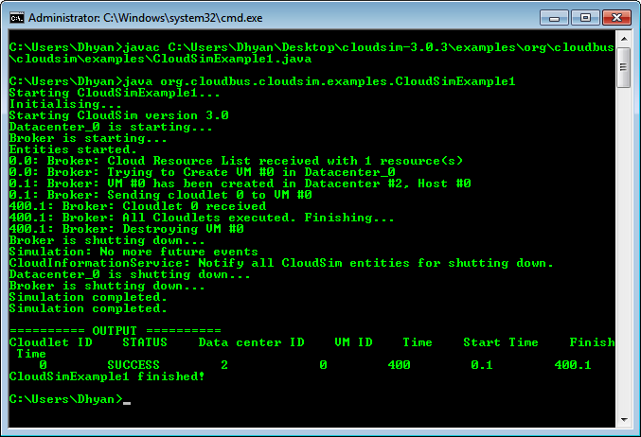

**RESULT:**

Thus the program to create one host and one cloudlet using cloudsim was executed successfully.

Ex.No 5 **Transfer files from VM to VM**

Date:

Aim:

To transfer files between VM’s.

Once you’ve installed the guest additions, enable shared folders by adding a folder from your host machine in the settings for the guest machine. To do this, first make sure the guest machine is powered off. Then, select the guest machine in the list on the left of the VirtualBox Manager and click Settings on the toolbar.

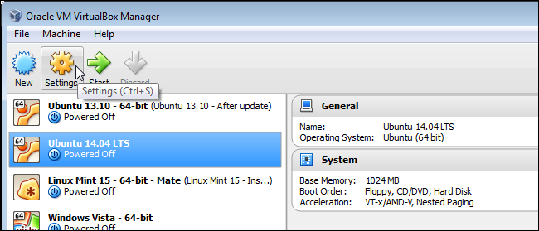

On the Settings dialog box, click Shared Folders in the list of options on the left. On the Shared Folders screen, click the folder button with the plus sign to add a folder.

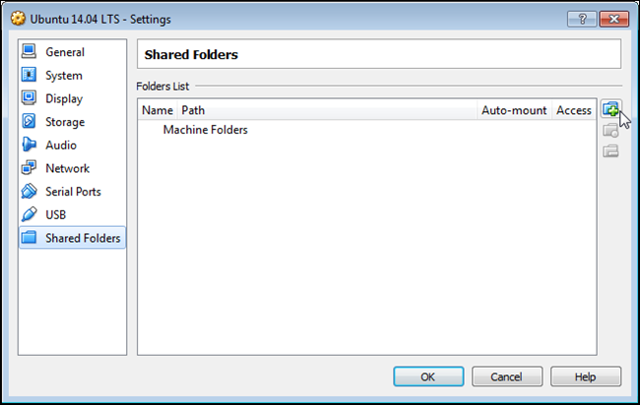

On the Add Share dialog box, select Other from the Folder Path drop-down list.

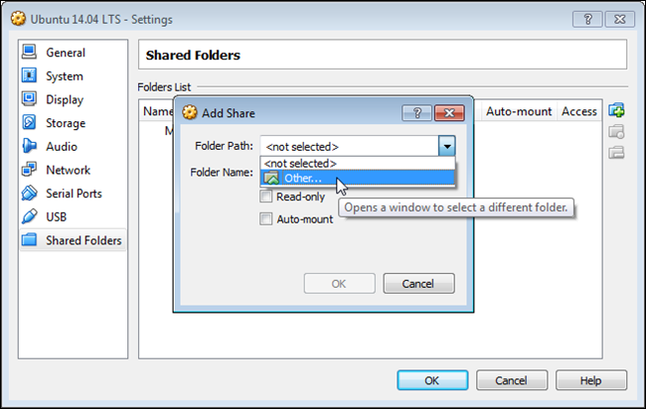

The Browse For Folder dialog box displays. Navigate to the folder you want to share between the host and the guest, select it, and click OK.

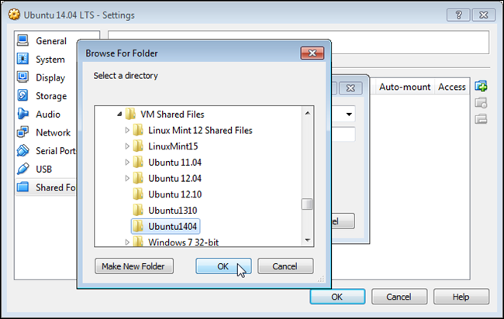

The path to the selected folder is inserted in the Folder Path edit box. The name of the folder automatically becomes the Folder Name, but you can change this name if you want. If you don’t want to be able to change items in this folder in the guest machine, select the Read-only check box. To have the selected folder automatically mounted in the guest machine when you boot it, select the Auto-mount check box. Click OK once you’ve finished choosing your settings for the shared folder.

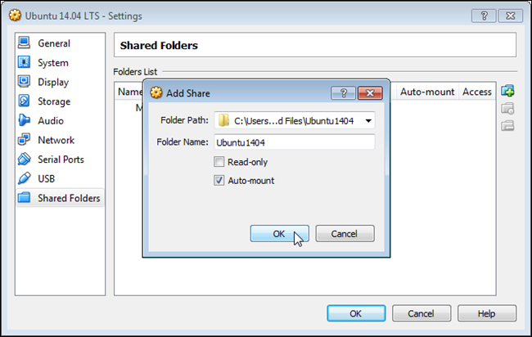

The selected folder displays in the Folders List. Click OK to close the dialog box.

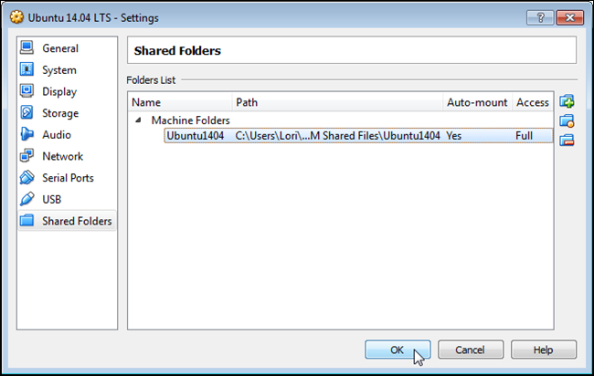

Now, make sure the guest machine is still selected in the VirtualBox Manager and click Start to boot it.

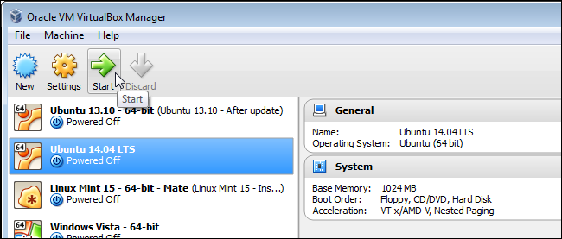

Once the guest machine is booted, open Nautilus (File Manager) by clicking the file cabinet on the Unity bar on the left side of the desktop.

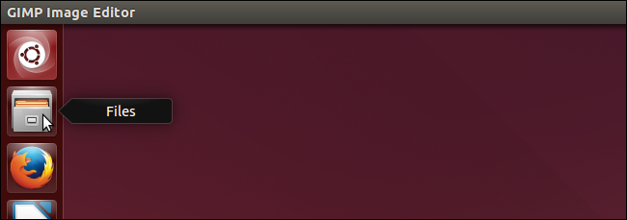

In the Devices list on the left, click Computer and then double-click the Media folder on the right. You’ll see a folder named similarly to the folder you selected to share on your host machine with “sf\_” added to the beginning of the name.

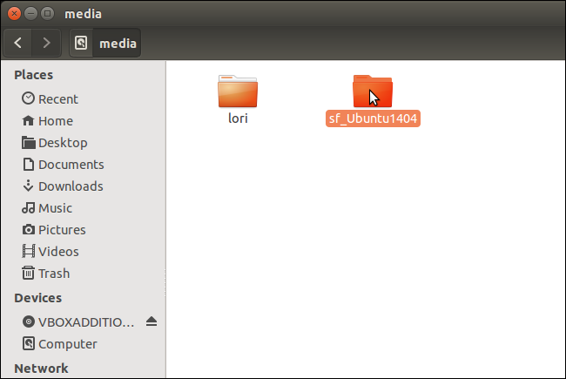

If you double-click on that folder, the following dialog box displays. This is because there is one more task to perform before you can access the shared folder.

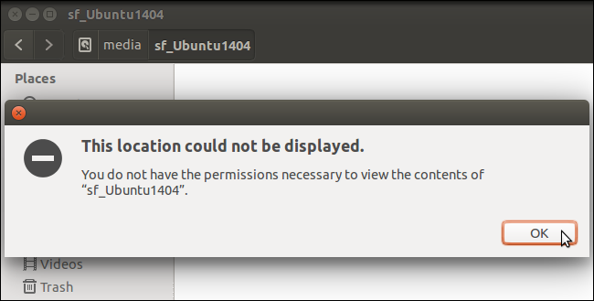

In addition to users in Ubuntu, there are also groups. When VirtualBox installed the Ubuntu operating system, it added a group called “vboxsf”. Before you can access any shared folders, you must add yourself to the vboxsf group. To do this, press Ctrl + Alt + T to open a Terminal window. Type the following at the prompt, replacing “[username]” with your username, and press Enter.

sudo adduser [username] vboxsf

Type your password when prompted and press Enter again. Messages display as you are being added to the group and “Done.” displays when the process has been successfully completed.

To close the Terminal window, type “exit” (without the quotes) at the prompt and press Enter.

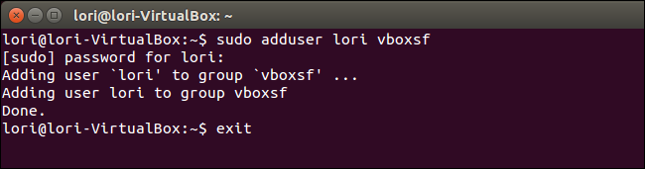

To verify you are in the vboxsf group, you can type “id [username]” (without the quotes, and replacing “[username]” with your username) at the prompt and press Enter. All the groups of which the specified user is a member display.

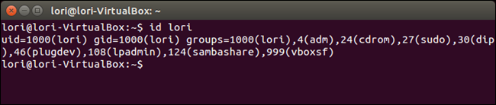

Now, when you access the shared folder in the Media folder as described above, you should see any files in that exist in that folder on the host machine.

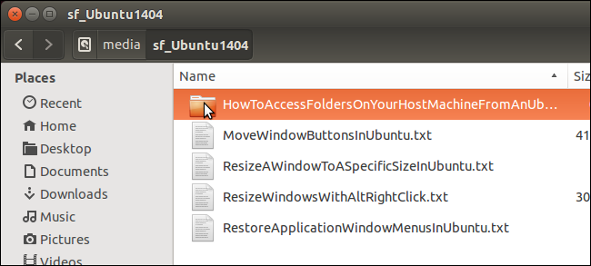

You can edit these files directly in this folder if you DID NOT select the “Read-only” option when selecting the folder in the Settings. You can also copy files into and out of this folder. If the folder was set to “Read-only”, you can only copy files from this folder and cannot copy files into it.

Result:

Thus the files are shared between two VM’s.

Ex.No 6

Date:

Single-node OpenStack deployment

Aim:

Install single node openstack in ubuntu.

# Downloading CentOS 7 ISO Image:

First, you have to download the CentOS 7 ISO installation image from the official website of CentOS 7.

To do that, visit <https://www.centos.org/download/> and click on Minimal ISO as marked in the screenshot below.

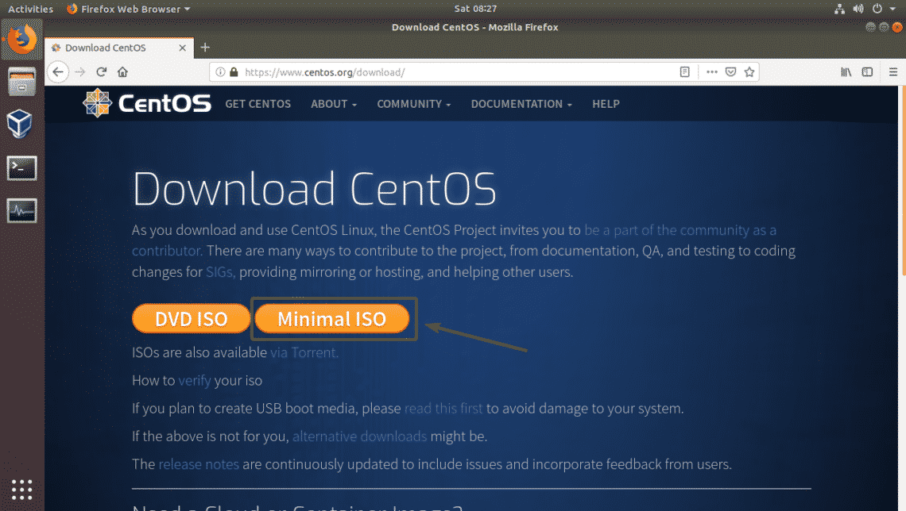

Now, click on any of the link.

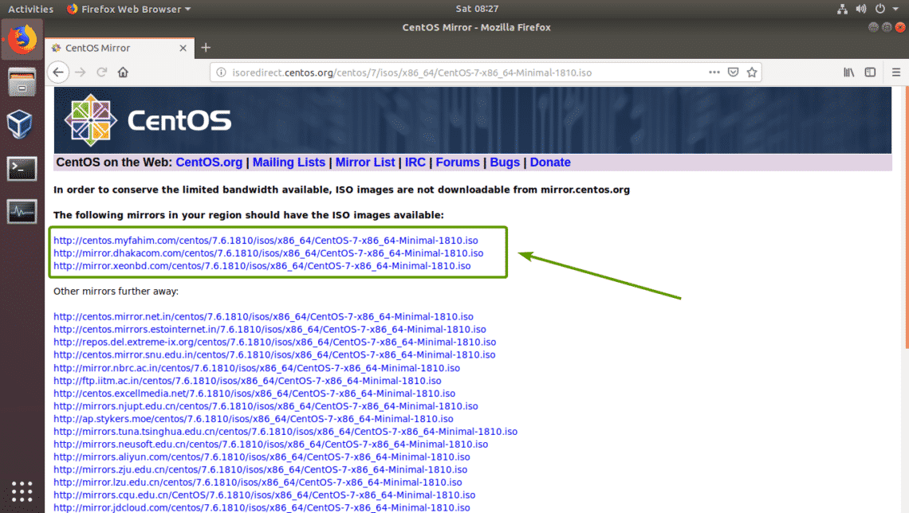

Your browser should prompt you to save the file. Select **Save File** and click on **OK**.

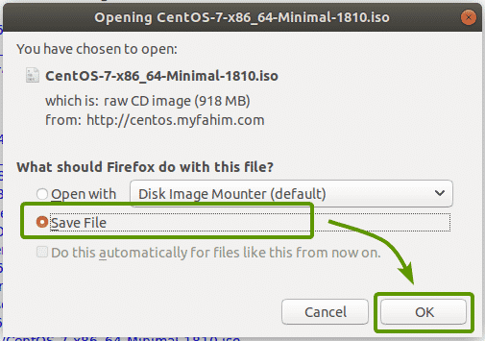

CentOS 7 ISO installation media is being downloaded.

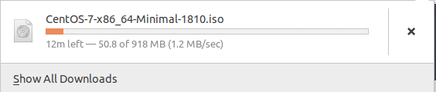

## Creating a Virtual Machine:

Once the CentOS 7 ISO installation image is downloaded, open VirtualBox and click on **Machine** > **New…** as marked in the screenshot below.

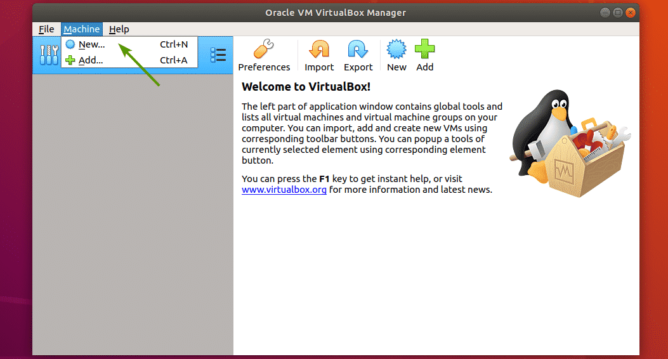

Now, type in a name for the VM. Then, select **Linux** and **Red Hat (64-bit)** as the Type and Version respectively. Then, click on **Next**.

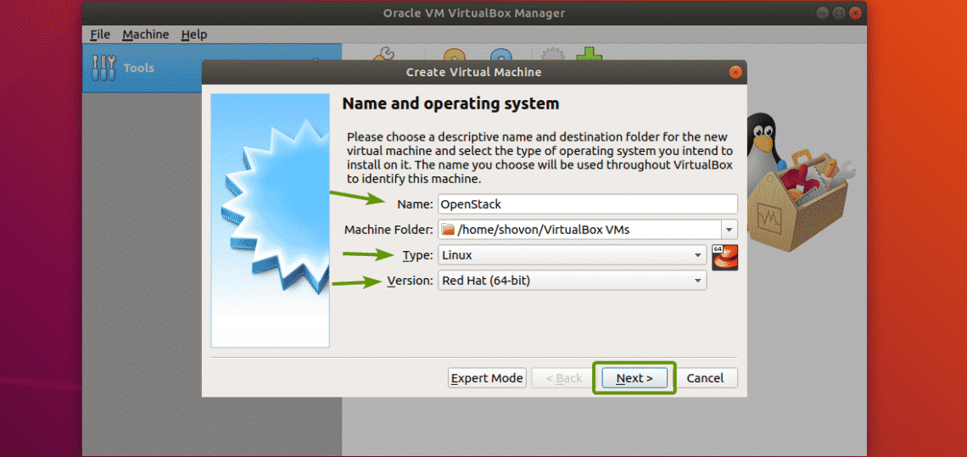

You need at least 16 GB of RAM in order to run OpenStack. So, make sure you assign 16 GB (16384 MB) of RAM to your VM. Once you’ve set the memory size, click on **Next**.

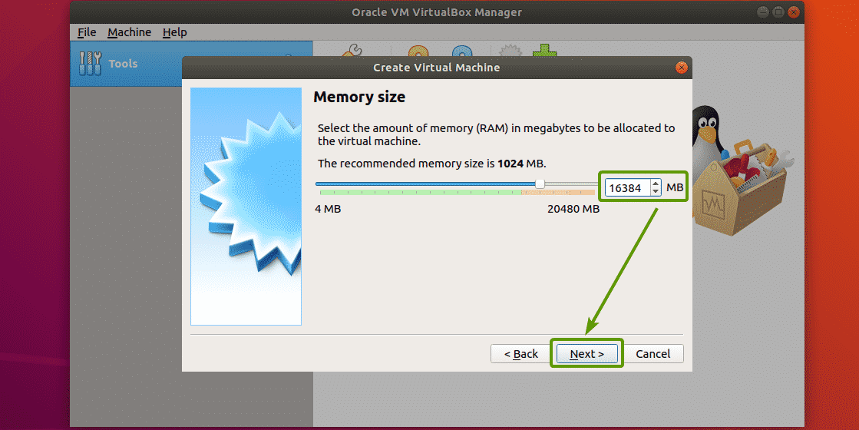

Now, click on **Create**.

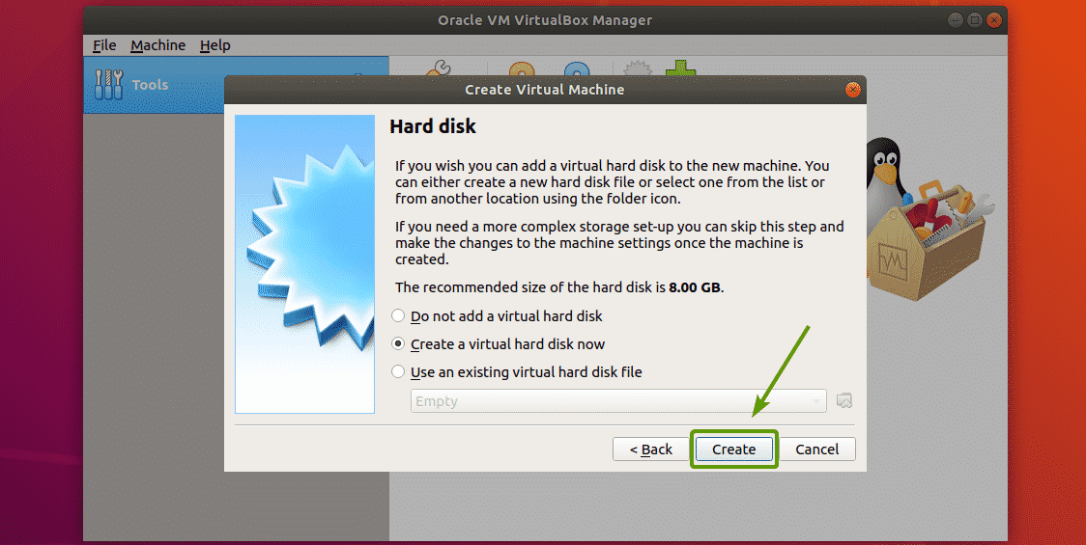

Now, click on **Next >**.

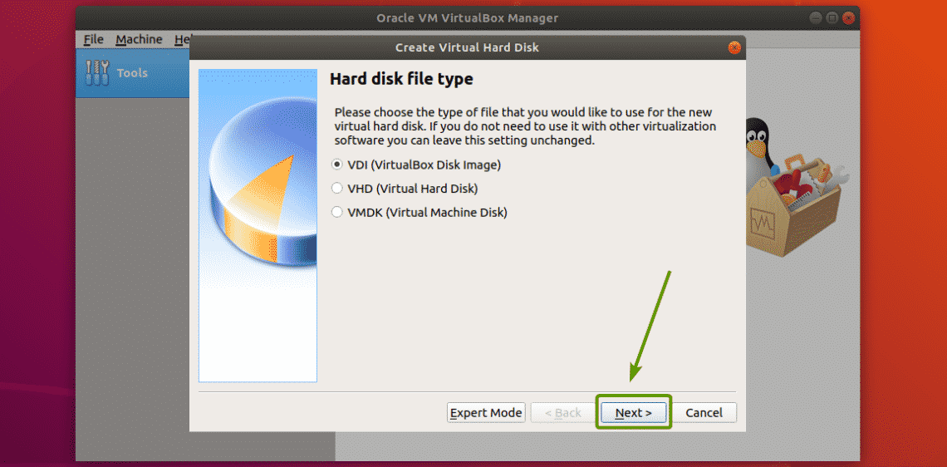

Now, click on **Next >**.

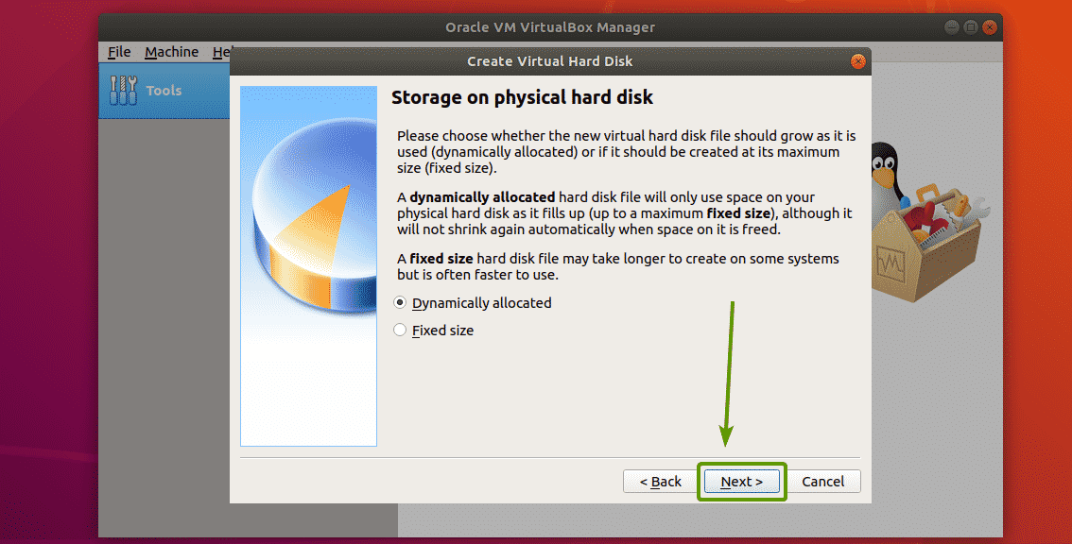

Now, set 100 GB as the hard disk size and click on **Create**.

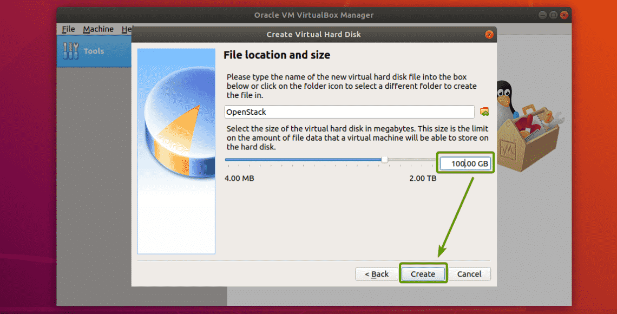

OpenStack VM should be created. Now, select the OpenStack VM and click on **Settings**.

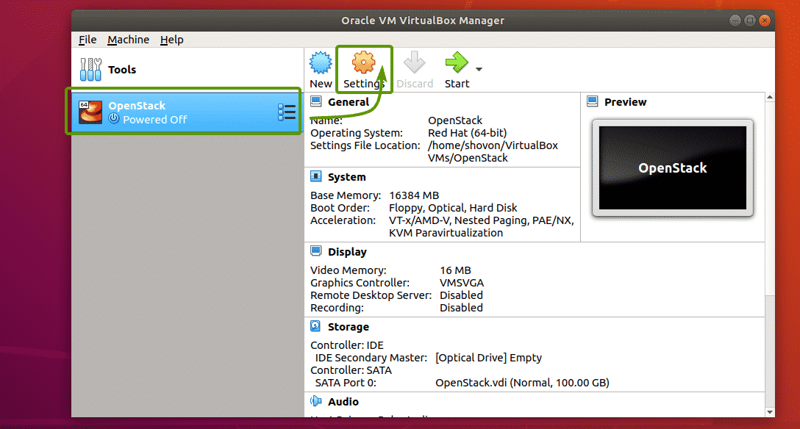

Now, select **USB Tablet** as the **Pointing Device** from **System** > **Motherboard** as marked in the screenshot below.

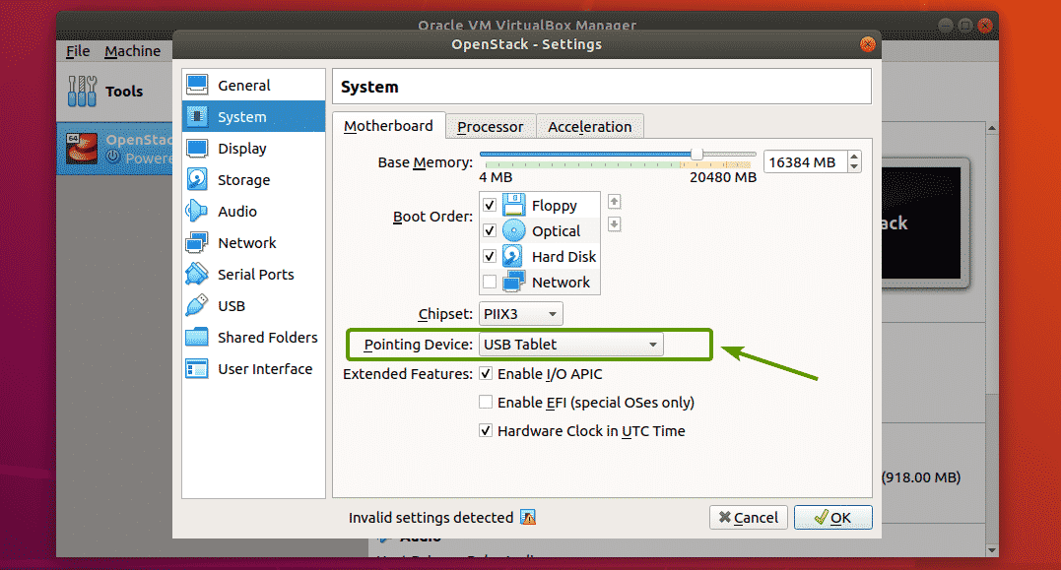

Now, check **Enable Nested VT-x/AMD-v**from **System** > **Processor** as marked in the screenshot below.

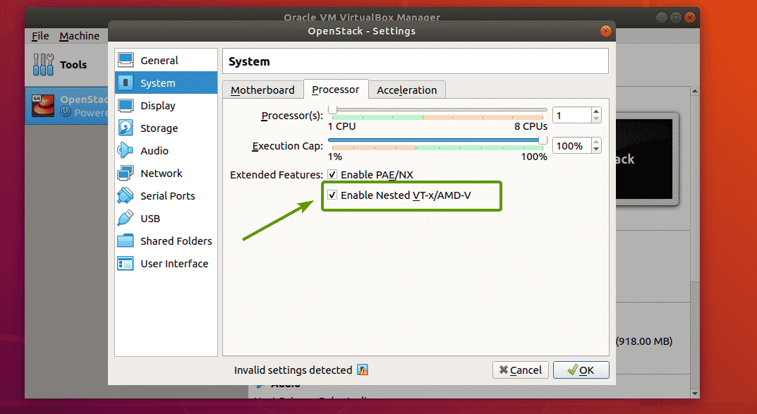

Now, from the **Network** section, change **Attached to** to **Bridged Adapter**, **Adapter Type** to **Paravirtualized Network (virtio-net)** and **Promiscuous Mode** to **Allow All**.

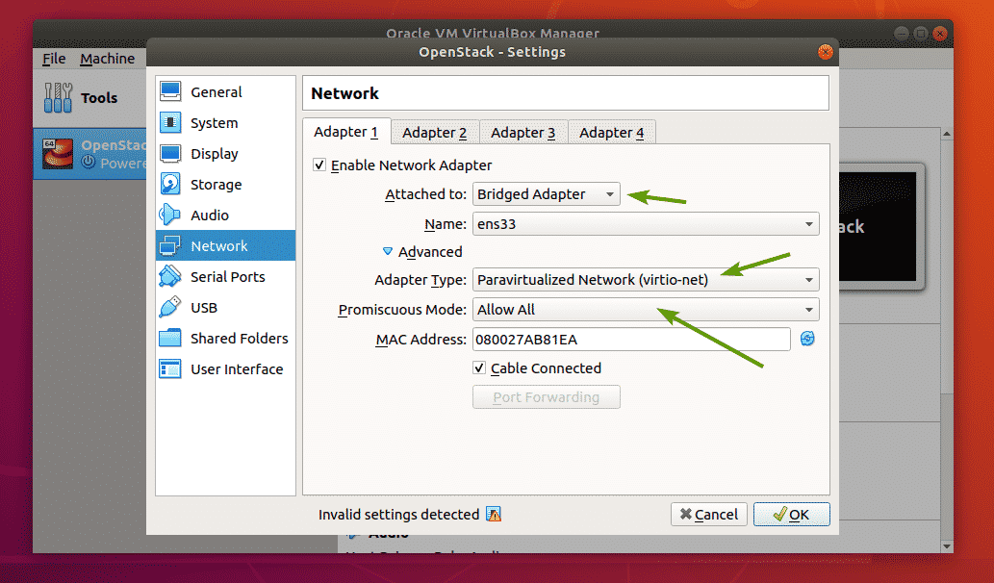

Now, you have to set the CentOS 7 ISO installation image as the Optical drive. To do that, follow the procedures as marked in the screenshot below.

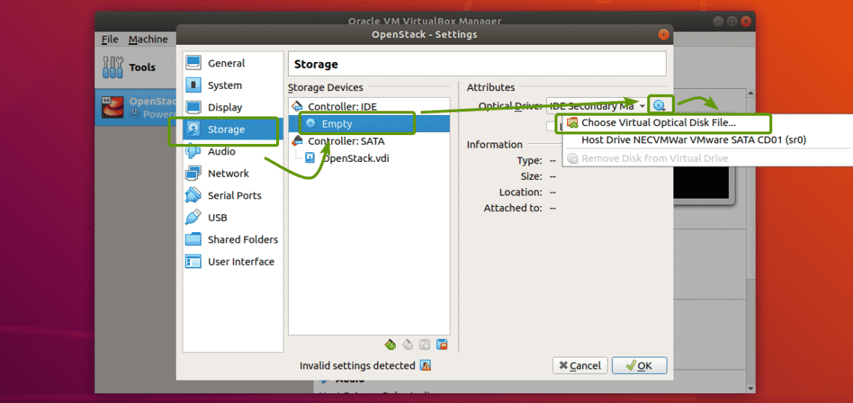

Now, select the CentOS 7 ISO installation image and click on **Open**.

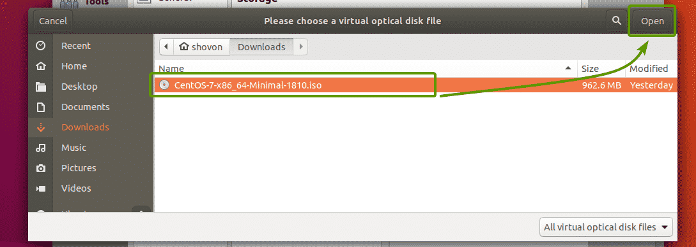

Now, click on **OK**.

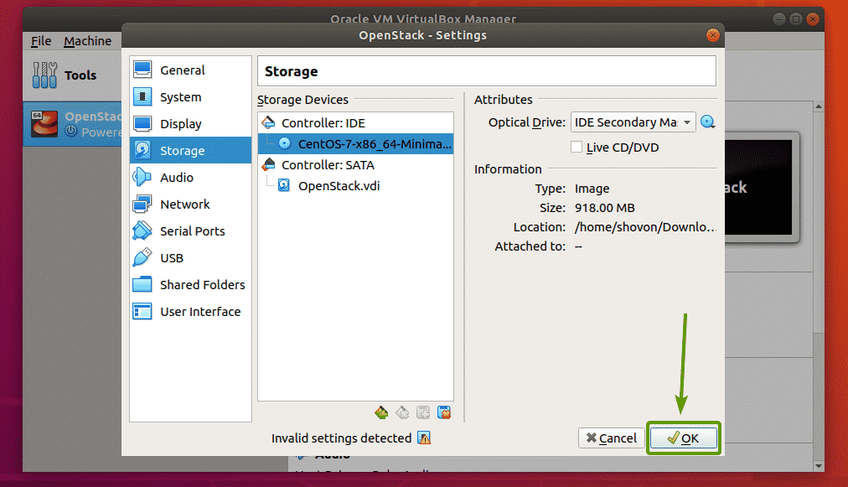

The VM is now ready to install CentOS 7.

### Installing CentOS 7 on the Virtual Machine:

Now, select the **OpenStack** VM and click on **Start**.

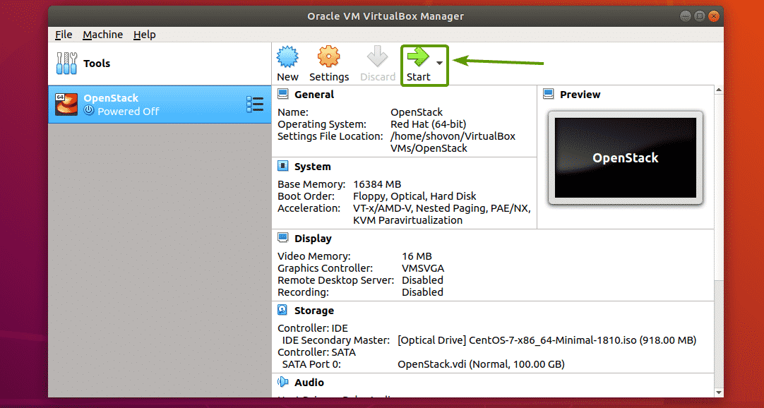

The VM should boot from the ISO installation image. Now, select **Install CentOS 7** and press **<Enter>**.

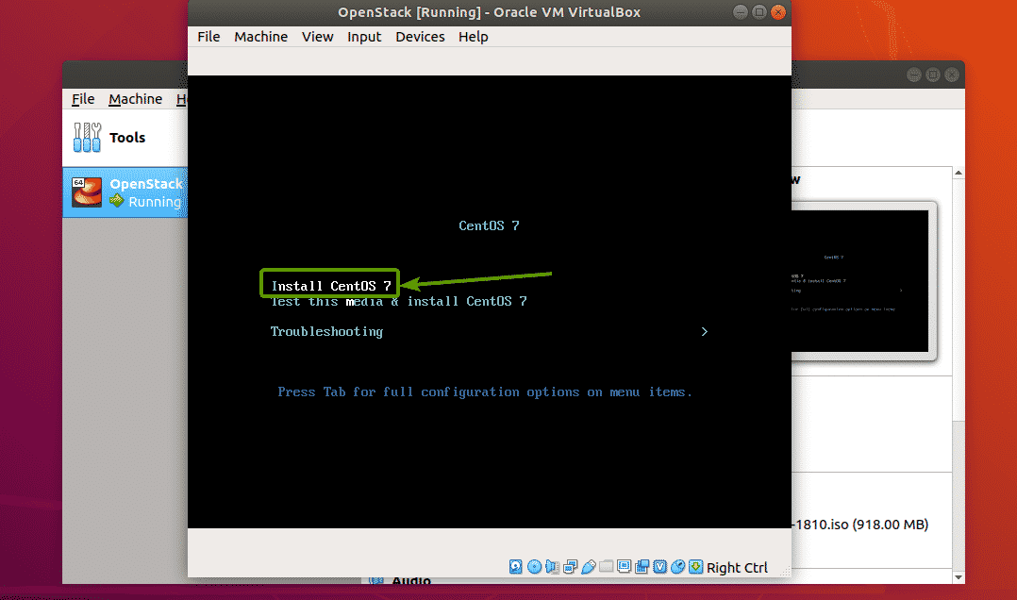

The CentOS 7 GUI installer should start. Now, install CentOS 7 as usual. Make sure to set a **root** password during installation.

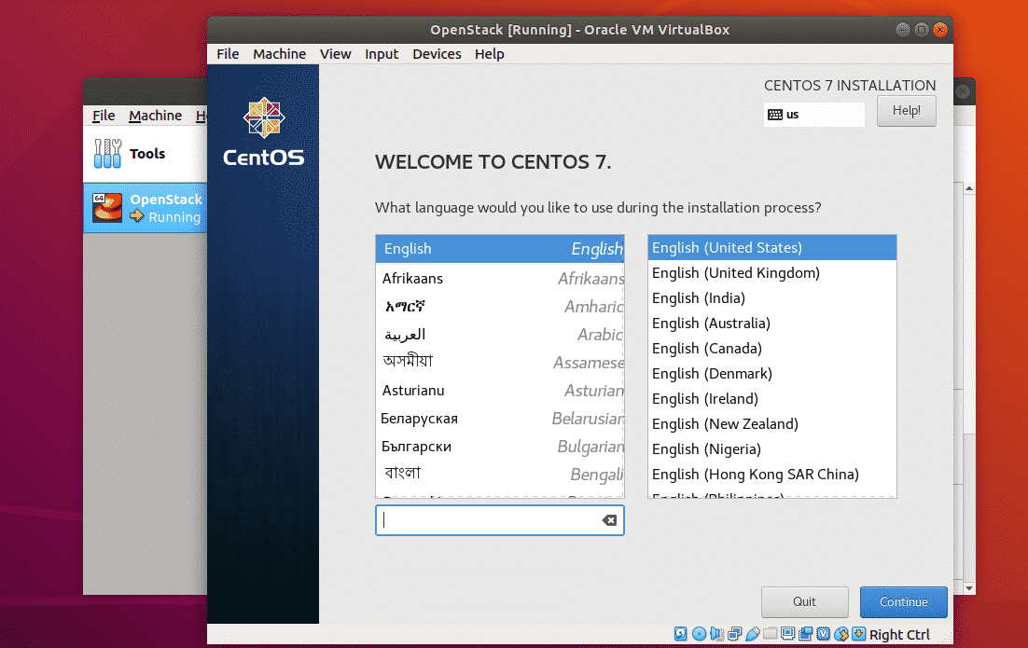

Once CentOS 7 is installed, you should be able to log in as the user **root** using the password that you’ve set during installation.

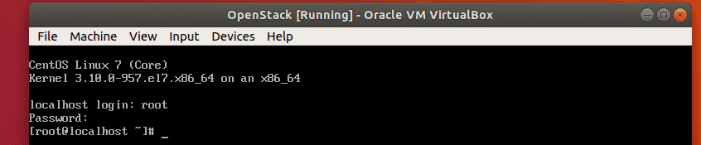

### Configuring Network:

Now, disable **firewalld** service with the following command:

*#*systemctl disable firewalld

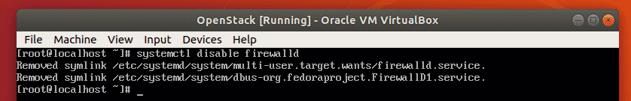

Now, stop the **firewalld** service with the following command:

*#*systemctl stop firewalld

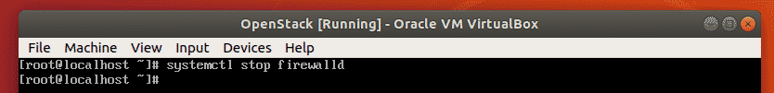

Now, disable **NetworkManager** service with the following command:

*#*systemctl disable NetworkManager

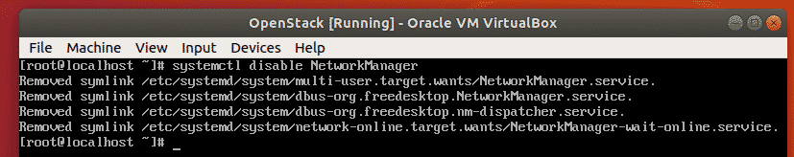

Now, stop **NetworkManager** service with the following command:

*#*systemctl stop NetworkManager

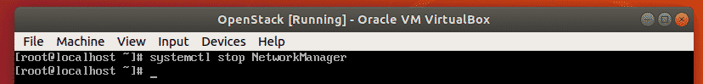

Now, enable **network**service with the following command:

*#*systemctl enable network

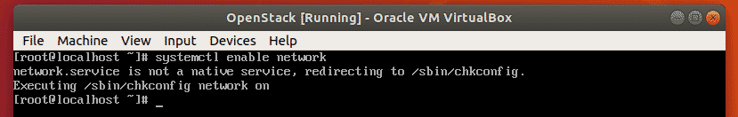

Now, start **network**service with the following command:

*#*systemctl start network

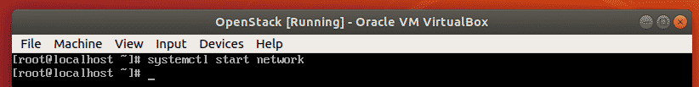

Now, check the name of your network interface as follows:

*$*ip a

The name of the network interface of my CentOS 7 VM is **eth0**.

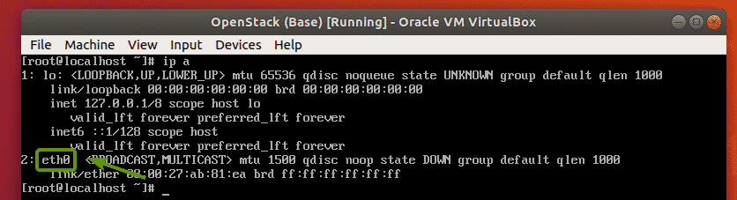

Now, run the following command to configure the network interface **eth0** to automatically get IP address via DHCP:

*#*echo -e 'DEVICE=eth0\nBOOTPROTO=dhcp\n' > /etc/sysconfig/network-scripts/ifcfg-eth0

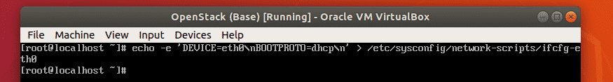

Now, reboot your CentOS 7 VM as follows:

*$*sudo reboot



Once it boots, the network interface **eth0** should have an IP address.

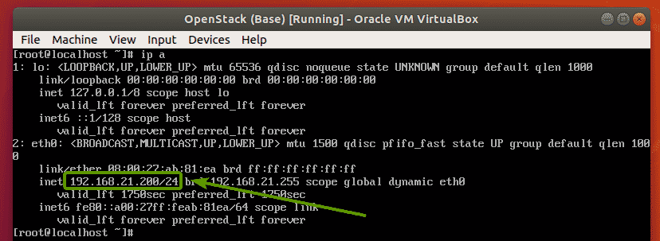

### Installing OpenStack:

Before you do anything, make sure to set the **LANG** and **LC\_ALL** environment variables correctly with the following command:

*#*echo -e "LANG=en\_US.utf-8\nLC\_ALL=en\_US.utf-8\n" > /etc/environment



Now, to make sure all the CentOS 7 packages are up to date, run the following command:

*#*yum update -y



CentOS packages are being updated.

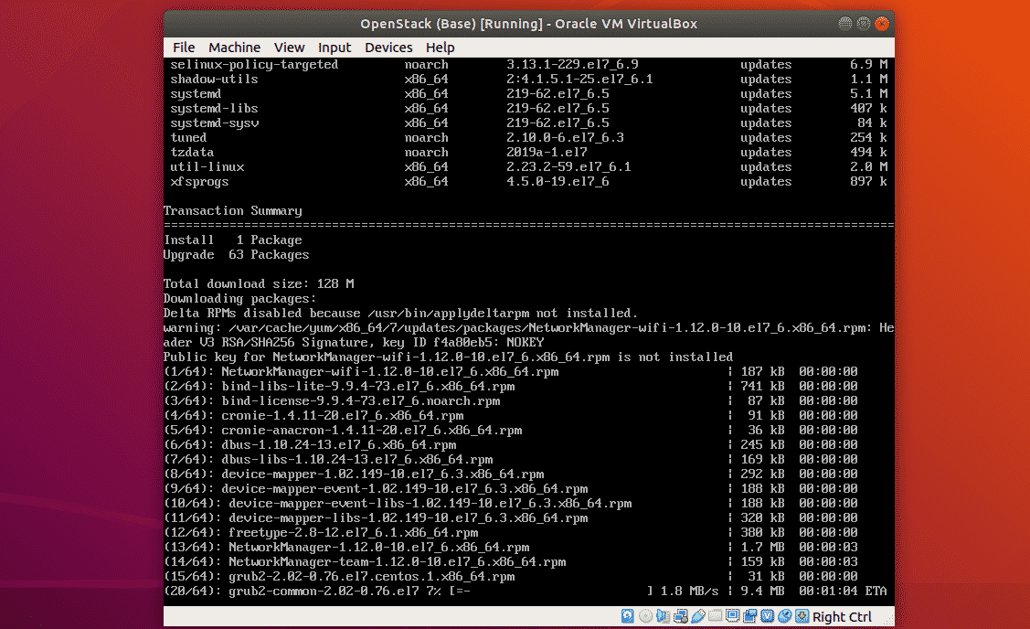

All the CentOS 7 packages should be updated.

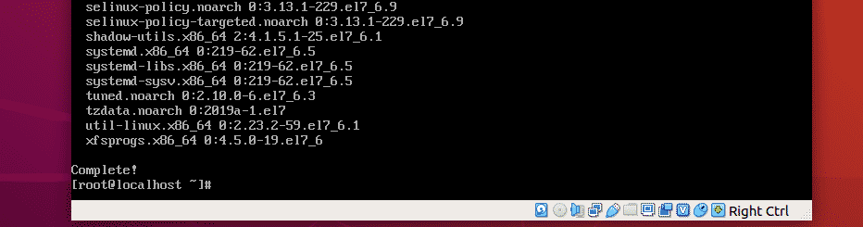

Now, add the OpenStack Rocky package repository with the following command:

*#*yum install -y centos-release-openstack-rocky



The OpenStack Rocky package repository should be added.

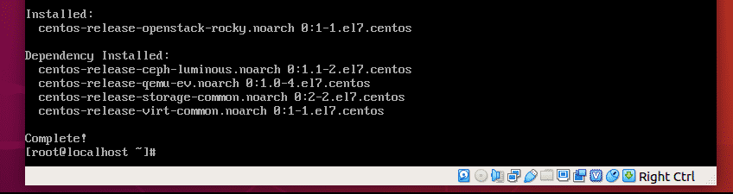

Now, update the CentOS 7 system packages again with the following command:

*#*yum update -y



All the system packages should be updated.

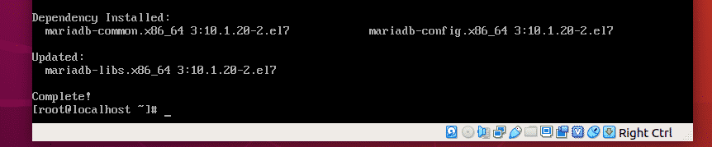

Now, install PackStack with the following command:

*#*yum install -y openstack-packstack

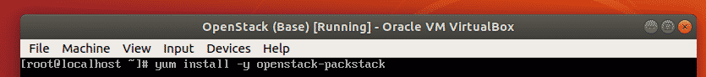

PackStack is being installed. It may take a while to complete.

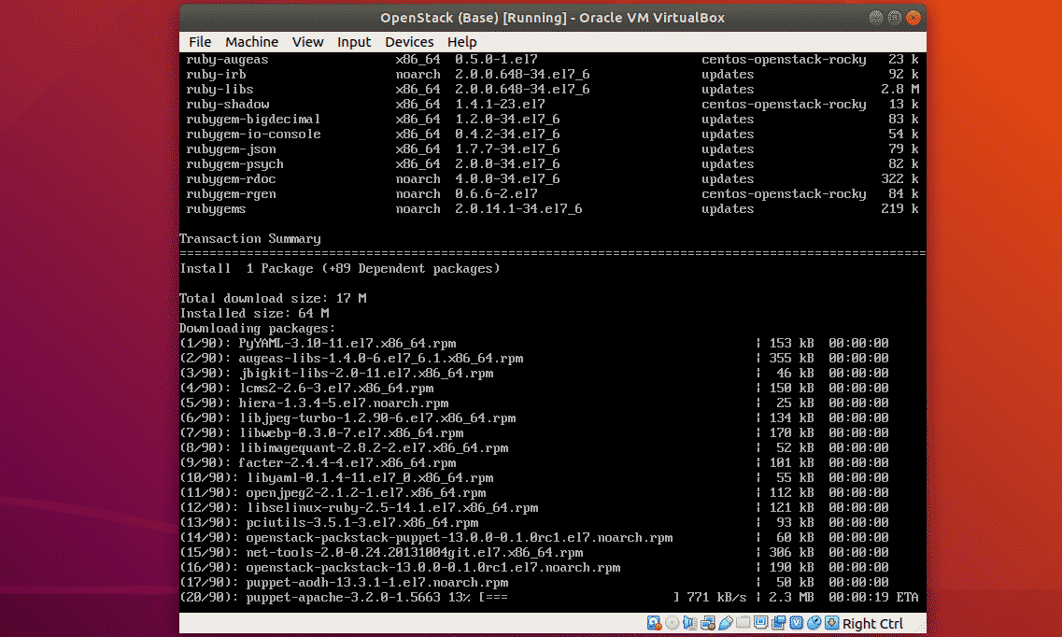

PackStack should be installed.

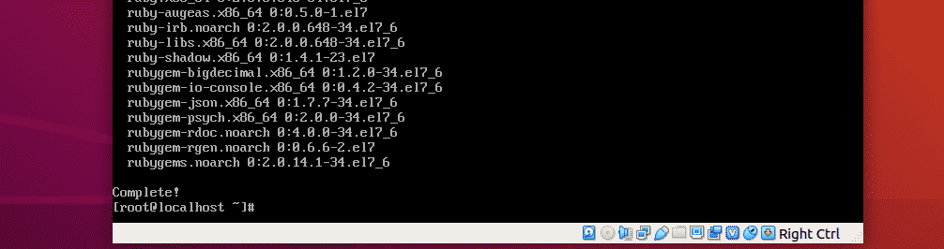

Now, install all the components of OpenStack on CentOS 7 with the following command:

*#*packstack --allinone



OpenStack is being installed.

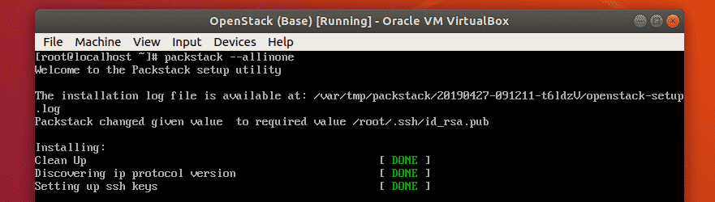

PackStack is configuring required components with Puppet. It will take a long time to complete.

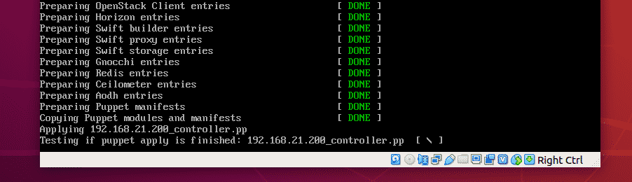

OpenStack is installed.

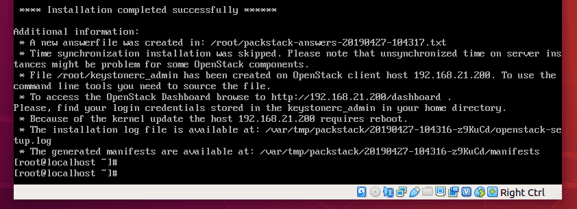

### Testing OpenStack:

You need the IP address of your CentOS 7 machine in order to access OpenStack Horizon dashboard.

To find the IP address of CentOS 7, run the following command:

*#*ip a

As you can see, the IP address of my CentOS 7 machine is **192.168.21.200**. It will be different for you. So, make sure to replace it with yours from now on.

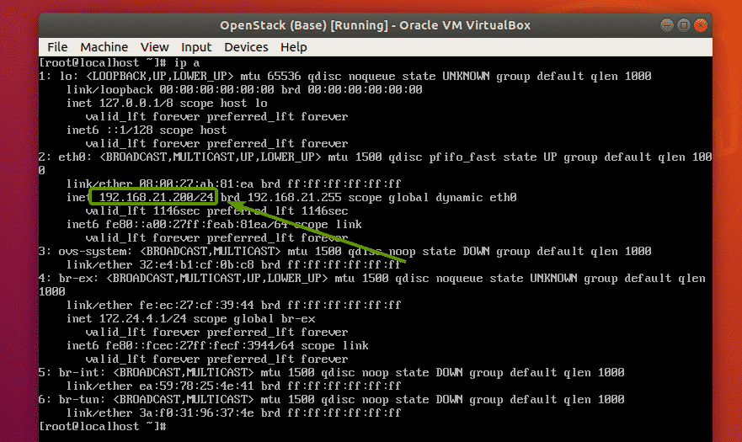

Now, to find the OpenStack Horizon dashboard password, run the following command:

*#*cat keystonerc\_admin | grep PASSWORD

As you can see, **df29616110934166**is the password for my OpenStack Horizon dashboard.

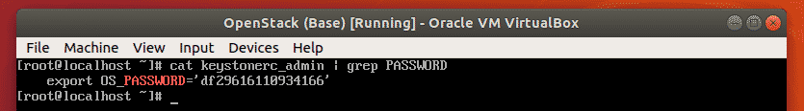

Now, from your favorite web browser, visit [http://192.168.21.200](http://192.168.21.200/) and you should see the OpenStack login page. Type in the username **admin** and the password **df29616110934166**(password should be different for you. So, replace it with yours.). Then, click on **Sign In**.

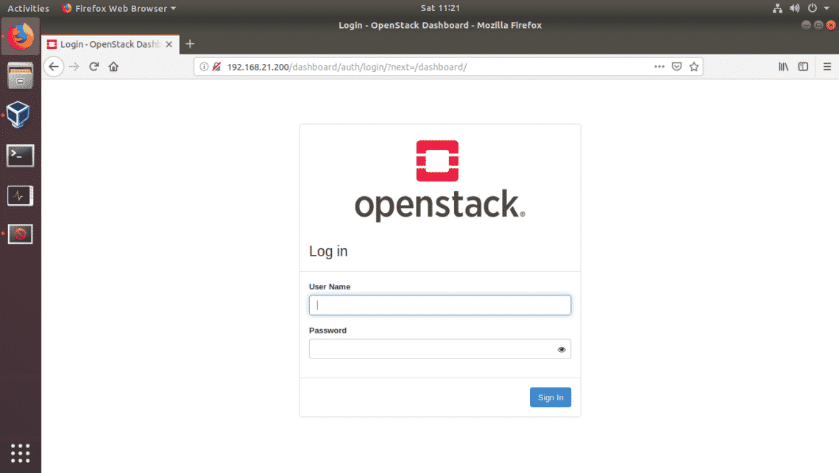  
a  
You should be logged in to OpenStack Horizon dashboard. Now, you can configure OpenStack any way you like from here.

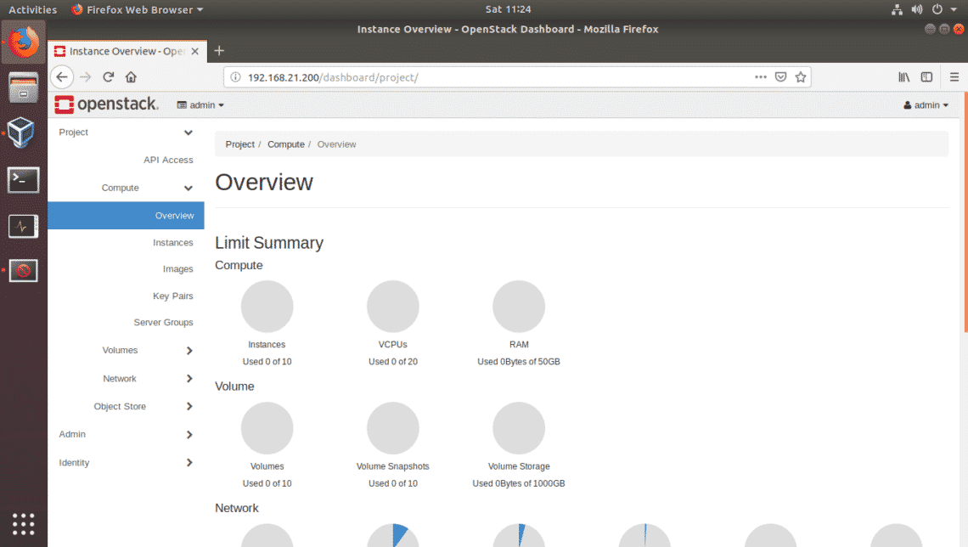

Result:

Thus the one node openstack is installed on ubuntu.

Ex.No 7

Date: Installing VM instances in Openstack

Aim:

To install instances of Openstack.

**Step 1: Allocate Floating IP to OpenStack**

**1.** Before you deploy an **OpenStack** image, first you need to assure that all pieces are in place and we’ll start by allocating floating IP.

Floating IP allows external access from outside networks or internet to an Openstack virtual machine. In order to create floating IPs for your project, login with your **user** credentials and go to **Project** -> **Compute** -> **Access & Security** -> **Floating IPs** tab and click on **Allocate IP** to The Project.

Choose external **Pool** and hit on **Allocate IP** button and the IP address should appear in dashboard. It’s a good idea to allocate a Floating IP for each instance you run.

[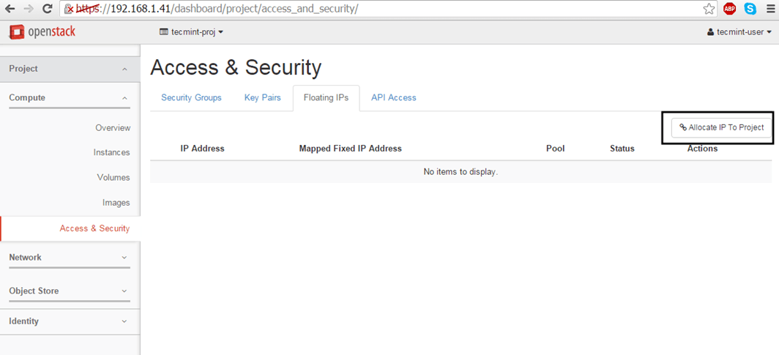](https://www.tecmint.com/wp-content/uploads/2016/04/Allocate-Floating-IP-to-Project-in-OpenStack.png)Allocate Floating IP to Project in OpenStack[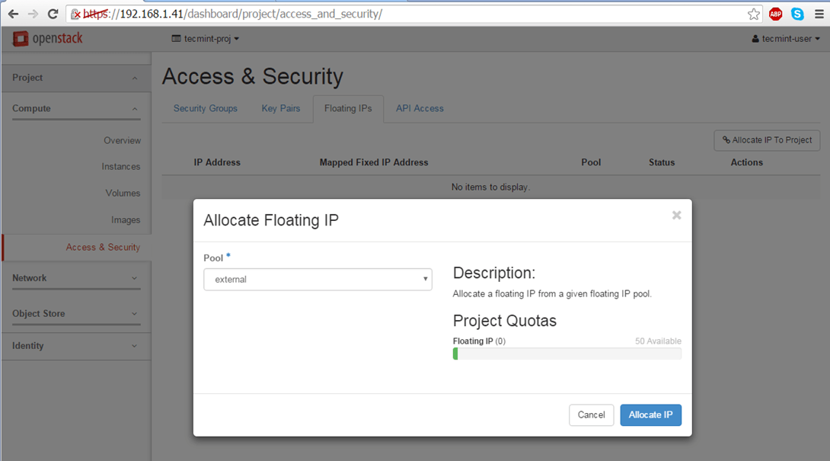](https://www.tecmint.com/wp-content/uploads/2016/04/Allocate-Floating-IP-to-External-Pool.png)Allocate Floating IP to External Pool[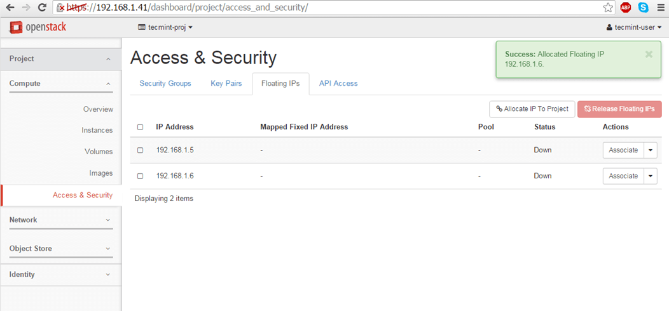](https://www.tecmint.com/wp-content/uploads/2016/04/Confirmation-of-Adding-Floating-IP.png)Confirmation of Adding Floating IP

**Step 2: Create an OpenStack Image**

**2.** OpenStack images are just virtual machines already created by third-parties. You can create your own customized images on your machine by installing an Linux OS in a virtual machine using a virtualization tool, such as [KVM](https://www.tecmint.com/install-and-configure-kvm-in-linux/), [VirtualBox](https://www.tecmint.com/install-virtualbox-on-redhat-centos-fedora/), [VMware](https://www.tecmint.com/install-vmware-workstation-11-in-linux/) or [Hyper-V](https://www.tecmint.com/deploy-redhat-enterprise-virtualization-hypervisor-rhev/).

Once you have installed the OS, just convert the file to raw and upload it to your OpenStack cloud infrastructure.

To deploy official images provided by major Linux distributions use the following links to download the latest packaged images:

1. **CentOS 7** – <http://cloud.centos.org/centos/7/images/>
2. **CentOS 6** – <http://cloud.centos.org/centos/6/images/>
3. **Fedora 23** – <https://download.fedoraproject.org/pub/fedora/linux/releases/23/Cloud/>
4. **Ubuntu** – [http://cloud-images.ubuntu.com/](https://cloud-images.ubuntu.com/)
5. **Debian** – [http://cdimage.debian.org/cdimage/openstack/current/](https://cdimage.debian.org/cdimage/openstack/current/)
6. **Windows Server 2012 R2** – <https://cloudbase.it/windows-cloud-images/#download>

Official images additionally contain the **cloud-init** package which is responsible with SSH key pair and user data injection.

On this guide we’ll deploy a test image, for demonstration purposes, based on a lightweight Cirros cloud image which can be obtained by visiting the following link <http://download.cirros-cloud.net/0.3.4/>.

The image file can be used directly from the HTTP link or downloaded locally on your machine and uploaded to OpenStack cloud.

To create an image, go **OpenStack** web panel and navigate to **Project** -> **Compute** -> **Images** and hit on **Create Image** button. On the image prompt use the following settings and hit on **Create Image** when done.

Name: **tecmint-test**

Description: **Cirros test image**

Image Source: **Image Location** #Use Image File if you’ve downloaded the file locally on your hard disk

Image Location: **http://download.cirros-cloud.net/0.3.4/cirros-0.3.4-i386-disk.img**

Format: **QCOWW2 – QEMU Emulator**

Architecture: **leave blank**

**Minimum Disk:** leave blank

Minimum RAM: **leave blank**

Image Location: **checked**

Public: **unchecked**

Protected: **unchecked**

[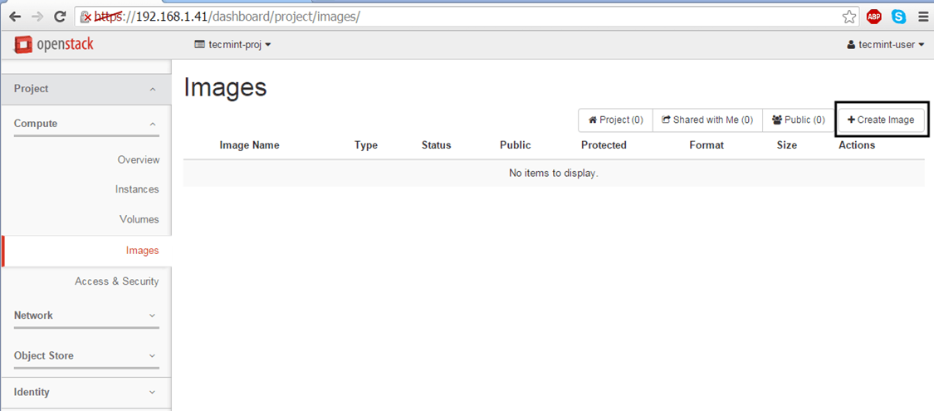](https://www.tecmint.com/wp-content/uploads/2016/04/Create-Images-in-OpenStack.png)Create Images in OpenStack[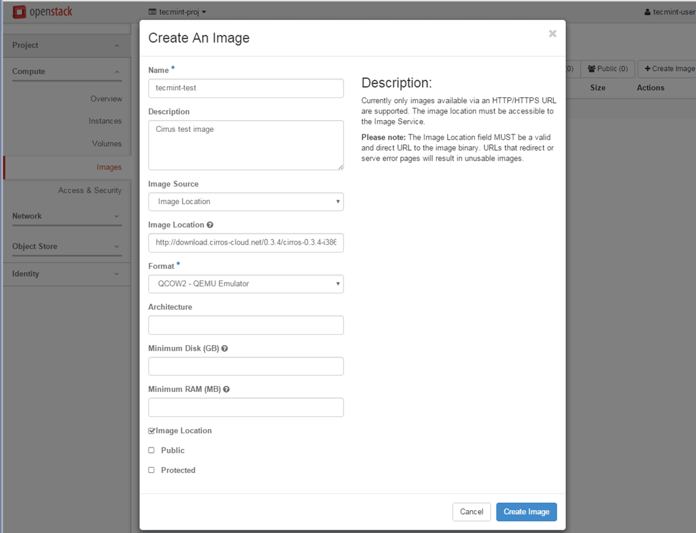](https://www.tecmint.com/wp-content/uploads/2016/04/Add-OpenStack-Image-Details.png)Add OpenStack Image Details[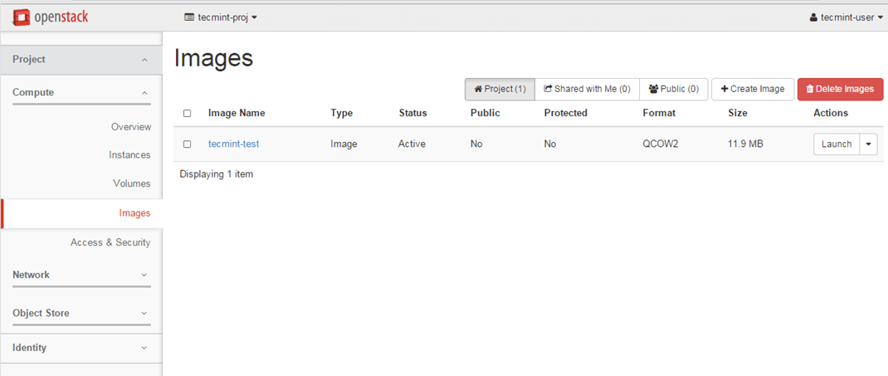](https://www.tecmint.com/wp-content/uploads/2016/04/OpenStack-Images.png)OpenStack Images

**Step 3: Launch an Image Instance in OpenStack**

**3.** Once you’ve created an image you’re good to go. Now you can run the virtual machine based on the image created earlier in your cloud environment.

Move to **Project** -> **Instances** and hit on **Launch Instance** button and a new window will appear.

[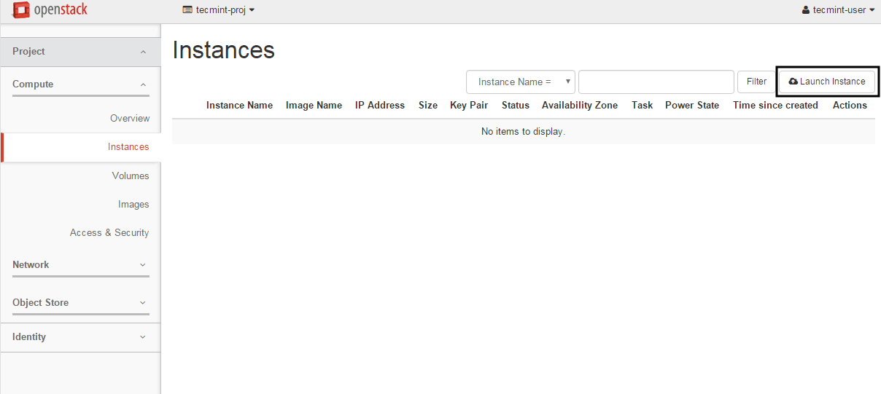](https://www.tecmint.com/wp-content/uploads/2016/04/Launch-Image-Instance-in-Openstack.png)Launch Image Instance in Openstack

**4.** On the first screen add a name for your instance, leave the **Availability Zone** to nova, use one instance count and hit on **Next** button to continue.

Choose a descriptive **Instance Name** for your instance because this name will be used to form the virtual machine hostname.

[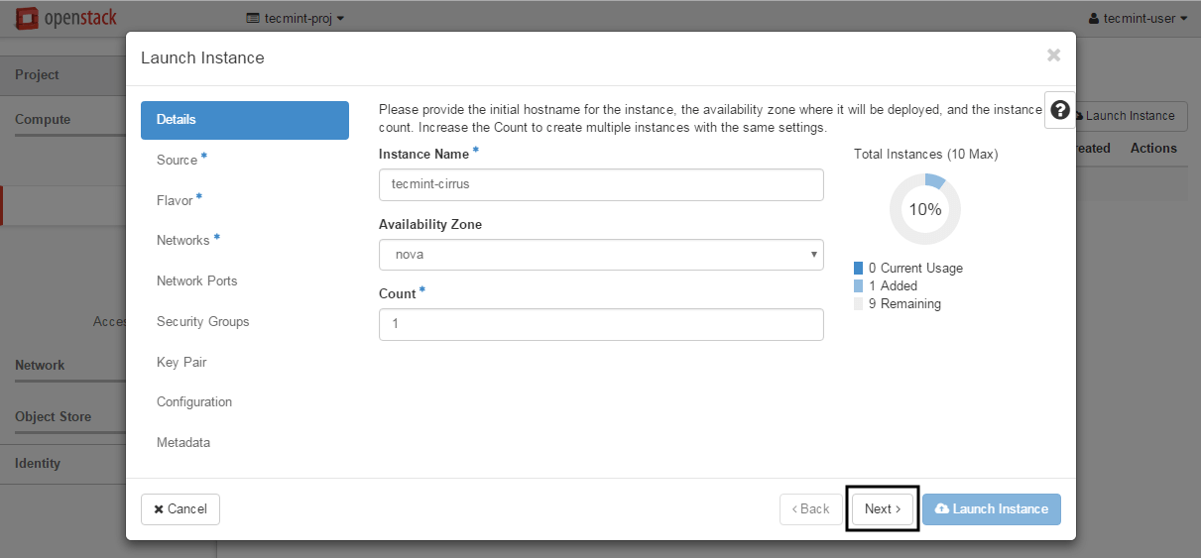](https://www.tecmint.com/wp-content/uploads/2016/04/Add-Hostname-to-OpenStack-Instance.png)Add Hostname to OpenStack Instance

**5.** Next, select Image as a **Boot Source**, add the **Cirros** test image created earlier by hitting the + button and hit **Next** to proceed further.

[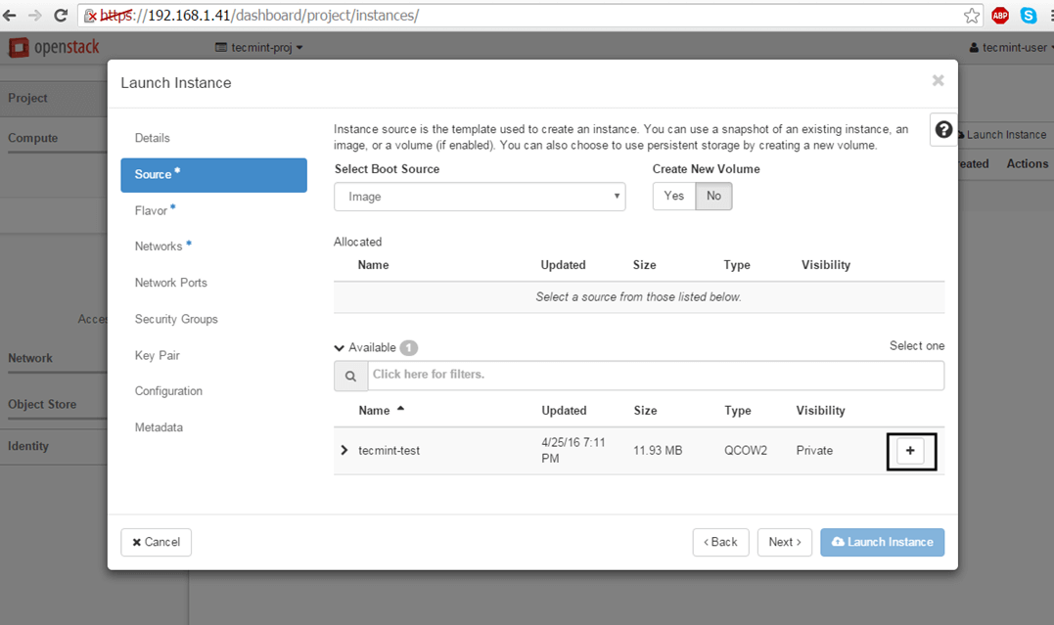](https://www.tecmint.com/wp-content/uploads/2016/04/Select-OpenStack-Instance-Boot-Source.png)Select OpenStack Instance Boot Source[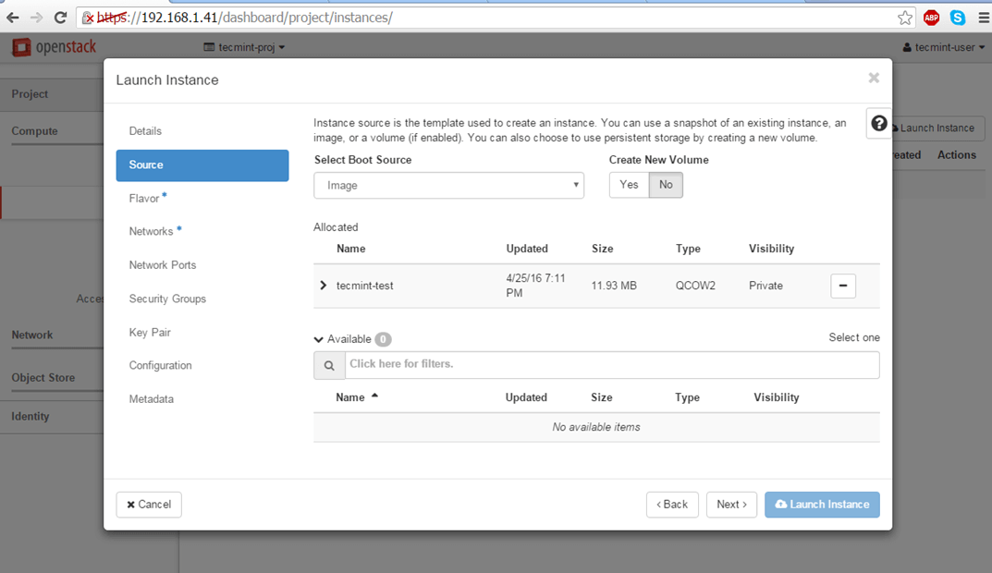](https://www.tecmint.com/wp-content/uploads/2016/04/Add-Cirros-Image.png)Add Cirros Text Image

**6.** Allocate the virtual machine resources by adding a flavor best suited for your needs and click on **Next** to move on.

[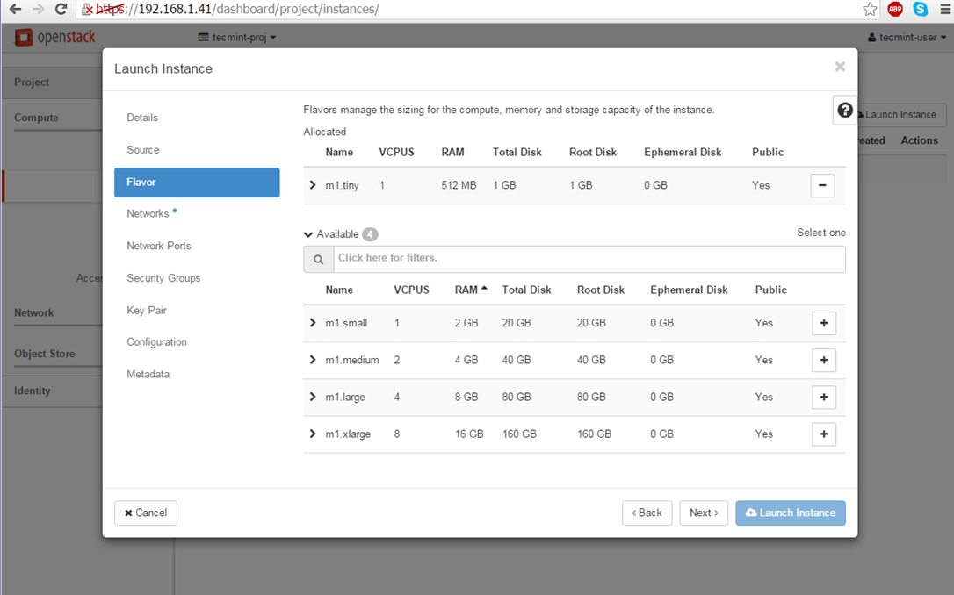](https://www.tecmint.com/wp-content/uploads/2016/04/Add-Resources-to-OpenStack-Instance.png)Add Resources to OpenStack Instance

**7.** Finally, add one of the OpenStack available networks to your instance using the + button and hit on **Launch Instance** to start the virtual machine.

[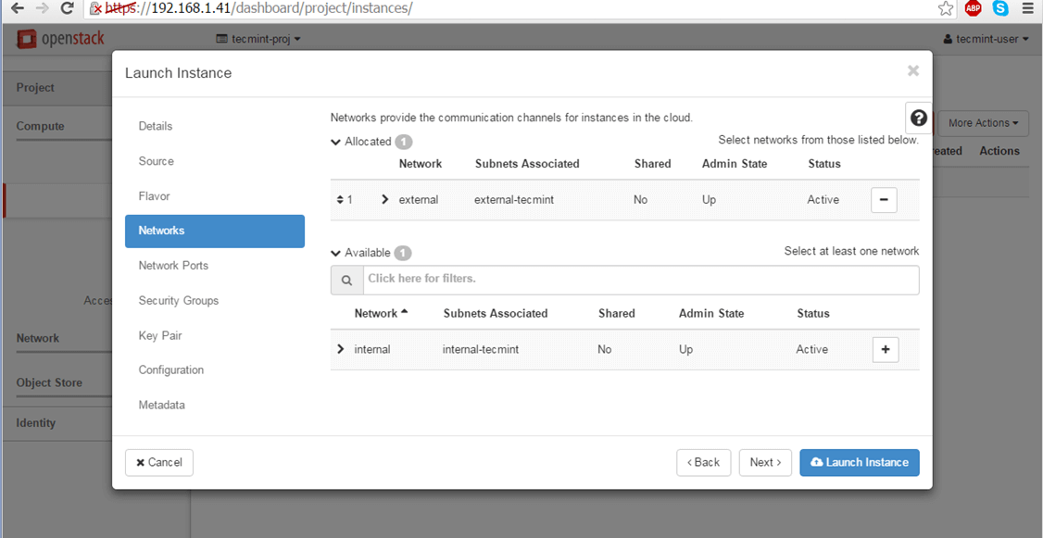](https://www.tecmint.com/wp-content/uploads/2016/04/Add-Network-to-OpenStack-Instance.png)Add Network to OpenStack Instance

**8.** Once the instance has been started, hit on the right arrow from **Create Snapshot** menu button and choose **Associate Floating IP**.

Select one of the floating IP created earlier and hit on **Associate** button in order to make the instance reachable from your internal LAN.

[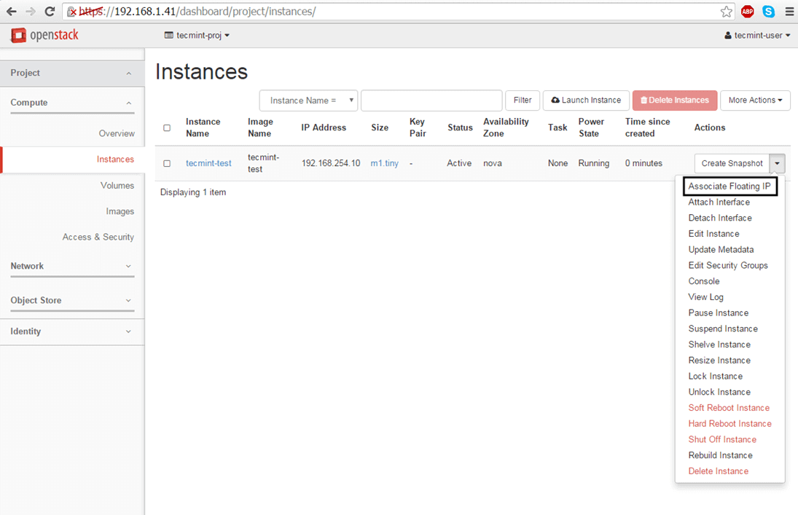](https://www.tecmint.com/wp-content/uploads/2016/04/Add-Associate-Floating-IP-to-OpenStack-Instance.png)Add Associate Floating IP to OpenStack Instance[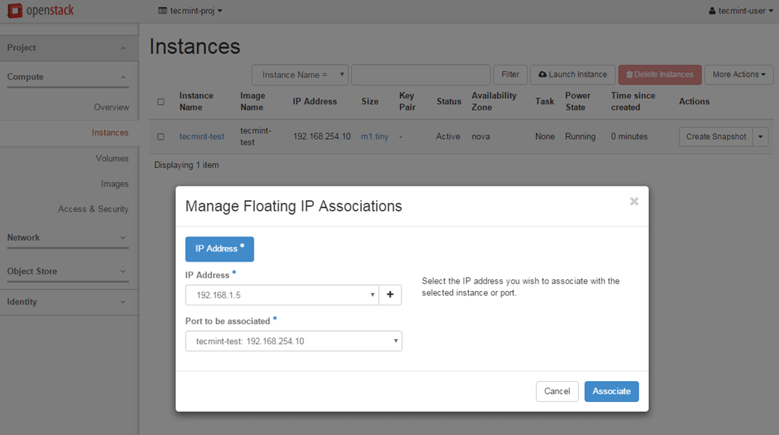](https://www.tecmint.com/wp-content/uploads/2016/04/Manage-Floating-IP-Associations.png)Manage Floating IP Associations

**9.** To test the network connectivity for your active virtual machine issue a **ping** command against the instance floating IP address from a remote computer in your LAN.

[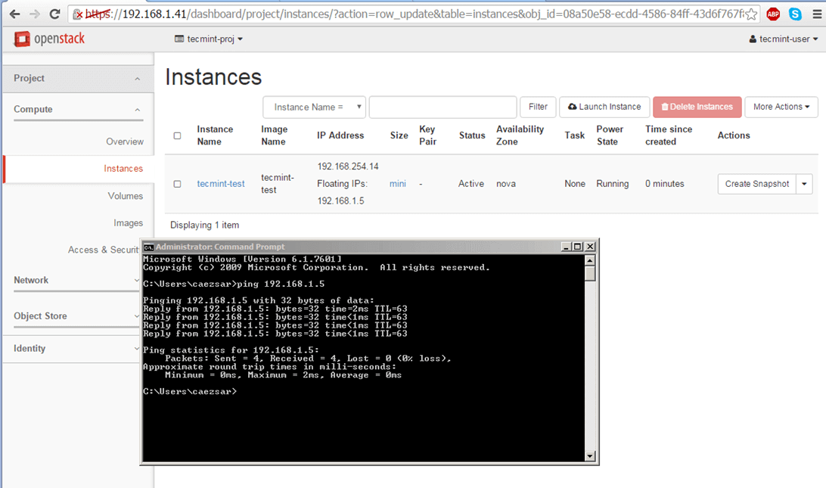](https://www.tecmint.com/wp-content/uploads/2016/04/Check-Network-of-Virtual-Machine-in-OpenStack.png)Check Network of Virtual Machine in OpenStack

**10.** In case there’s no issue with your instance and the **ping** command succeeds you can remotely login via SSH on your instance.

Use the instance **View Log** utility to obtain **Cirros** default credentials as illustrated on the below screenshots.

[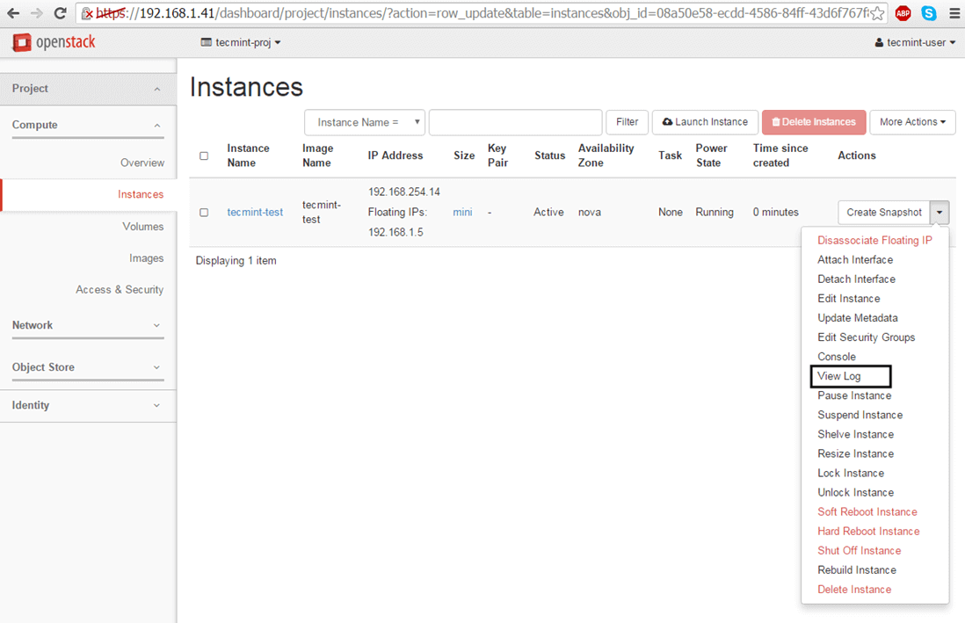](https://www.tecmint.com/wp-content/uploads/2016/04/Instance-View-Log-Utility.png)Instance View Log Utility[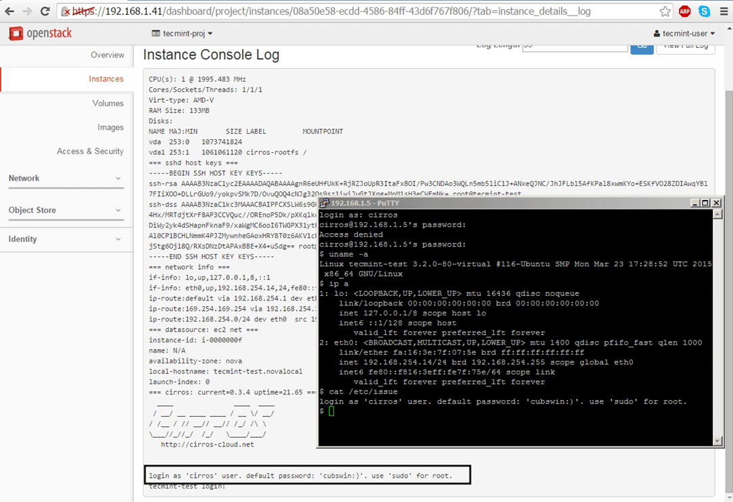](https://www.tecmint.com/wp-content/uploads/2016/04/Instance-Login-Credentials.png)Instance Login Credentials

**11.** By default, no DNS name servers will be allocated from the internal network DHCP server for your virtual machine. This problem leads to domain connectivity issues from instance counterpart.

To solve this issue, first stop the instance and go to **Project** -> **Network** -> **Networks** and edit the proper subnet by hitting the **Subnet Details** button.

Add the required DNS name servers, save the configuration, start and connect to the instance console to test if the new configuration has been applied by pinging a domain name. Use the following screenshots as a guide.

[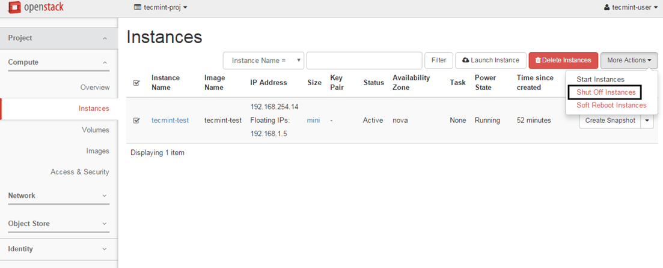](https://www.tecmint.com/wp-content/uploads/2016/04/Shutdown-Instance-in-OpenStack.png)Shutdown Instance[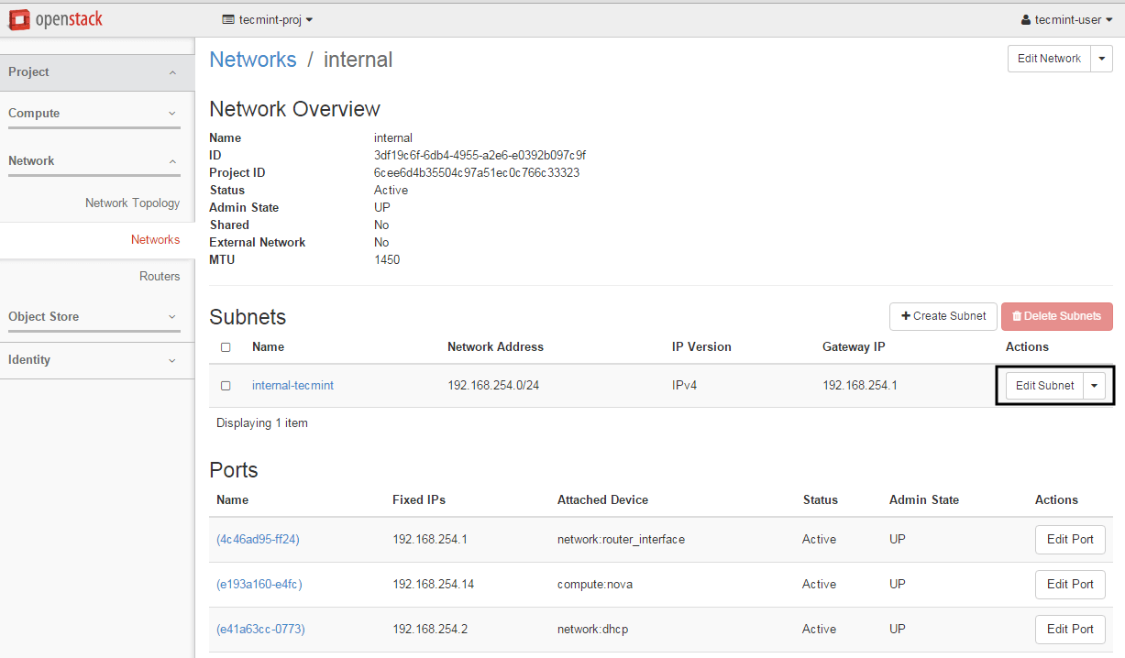](https://www.tecmint.com/wp-content/uploads/2016/04/Modify-Instance-Network-Subnet.png)Modify Instance Network Subnet[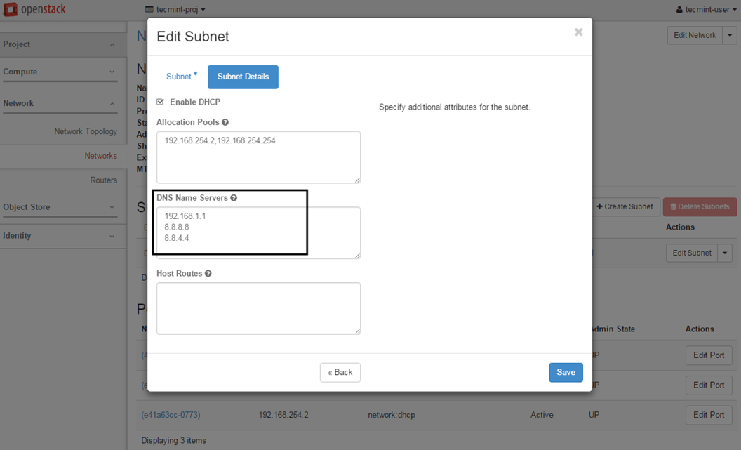](https://www.tecmint.com/wp-content/uploads/2016/04/Add-DNS-Servers-to-Instance.png)Add DNS Servers to Instance[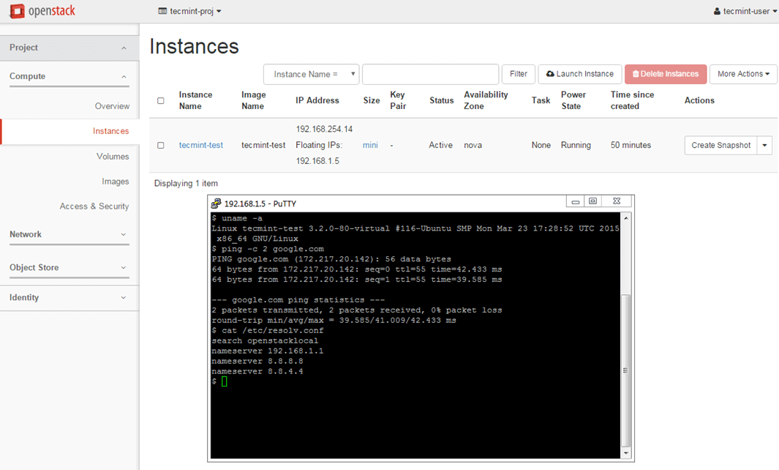](https://www.tecmint.com/wp-content/uploads/2016/04/Check-Instance-Network-Connectivity.png)Check Instance Network Connectivity

In case you have limited physical resources in your infrastructure and some of your instances refuse to start, edit the following line from nova configuration file and restart the machine in order to apply changes.

# vi /etc/nova/nova.conf

Change the following line to look like this:

ram\_allocation\_ratio=3.0

[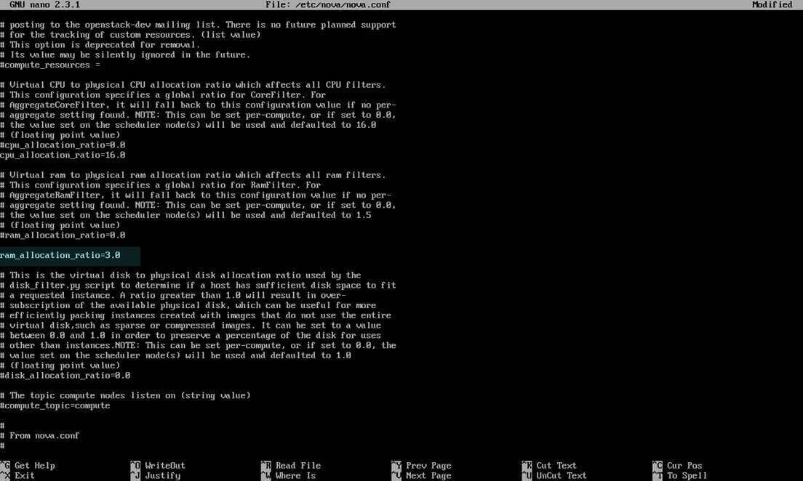](https://www.tecmint.com/wp-content/uploads/2016/04/Nova-Configuration.jpg)Configure Physical Resources in Nova Configuration

Result:

Thus the openstack instances are created on ubuntu.

Ex:No 8 Install Hadoop 3 on Ubuntu

Date:

Aim:

To install Apache Hadoop 3.2.1 on Ubuntu 16.0.4

Prerequisites

First, download the Hadoop 3.1.2 from the below link:

[Hadoop 3.1.2](https://archive.apache.org/dist/hadoop/common/hadoop-3.1.2/hadoop-3.1.2.tar.gz)

Here are the steps for installing Hadoop 3 on ubuntu for your system:

**Step 1:** Install ssh on your system using the below command:

sudo apt-get install ssh

[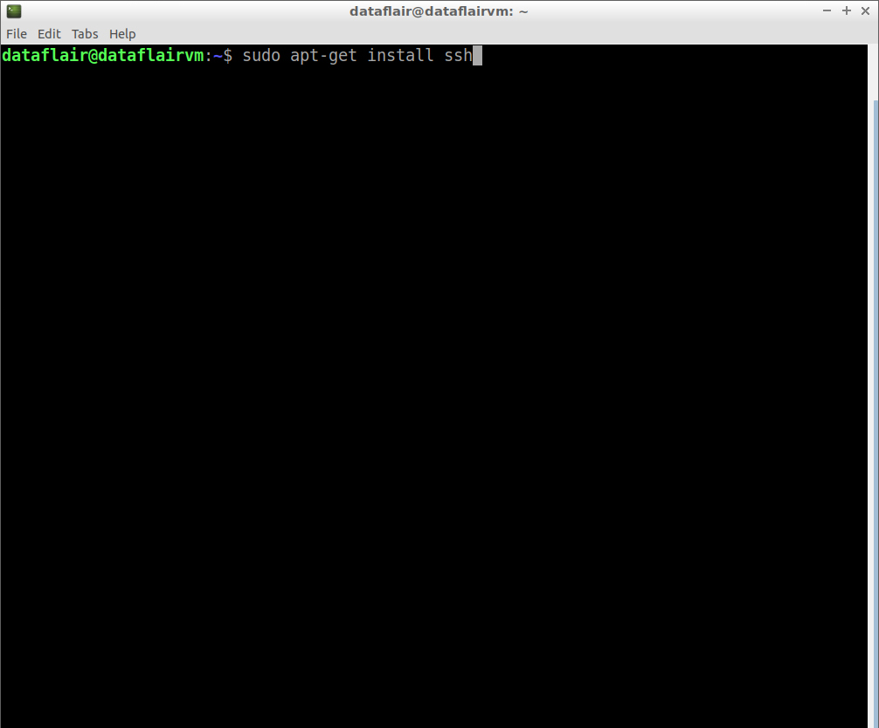](https://d2h0cx97tjks2p.cloudfront.net/blogs/wp-content/uploads/sites/2/2019/09/Command-to-install-ssh.jpg)

Type the password for the sudo user and then press **Enter**.

[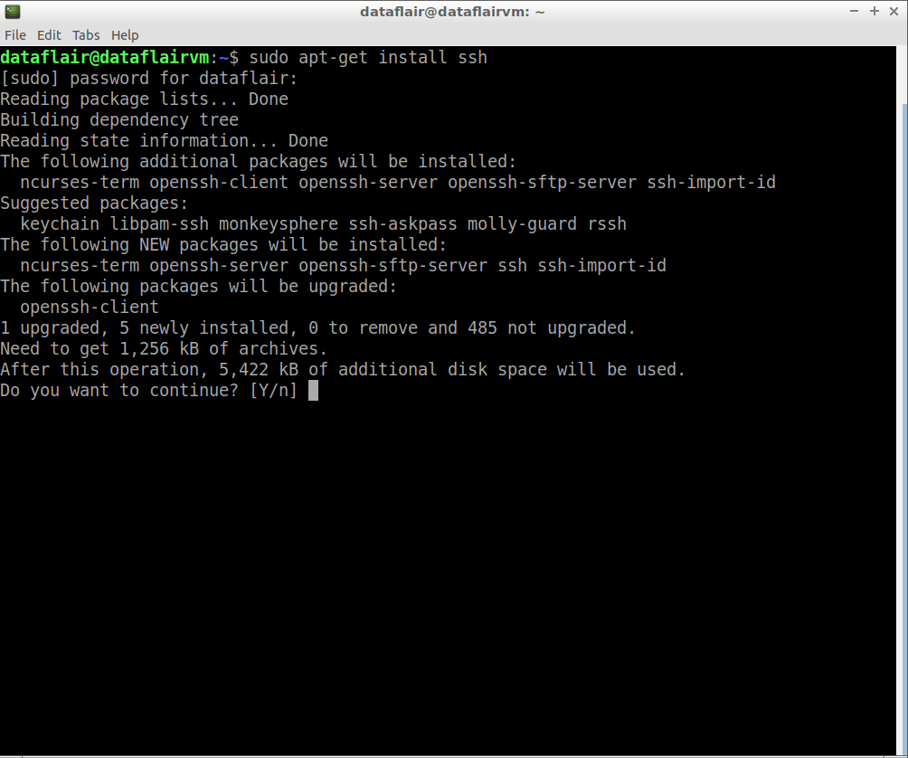](https://d2h0cx97tjks2p.cloudfront.net/blogs/wp-content/uploads/sites/2/2019/09/ssh-installation.jpg)

Type **‘Y’** and then press **Enter** to continue with the installation process.

[***520+ FREE Hadoop Tutorials***](https://data-flair.training/blogs/hadoop-tutorials-home/)***to become a Hadoop Expert***

**Step 2:** Install pdsh on your system using the below command:

sudo apt-get install pdsh

[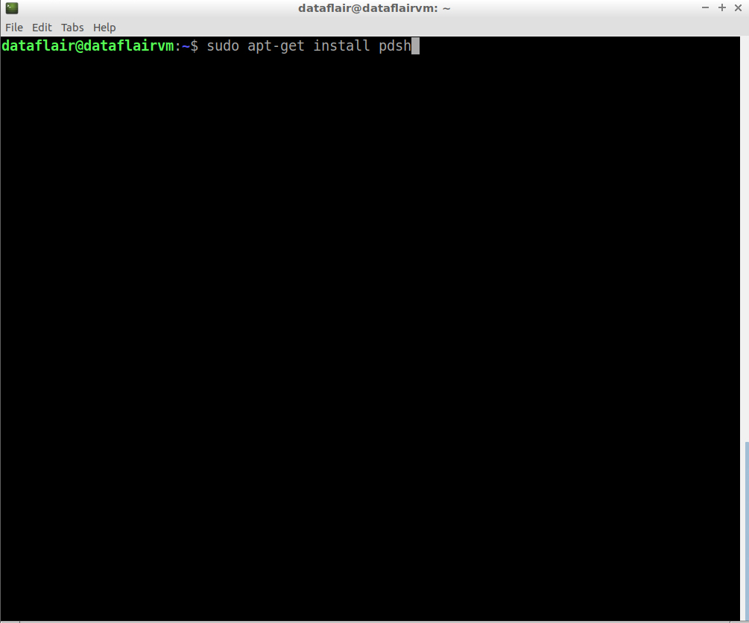](https://d2h0cx97tjks2p.cloudfront.net/blogs/wp-content/uploads/sites/2/2019/09/Command-to-install-pdsh.jpg)

*Install pdsh command*

[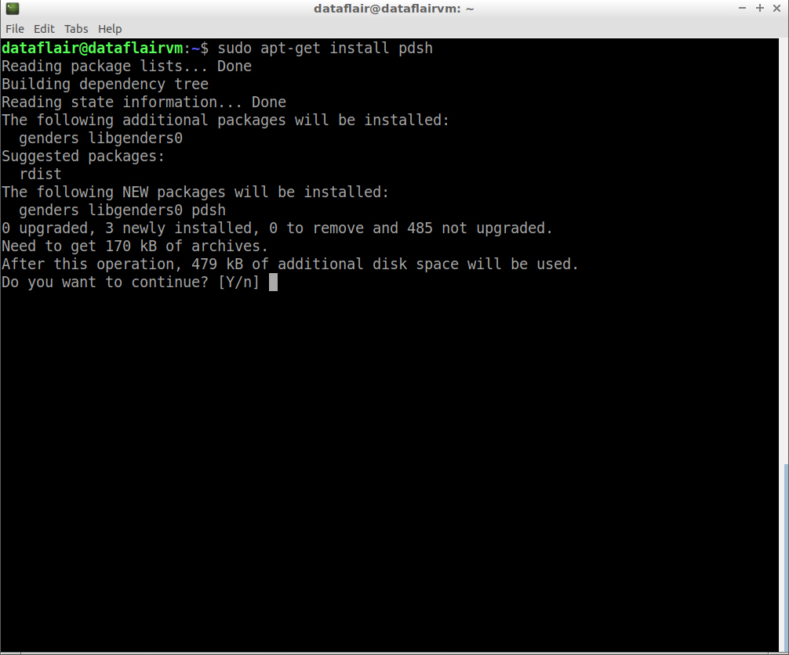](https://d2h0cx97tjks2p.cloudfront.net/blogs/wp-content/uploads/sites/2/2019/09/pdsh-installation.jpg)

*pdsh installation*

Type **‘Y’** and then press **Enter** to continue with the installation process.

**Step 3:** Open the .bashrc file in the nano editor using the following command:

nano .bashrc

[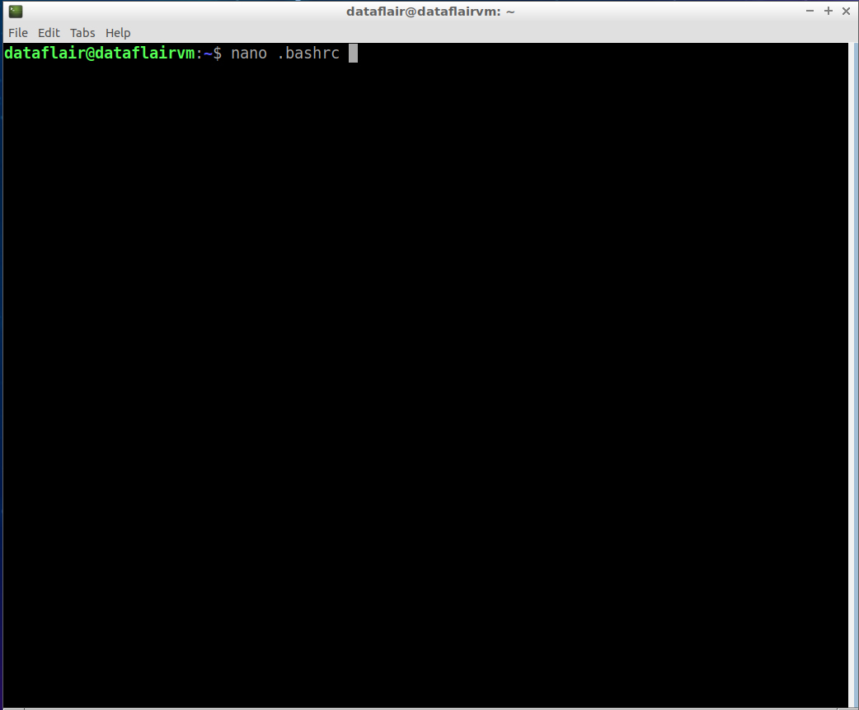](https://d2h0cx97tjks2p.cloudfront.net/blogs/wp-content/uploads/sites/2/2019/09/bashrc-file-in-nano-editor-1.jpg)

Now set the **PDSH\_RCMD\_TYPE** environment variable to **ssh**

export PDSH\_RCMD\_TYPE=ssh

[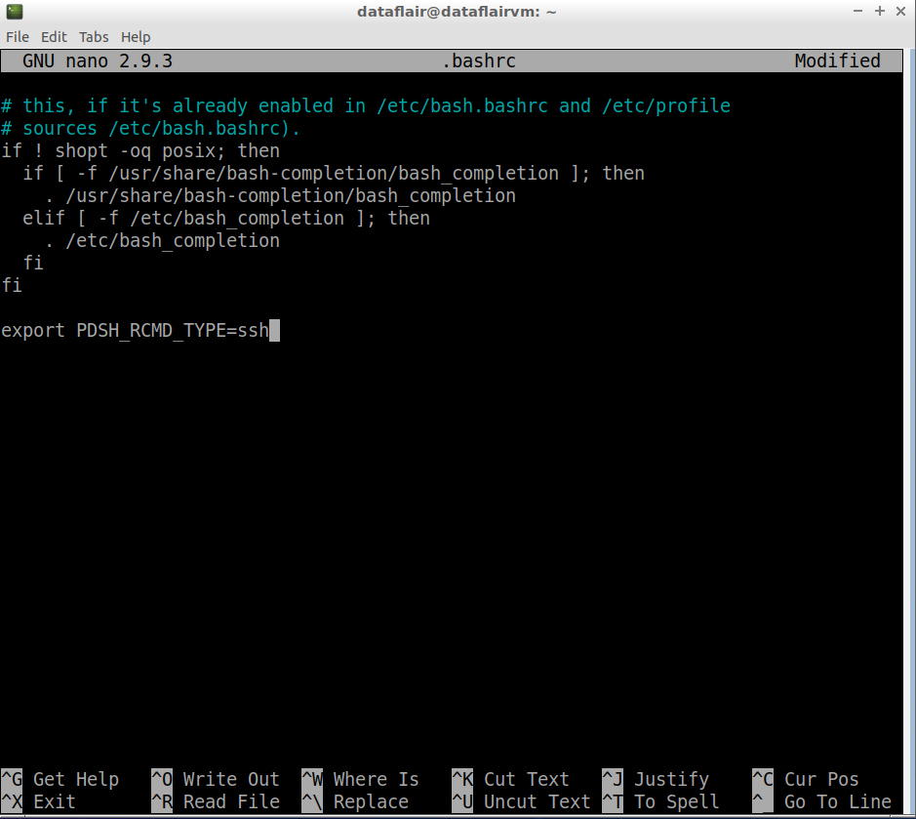](https://d2h0cx97tjks2p.cloudfront.net/blogs/wp-content/uploads/sites/2/2019/09/set-PDSH_RCMD_TYPE-to-ssh.jpg)

To save the changes you’ve made, press **Ctrl+O**. To exit the nano editor, press**Ctrl+X** and then press **‘Y’** to exit the editor.

**Step 4:** Now configure ssh. To do so, create a new key with the help of the following command:

ssh-keygen -t rsa -P ""

Press **Enter** when asked the **file name**.

[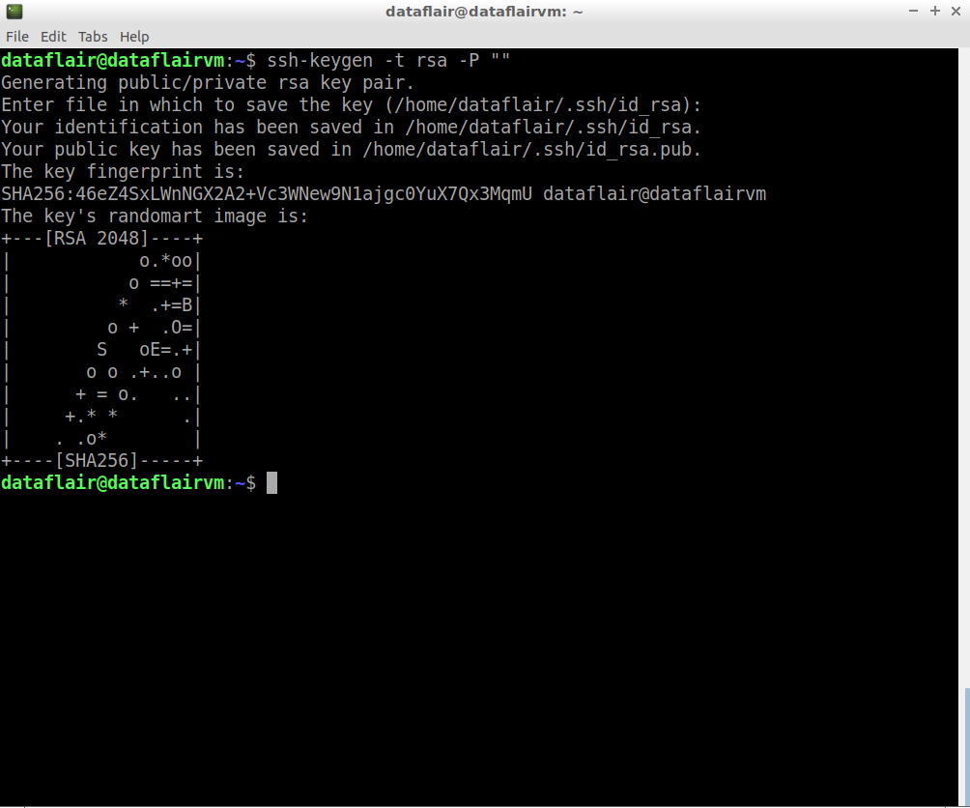](https://d2h0cx97tjks2p.cloudfront.net/blogs/wp-content/uploads/sites/2/2019/09/create-new-ssh-key.jpg)

**Step 5:** Copy the content of the public key to authorized\_keys.

cat ~/.ssh/id\_rsa.pub >> ~/.ssh/authorized\_keys

[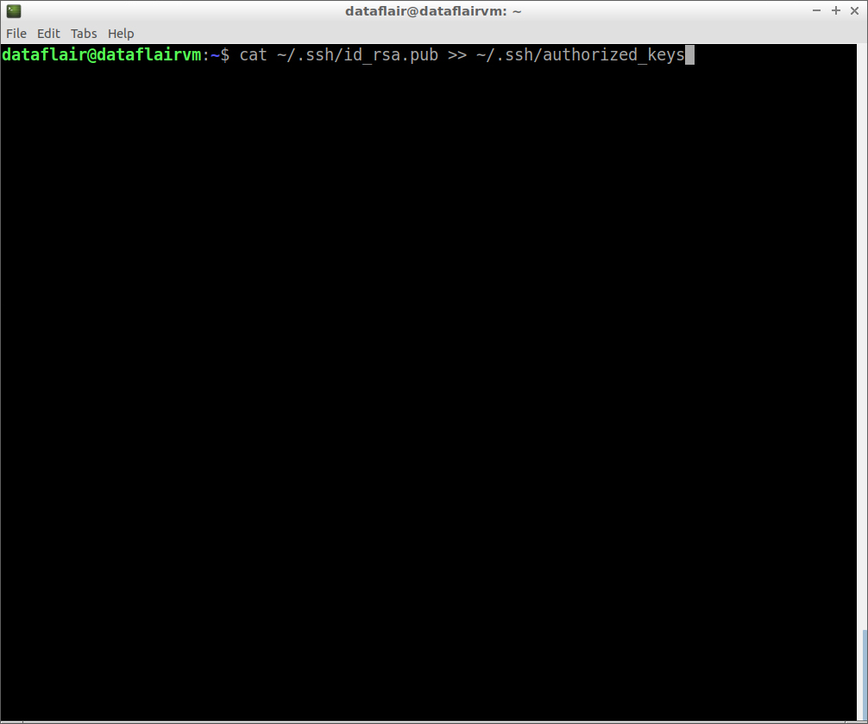](https://d2h0cx97tjks2p.cloudfront.net/blogs/wp-content/uploads/sites/2/2019/09/ssh-access-to-host-machine.jpg)

**Step 6:** Now examine the SSH setup by connecting to the localhost.

ssh localhost

[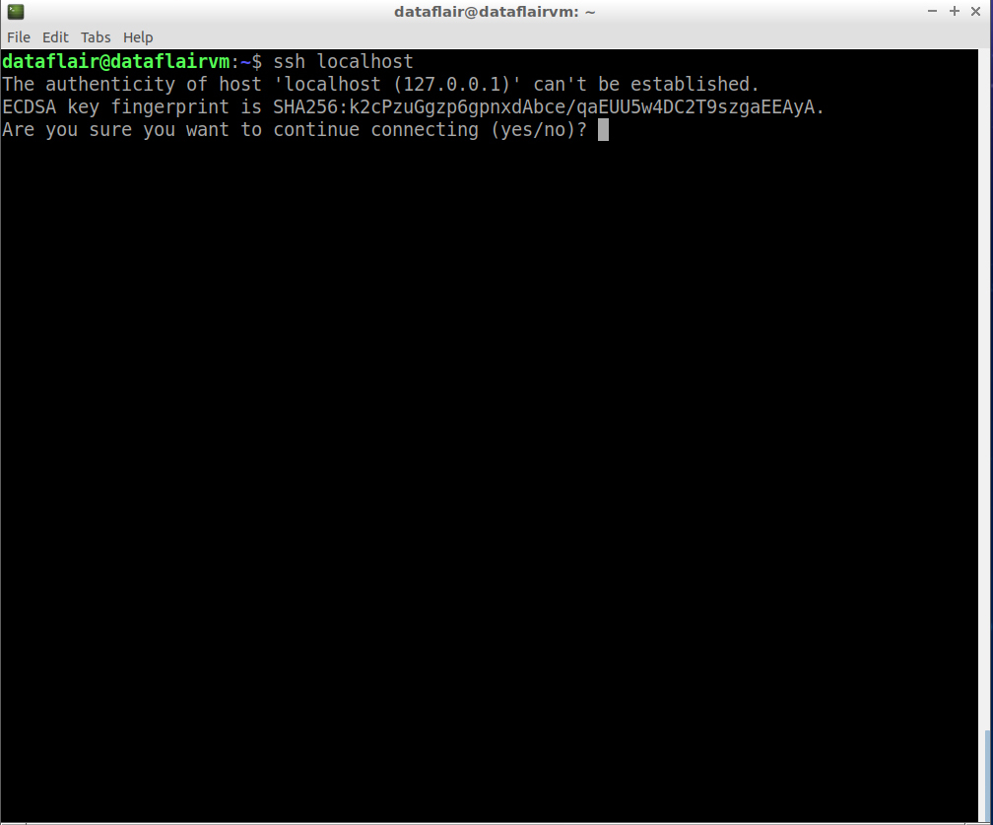](https://d2h0cx97tjks2p.cloudfront.net/blogs/wp-content/uploads/sites/2/2019/09/check-connection-of-ssh.jpg)

*connection check of ssh*

Type **‘Y’** and then press **Enter** to continue with the connection.

[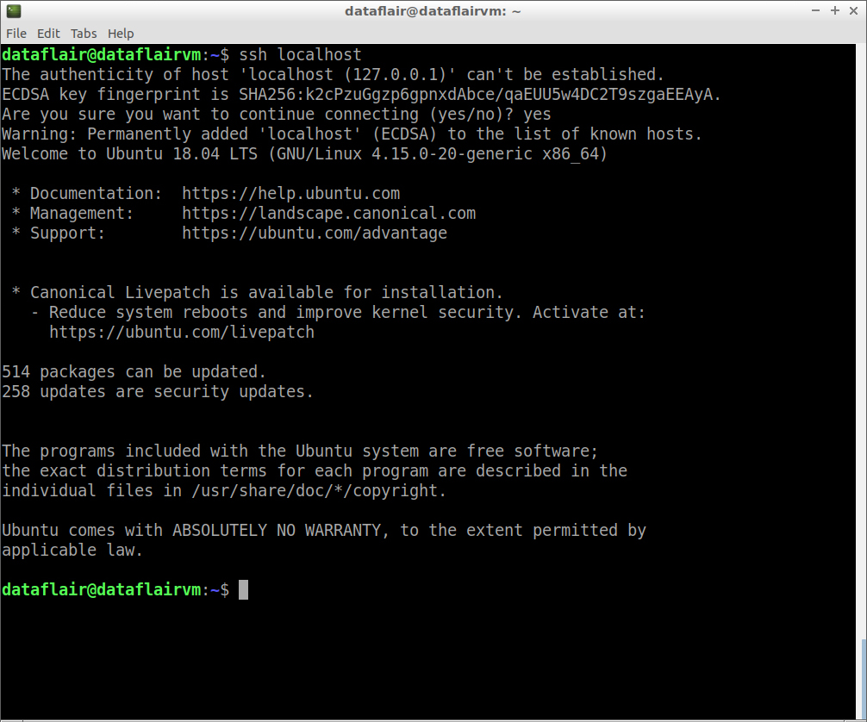](https://d2h0cx97tjks2p.cloudfront.net/blogs/wp-content/uploads/sites/2/2019/09/ssh-connection-checked.jpg)

**Step 7:** Update the source lists.

sudo apt-get update

[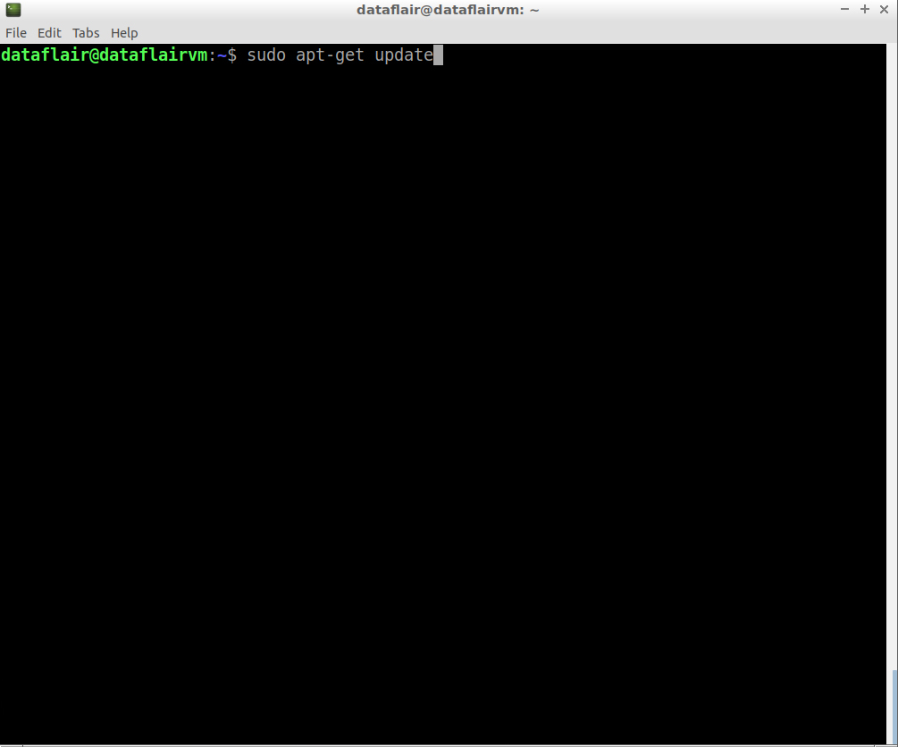](https://d2h0cx97tjks2p.cloudfront.net/blogs/wp-content/uploads/sites/2/2019/09/command-to-update-packages.jpg)

*command to update packages*

[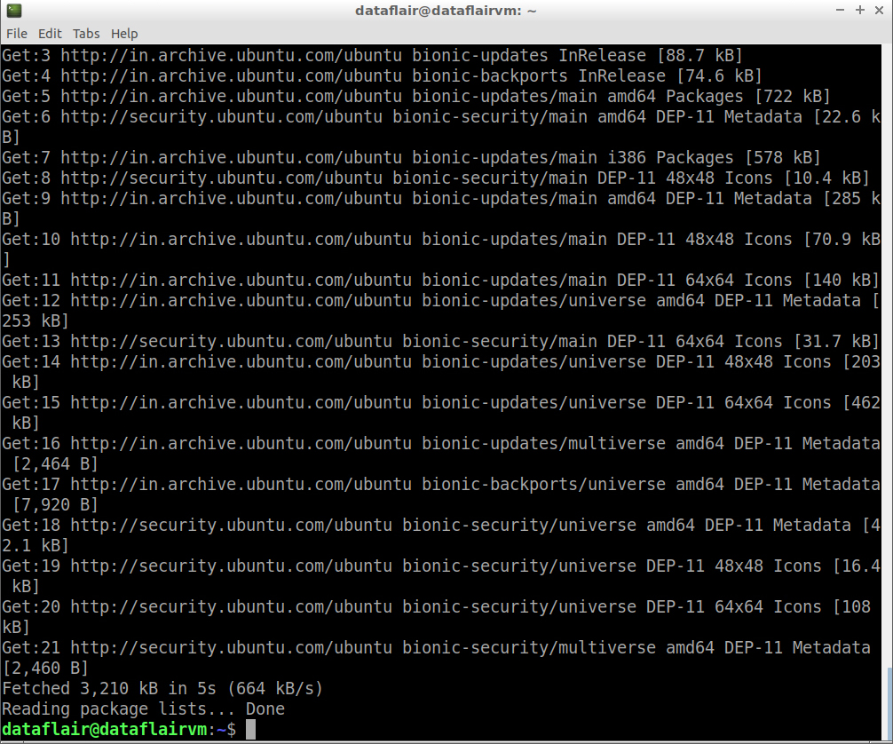](https://d2h0cx97tjks2p.cloudfront.net/blogs/wp-content/uploads/sites/2/2019/09/updating-packages.jpg)

*updating packages*

**Step 8:** Now install Java 8 using the following command:

sudo apt-get install openjdk-8-jdk

[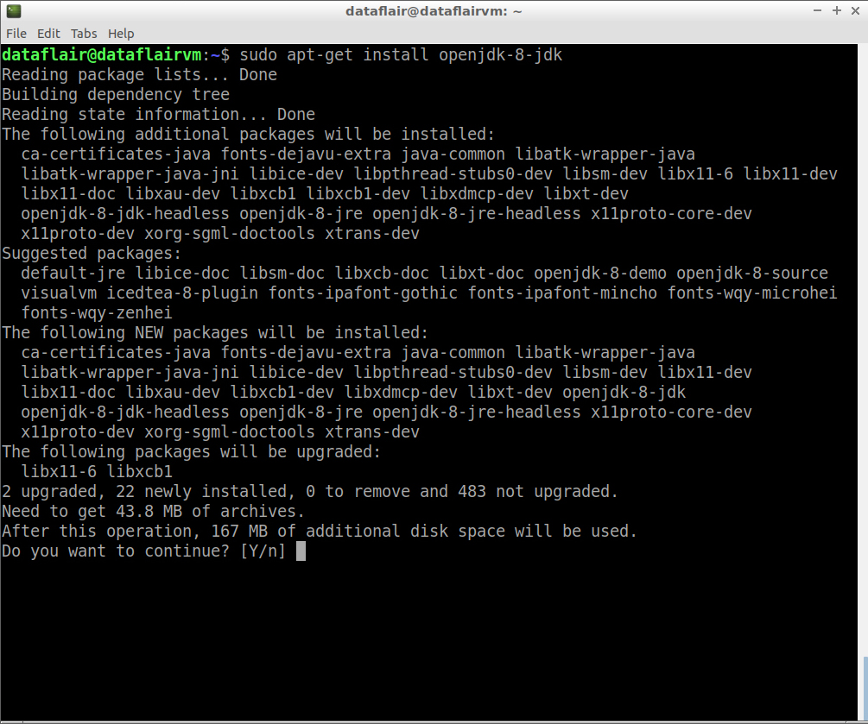](https://d2h0cx97tjks2p.cloudfront.net/blogs/wp-content/uploads/sites/2/2019/09/java-installation-1.jpg)

*java installation*

Type **‘Y’** and then press **Enter** to finish with the installation process.

[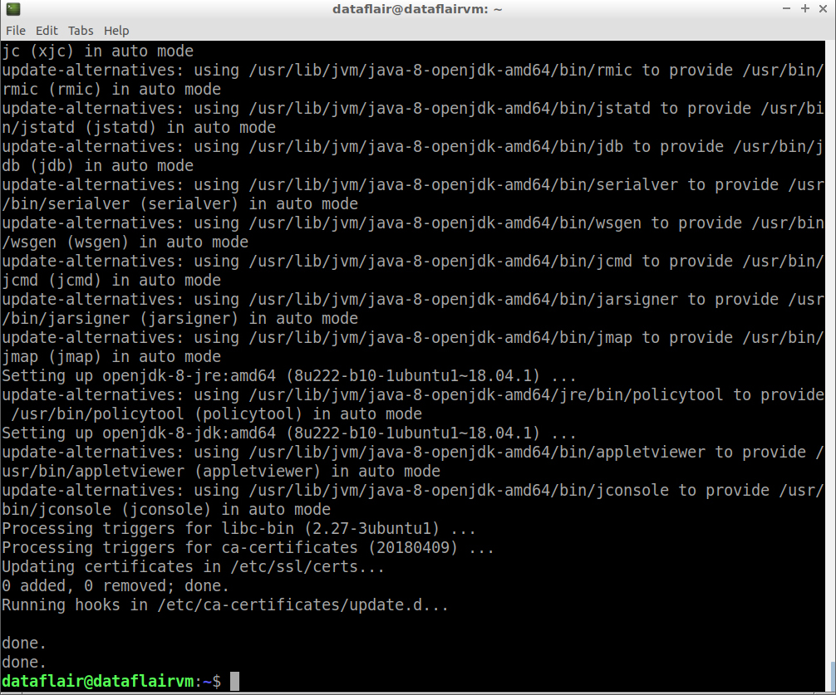](https://d2h0cx97tjks2p.cloudfront.net/blogs/wp-content/uploads/sites/2/2019/09/java-installation-2.jpg)

*java installation completion*

**Step 9:**To cross-check whether you have successfully installed Java on your machine or not, run the below command:

java -version

[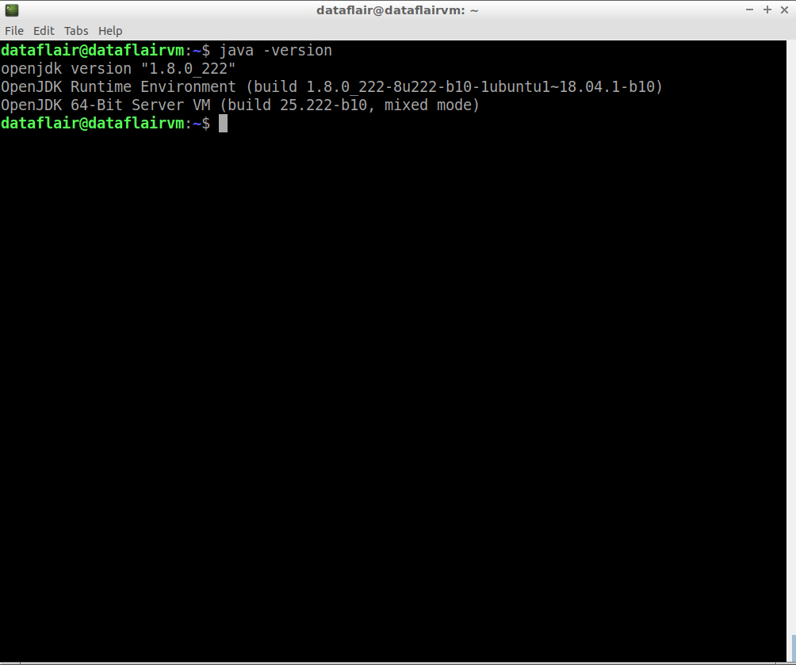](https://d2h0cx97tjks2p.cloudfront.net/blogs/wp-content/uploads/sites/2/2019/09/checking-java-version.jpg)

**Step 10:** Now locate the Hadoop tar file in your system.

[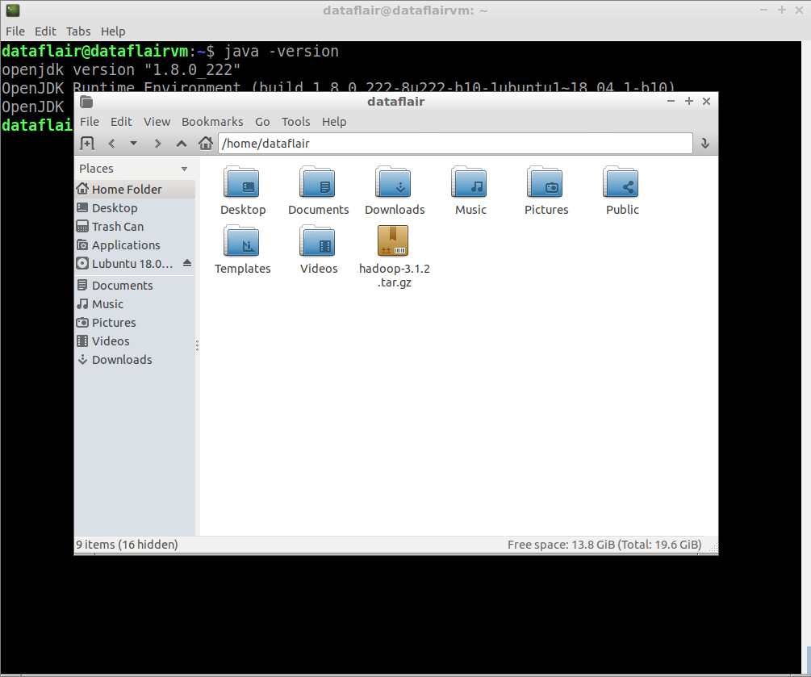](https://d2h0cx97tjks2p.cloudfront.net/blogs/wp-content/uploads/sites/2/2019/09/locate-hadoop-tar-file.jpg)

**Step 11:**Extract the **hadoop-3.1.2.tar.gz** file using the below command:

tar xzf hadoop-3.1.2.tar.gz

[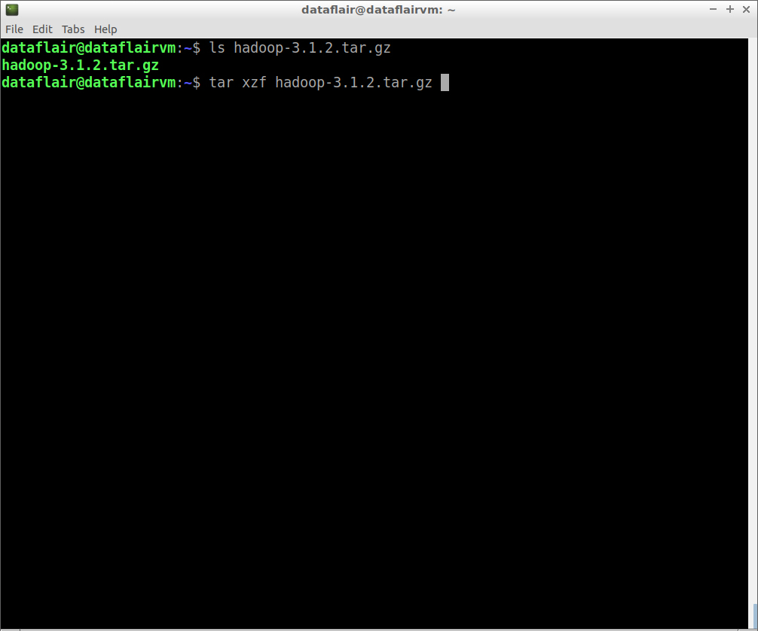](https://d2h0cx97tjks2p.cloudfront.net/blogs/wp-content/uploads/sites/2/2019/09/extract-hadoop-files.jpg)

*extract hadoop files*

[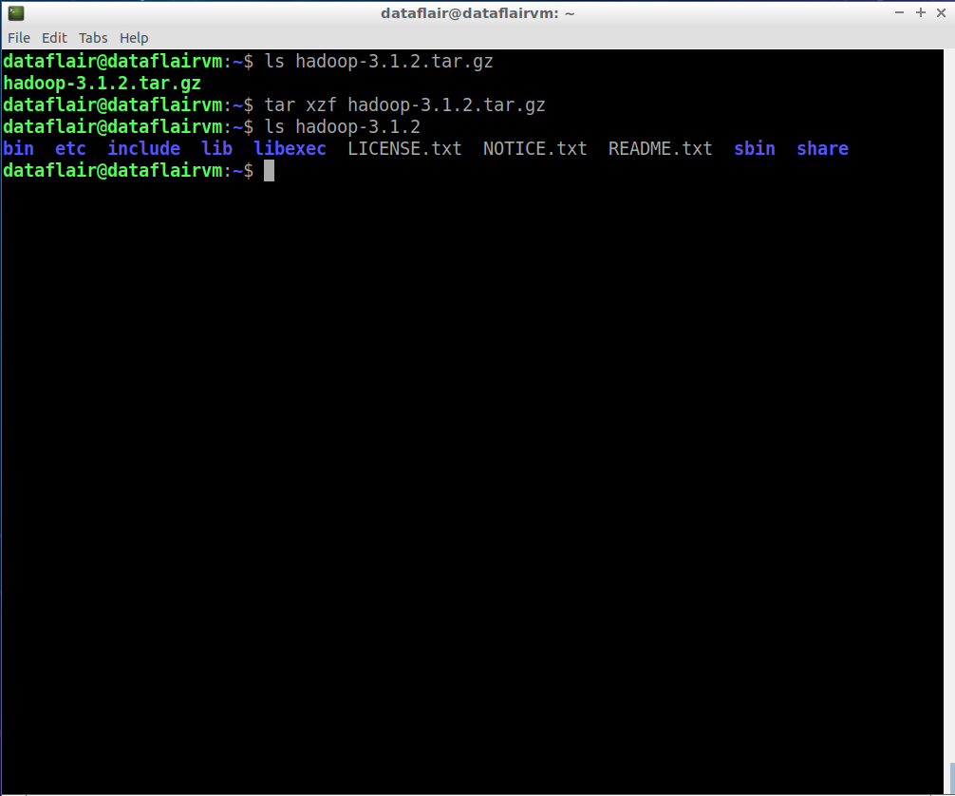](https://d2h0cx97tjks2p.cloudfront.net/blogs/wp-content/uploads/sites/2/2019/09/extraction-complete.jpg)

**Step 12:** Rename **hadoop-3.1.2.tar.gz** as **hadoop** for ease of use.

mv hadoop-3.1.2.tar.gz hadoop

[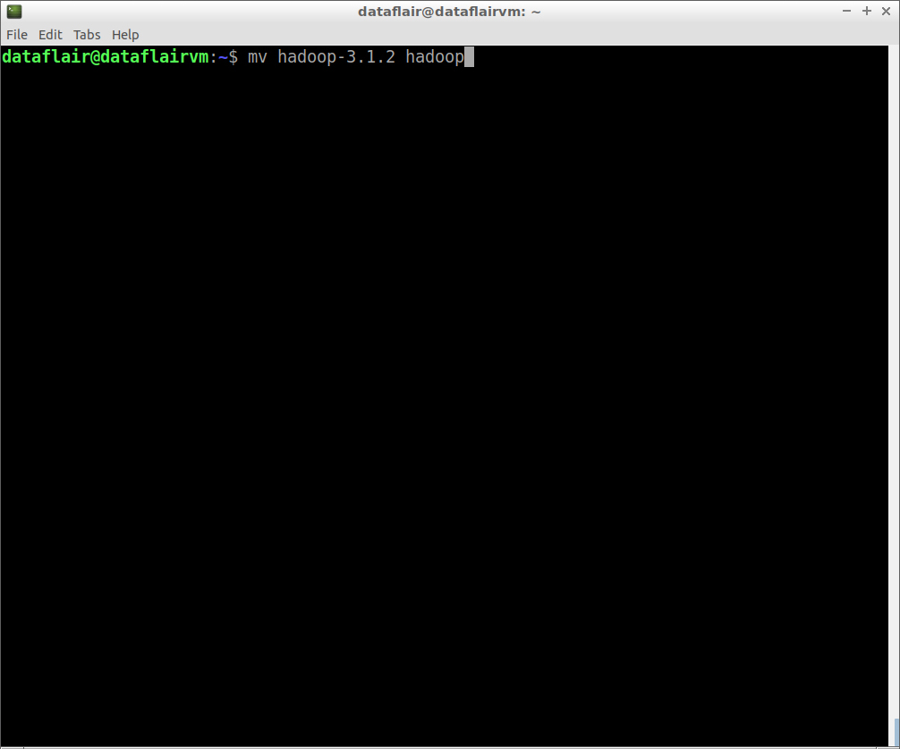](https://d2h0cx97tjks2p.cloudfront.net/blogs/wp-content/uploads/sites/2/2019/09/rename-hadoop.jpg)

*Any doubts in the process to install Hadoop 3.1.2 till now? Share them in the comment section.*

**Step 14:** Now check the Java home path which we will set up in Hadoop env.sh

ls /usr/lib/jvm/java-8-openjdk-amd64/

[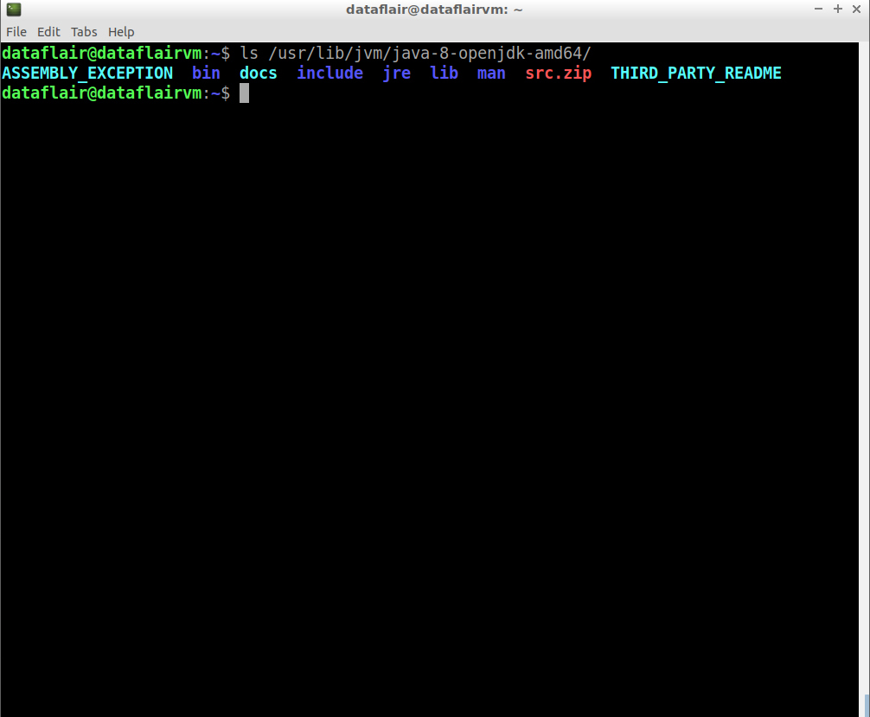](https://d2h0cx97tjks2p.cloudfront.net/blogs/wp-content/uploads/sites/2/2019/09/list-of-files-in-java.jpg)

**Step 15:** Open the **hadoop-env.sh** file in the nano editor. This file is located in **~/hadoop/etc/hadoop** configuration directory.

nano hadoop-env

Set JAVA\_HOME:

export JAVA\_HOME=<path-to-the-root-**of**-your-Java-installation> (eg: /usr/lib/jvm/java-8-openjdk-amd64/)

[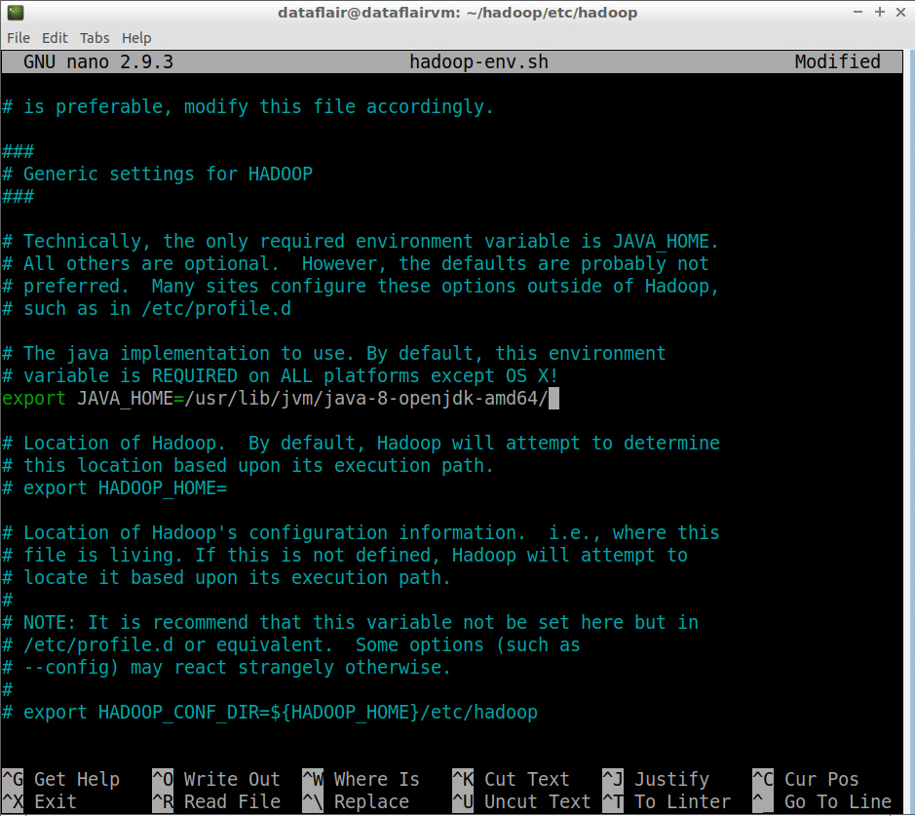](https://d2h0cx97tjks2p.cloudfront.net/blogs/wp-content/uploads/sites/2/2019/09/hadoop-env_file.jpg)

To save the changes you’ve made, press **Ctrl+O**. To exit the nano editor, press **Ctrl+X** and then press **‘Y’** to exit the editor.

**Step 16:** Open the **core-site.xml** file in the nano editor. This file is also located in the **~/hadoop/etc/hadoop** (Hadoop configuration directory).

nano core-site.xml

Add the following configuration properties:

<configuration>

<property>

<name>fs.defaultFS</name>

<value>hdfs://localhost:9000</value>

</property>

<property>

<name>hadoop.tmp.dir</name>

<value>/home/dataflair/hdata</value>

</property>

</configuration>

*Note: /home/dataflair/hdata is a sample location; please specify a location where you have Read Write privileges*[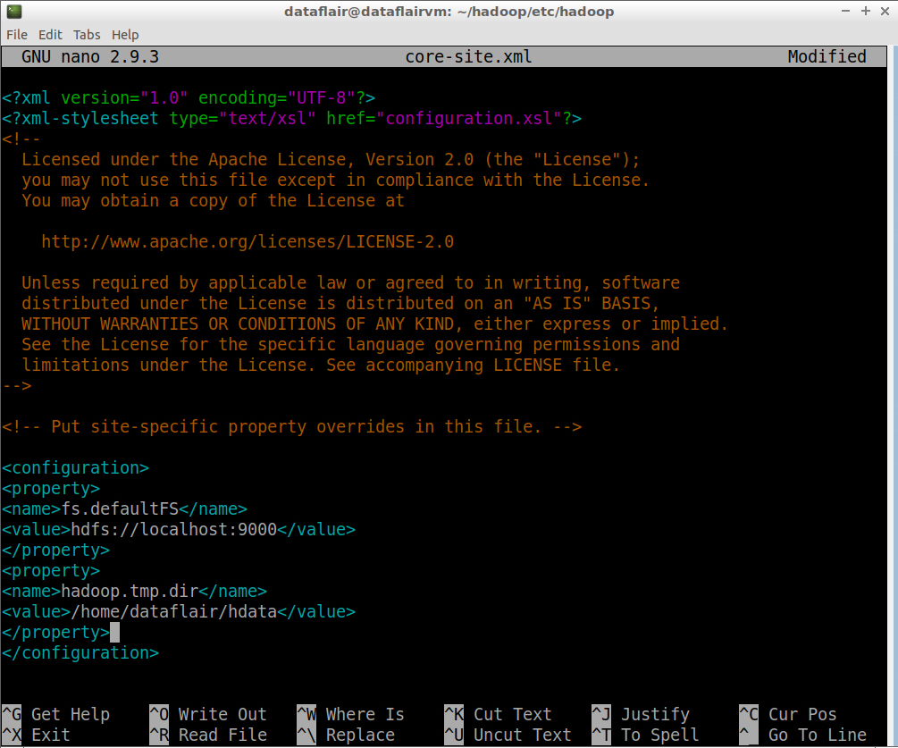](https://d2h0cx97tjks2p.cloudfront.net/blogs/wp-content/uploads/sites/2/2019/09/configure-core-site_xml.jpg)

**Step 17:** Open the**hdfs-site.xml** file in the nano editor. This file is also located in **~/hadoop/etc/hadoop**(Hadoop configuration directory):

nano hdfs-site.xml

Add the following entries in core-site.xml:

<configuration>

<property>

<name>dfs.replication</name>

<value>1</value>

</property>

</configuration>

[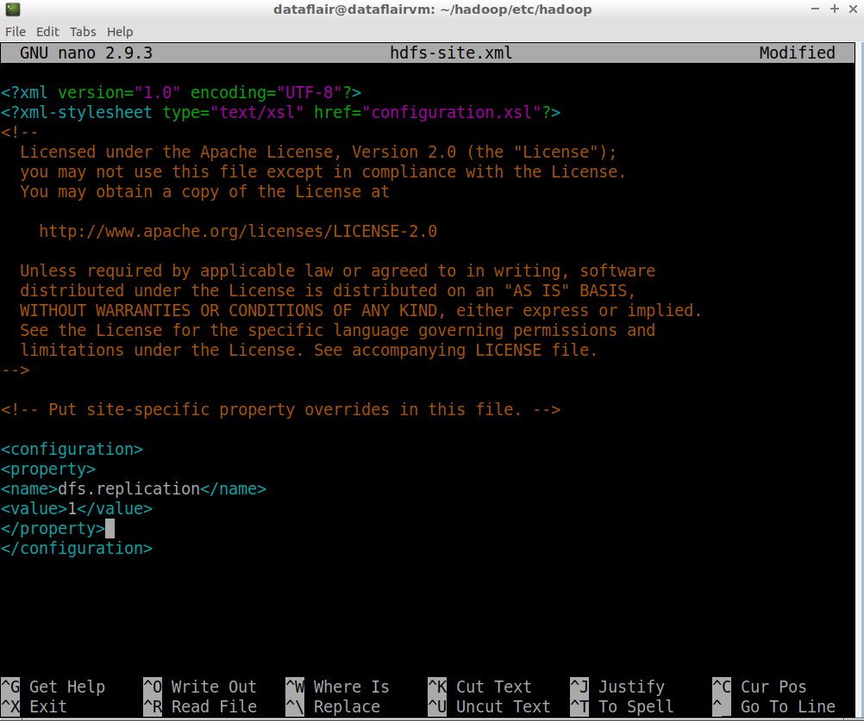](https://d2h0cx97tjks2p.cloudfront.net/blogs/wp-content/uploads/sites/2/2019/09/configure-hdfs-site_xml.jpg)

**Step 18:** Open the **mapred-site.xml** file in the nano editor. This file is also located in **~/hadoop/etc/hadoop**(Hadoop configuration directory).

nano mapred-site.xml

Add the following entries in core-site.html:

<configuration>

<property>

<name>mapreduce.framework.name</name>

<value>yarn</value>

</property>

<property>

<name>yarn.app.mapreduce.am.env</name>

<value>HADOOP\_MAPRED\_HOME=/home/dataflair/hadoop</value>

</property>

<property>

<name>mapreduce.map.env</name>

<value>HADOOP\_MAPRED\_HOME=/home/dataflair/hadoop</value>

</property>

<property>

<name>mapreduce.reduce.env</name>

<value>HADOOP\_MAPRED\_HOME=/home/dataflair/hadoop</value>

</property>

</configuration>

[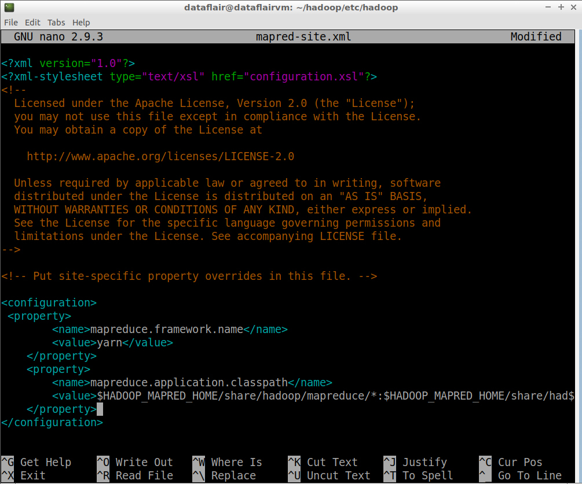](https://d2h0cx97tjks2p.cloudfront.net/blogs/wp-content/uploads/sites/2/2019/09/configure-mapred-site_xml.jpg)

**Step 19:** Open the **yarn-site.xml** file in the nano editor. This file is also located in **~/hadoop/etc/hadoop**(Hadoop configuration directory).

nano yarn-site.xml

Add the following entries in the core-site.xml:

<configuration>

<property>

<name>yarn.nodemanager.aux-services</name>

<value>mapreduce\_shuffle</value>

</property>

<property>

<name>yarn.nodemanager.aux-services.mapreduce.shuffle.class</name>

<value>org.apache.hadoop.mapred.ShuffleHandler</value>

</property>

</configuration>

[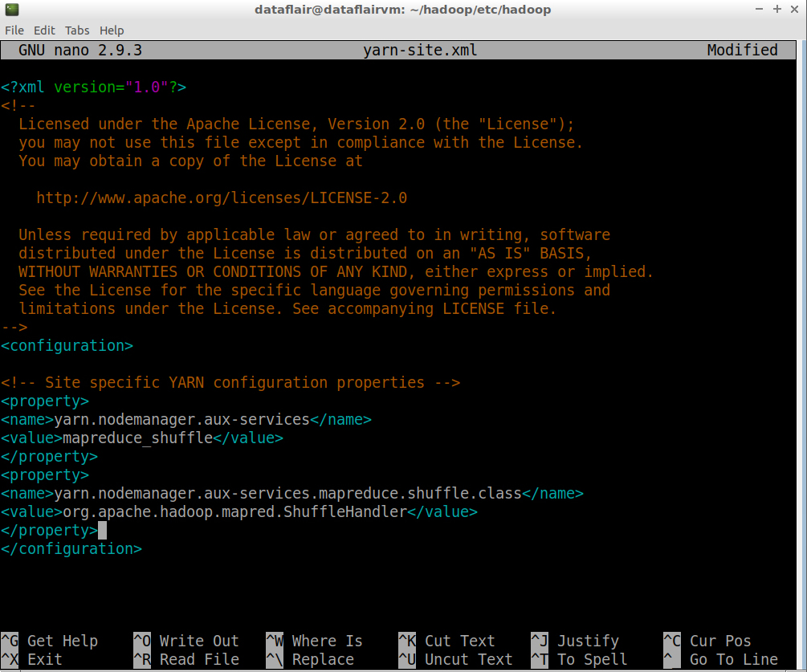](https://d2h0cx97tjks2p.cloudfront.net/blogs/wp-content/uploads/sites/2/2019/09/configure-yarn-site_xml.jpg)

**Step 20:** Open the bashrc files in the nano editor using the following command:

nano .bashrc

[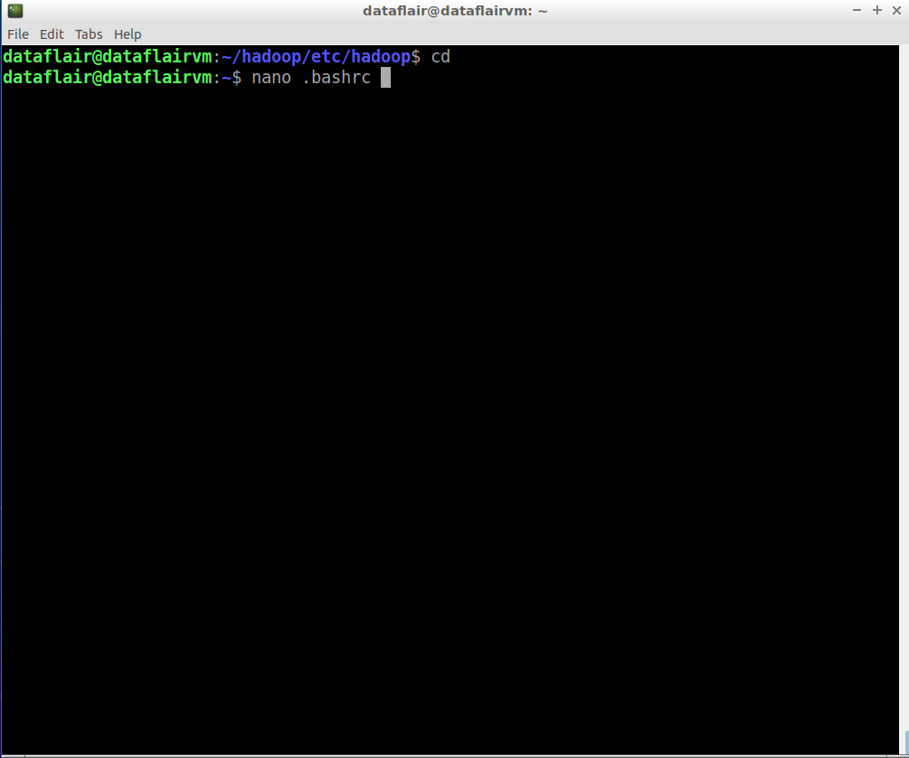](https://d2h0cx97tjks2p.cloudfront.net/blogs/wp-content/uploads/sites/2/2019/09/bashrc-file-in-nano-editor-2-2-1.jpg)

Edit .bashrc file located in the user’s home directory and add the following parameters:

export HADOOP\_HOME="/home/dataflair/hadoop"

export PATH=$PATH:$HADOOP\_HOME/bin

export PATH=$PATH:$HADOOP\_HOME/sbin

export HADOOP\_MAPRED\_HOME=${HADOOP\_HOME}

export HADOOP\_COMMON\_HOME=${HADOOP\_HOME}

export HADOOP\_HDFS\_HOME=${HADOOP\_HOME}

export YARN\_HOME=${HADOOP\_HOME}

[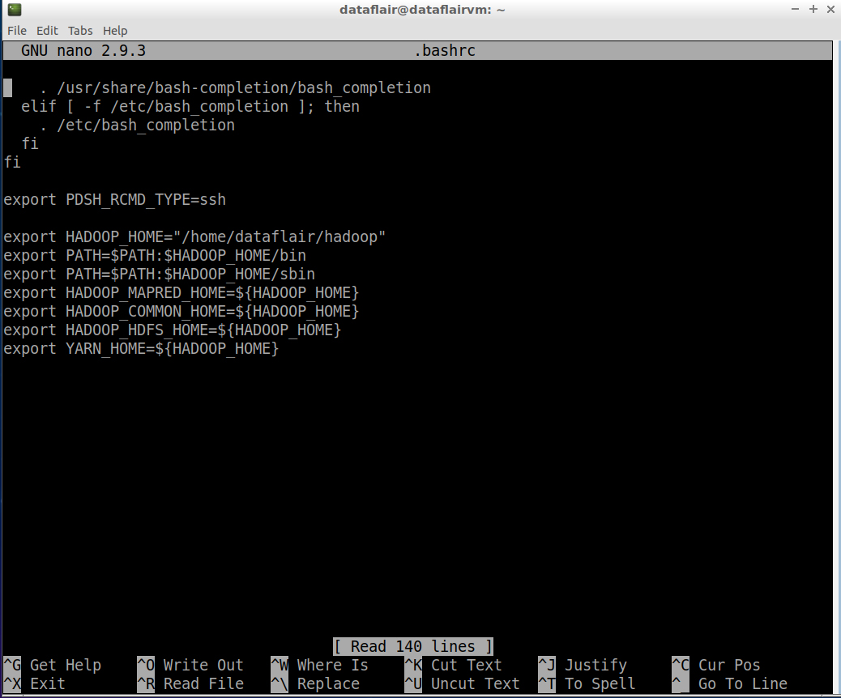](https://d2h0cx97tjks2p.cloudfront.net/blogs/wp-content/uploads/sites/2/2019/09/set-hadoop-home-variable-2.jpg)

To save the changes you’ve made, press **Ctrl+O**. To exit the nano editor, press **Ctrl+X** and then press **‘Y’** to exit the editor.

**Step 21:** Before starting Hadoop, we need to format HDFS, which can be done using the below command:

bin/hdfs namenode -format

[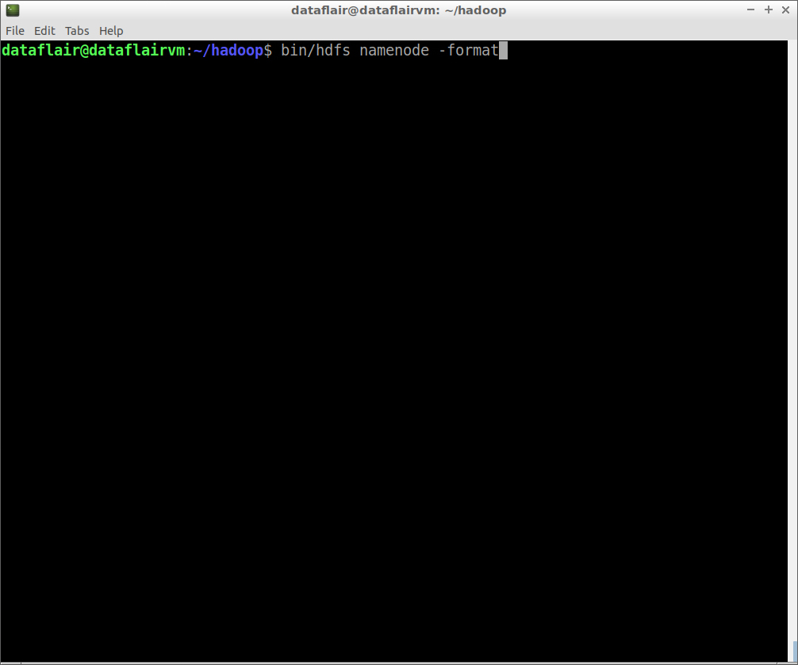](https://d2h0cx97tjks2p.cloudfront.net/blogs/wp-content/uploads/sites/2/2019/09/command-for-namenode-format.jpg)

*namenode format command*

[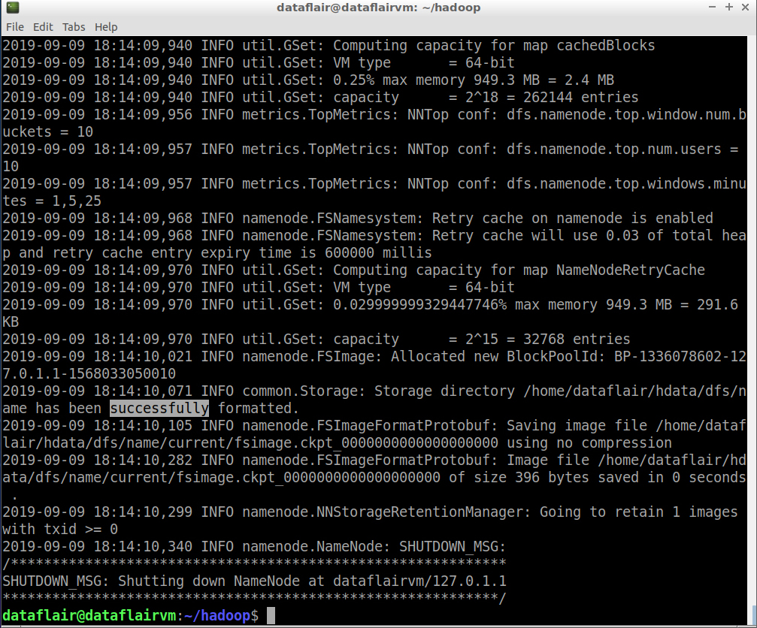](https://d2h0cx97tjks2p.cloudfront.net/blogs/wp-content/uploads/sites/2/2019/09/namenode-format.jpg)

*namenode format*

**Step 22:** Start the HDFS services:

sbin/start-dfs.sh

[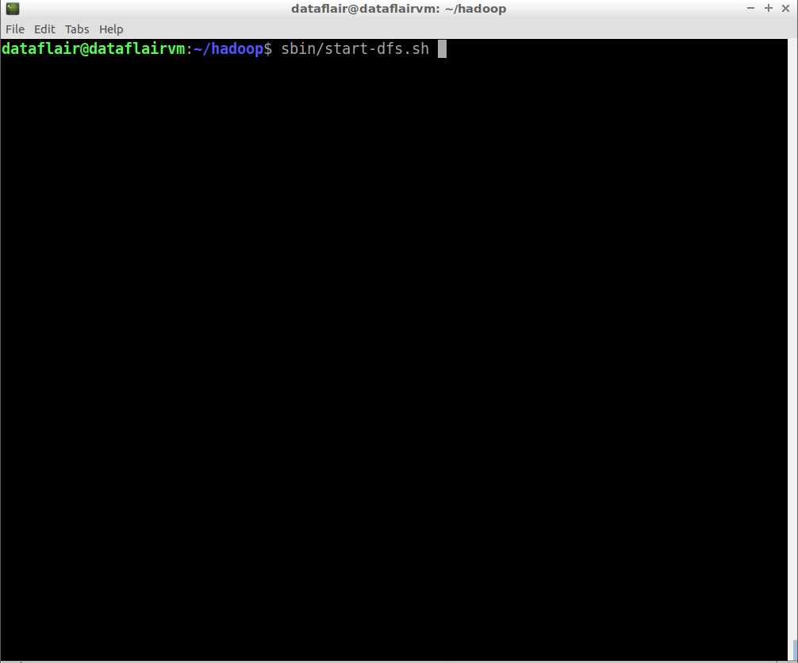](https://d2h0cx97tjks2p.cloudfront.net/blogs/wp-content/uploads/sites/2/2019/09/command-to-start-hadoop-cluster.jpg)

*command to start hadoop cluster*

[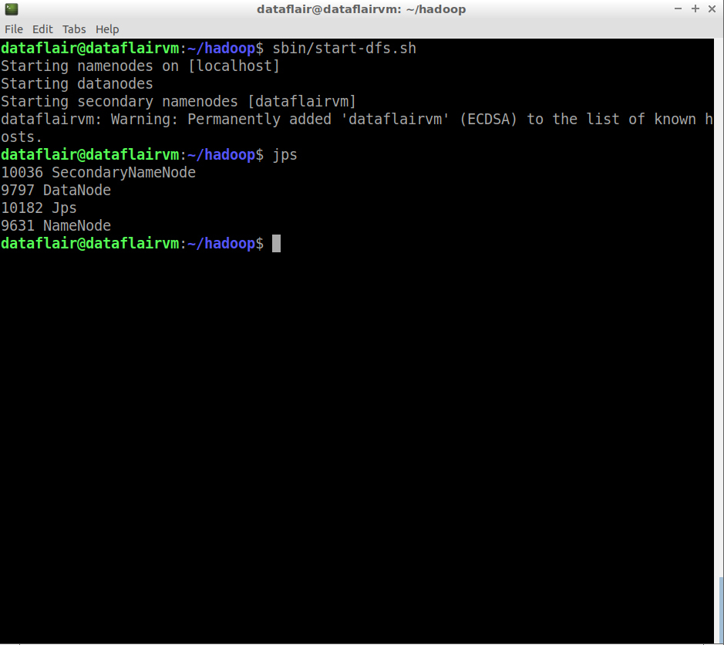](https://d2h0cx97tjks2p.cloudfront.net/blogs/wp-content/uploads/sites/2/2019/09/hadoop-cluster-started.jpg)

*hadoop cluster started*

**Step 23:** Open the HDFS web console:

localhost:9870

[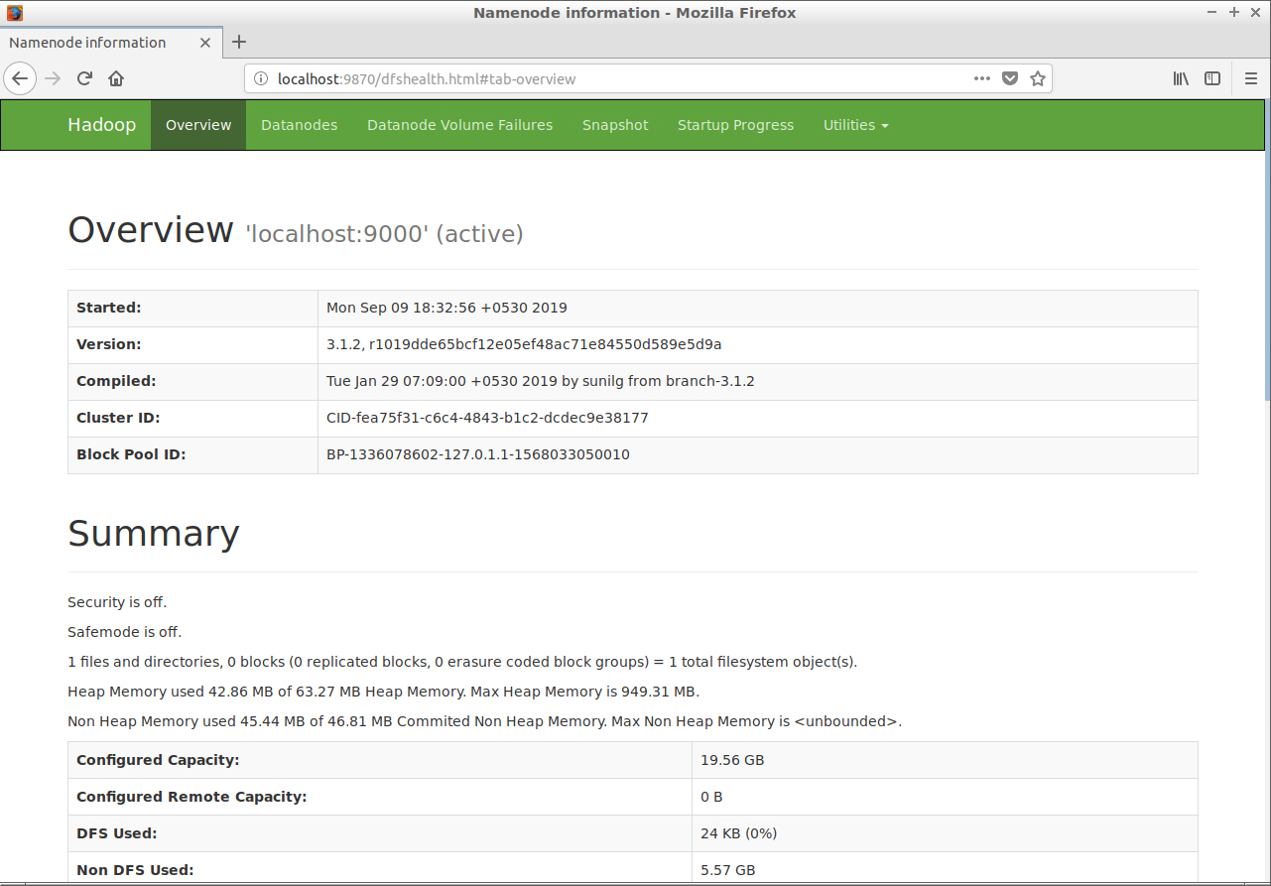](https://d2h0cx97tjks2p.cloudfront.net/blogs/wp-content/uploads/sites/2/2019/09/verify-hadoop-cluster.jpg)

**Step 24:** Now start the yarn services:

sbin/start-yarn.sh

[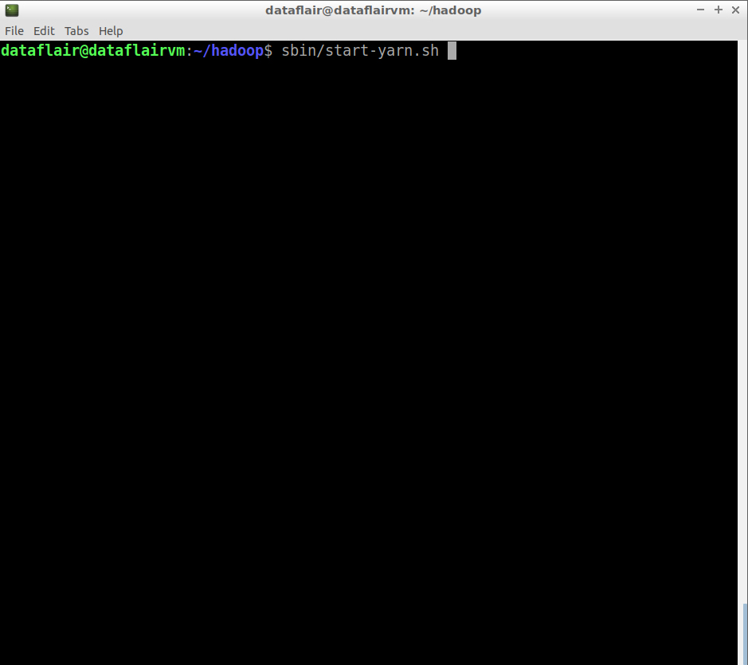](https://d2h0cx97tjks2p.cloudfront.net/blogs/wp-content/uploads/sites/2/2019/09/command-to-start-yarn.jpg)

*command to start yarn*

[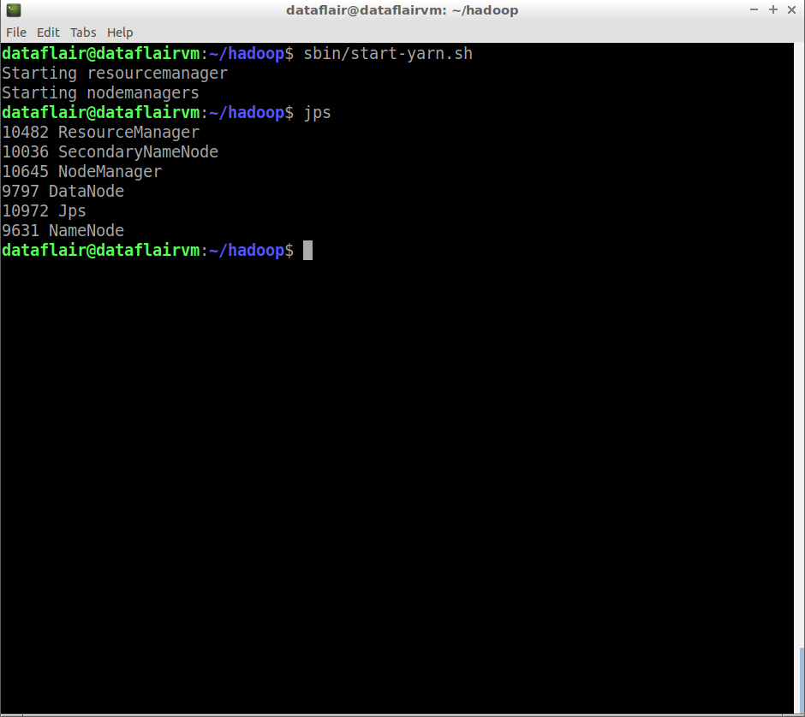](https://d2h0cx97tjks2p.cloudfront.net/blogs/wp-content/uploads/sites/2/2019/09/yarn-started.jpg)

*yarn started*

$jps

NameNode

DataNode

ResourceManager

NodeManager

SecondaryNameNode

The**‘jps’** command is used to check whether all the Hadoop processes are running or not.

**Step 25:**Open the yarn web console:

localhost:8088

[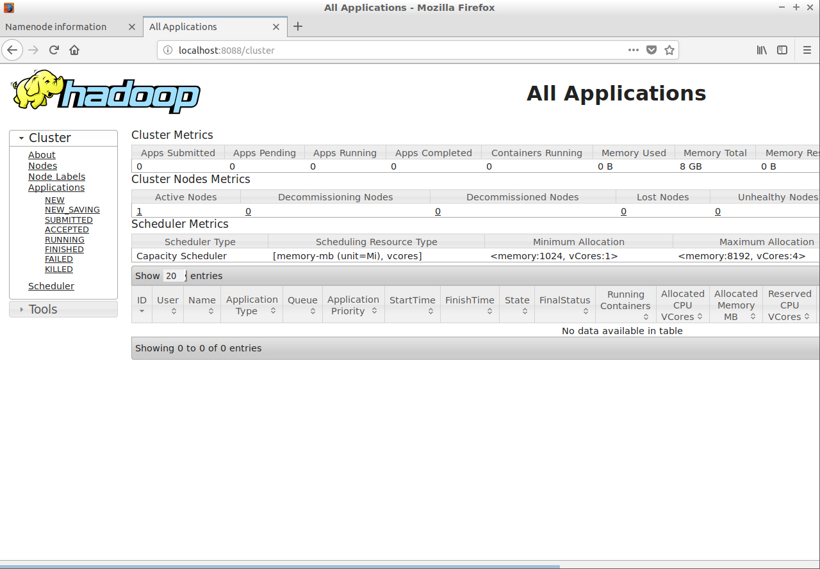](https://d2h0cx97tjks2p.cloudfront.net/blogs/wp-content/uploads/sites/2/2019/09/verify-yarn.jpg)

Result:

Thus the single node Hadoop is installed successfully on ubuntu.

Ex.No: 9 **Word Count – Using Hadoop Mapreduce**

**Date:**

**Aim:**

**To write a mapreduce program to execute word count.**

Steps to execute MapReduce word count example

* Create a text file in your local machine and write some text into it.  
  $ nano data.txt

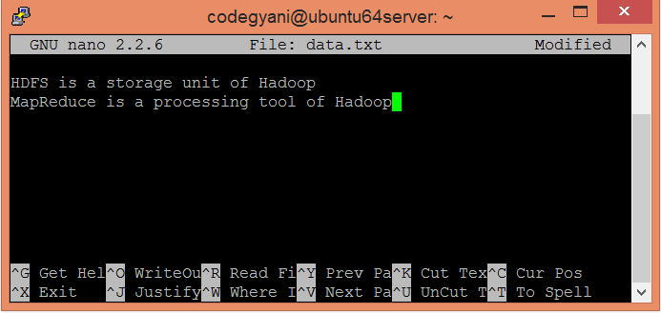

* Check the text written in the data.txt file.  
  $ cat data.txt

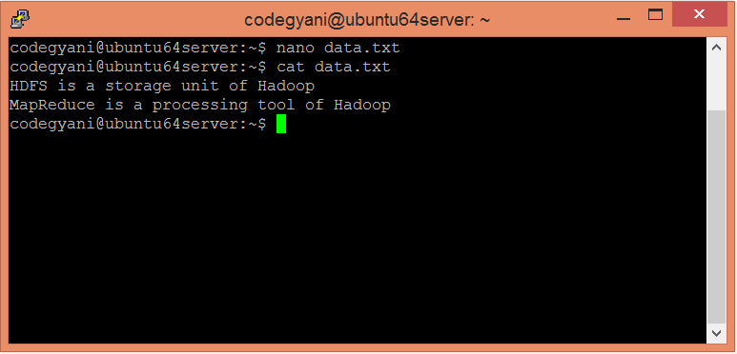

In this example, we find out the frequency of each word exists in this text file.

* Create a directory in HDFS, where to kept text file.  
  $ hdfs dfs -mkdir /test
* Upload the data.txt file on HDFS in the specific directory.  
  $ hdfs dfs -put /home/michael/data.txt /test

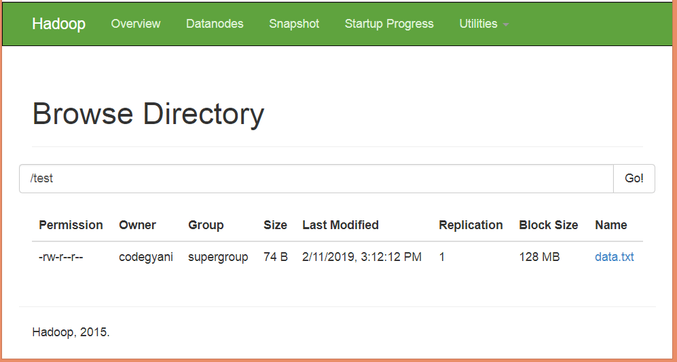

* Write the MapReduce program using eclipse.

File: WC\_Mapper.java

1. package com.javatpoint;
3. import java.io.IOException;
4. import java.util.StringTokenizer;
5. import org.apache.hadoop.io.IntWritable;
6. import org.apache.hadoop.io.LongWritable;
7. import org.apache.hadoop.io.Text;
8. import org.apache.hadoop.mapred.MapReduceBase;
9. import org.apache.hadoop.mapred.Mapper;
10. import org.apache.hadoop.mapred.OutputCollector;
11. import org.apache.hadoop.mapred.Reporter;
12. public class WC\_Mapper extends MapReduceBase implements Mapper**<LongWritable**,Text,Text,IntWritable**>**{
13. private final static IntWritable one = new IntWritable(1);
14. private Text word = new Text();
15. public void map(LongWritable key, Text value,OutputCollector**<Text**,IntWritable**>** output,
16. Reporter reporter) throws IOException{
17. String line = value.toString();
18. StringTokenizer  tokenizer = new StringTokenizer(line);
19. while (tokenizer.hasMoreTokens()){
20. word.set(tokenizer.nextToken());
21. output.collect(word, one);
22. }
23. }
25. }

File: WC\_Reducer.java

1. package com.javatpoint;
2. import java.io.IOException;
3. import java.util.Iterator;
4. import org.apache.hadoop.io.IntWritable;
5. import org.apache.hadoop.io.Text;
6. import org.apache.hadoop.mapred.MapReduceBase;
7. import org.apache.hadoop.mapred.OutputCollector;
8. import org.apache.hadoop.mapred.Reducer;
9. import org.apache.hadoop.mapred.Reporter;
11. public class WC\_Reducer  extends MapReduceBase implements Reducer**<Text**,IntWritable,Text,IntWritable**>** {
12. public void reduce(Text key, Iterator**<IntWritable>** values,OutputCollector**<Text**,IntWritable**>** output,
13. Reporter reporter) throws IOException {
14. int sum=0;
15. while (values.hasNext()) {
16. sum+=values.next().get();
17. }
18. output.collect(key,new IntWritable(sum));
19. }
20. }

File: WC\_Runner.java

1. package com.javatpoint;
3. import java.io.IOException;
4. import org.apache.hadoop.fs.Path;
5. import org.apache.hadoop.io.IntWritable;
6. import org.apache.hadoop.io.Text;
7. import org.apache.hadoop.mapred.FileInputFormat;
8. import org.apache.hadoop.mapred.FileOutputFormat;
9. import org.apache.hadoop.mapred.JobClient;
10. import org.apache.hadoop.mapred.JobConf;
11. import org.apache.hadoop.mapred.TextInputFormat;
12. import org.apache.hadoop.mapred.TextOutputFormat;
13. public class WC\_Runner {
14. public static void main(String[] args) throws IOException{
15. JobConf conf = new JobConf(WC\_Runner.class);
16. conf.setJobName("WordCount");
17. conf.setOutputKeyClass(Text.class);
18. conf.setOutputValueClass(IntWritable.class);
19. conf.setMapperClass(WC\_Mapper.class);
20. conf.setCombinerClass(WC\_Reducer.class);
21. conf.setReducerClass(WC\_Reducer.class);
22. conf.setInputFormat(TextInputFormat.class);
23. conf.setOutputFormat(TextOutputFormat.class);
24. FileInputFormat.setInputPaths(conf,new Path(args[0]));
25. FileOutputFormat.setOutputPath(conf,new Path(args[1]));
26. JobClient.runJob(conf);
27. }
28. }

* Create the jar file of this program and name it **countworddemo.jar.**
* Run the jar file  
  hadoop jar /home/codegyani/wordcountdemo.jar com.javatpoint.WC\_Runner /test/data.txt /r\_output
* The output is stored in /r\_output/part-00000

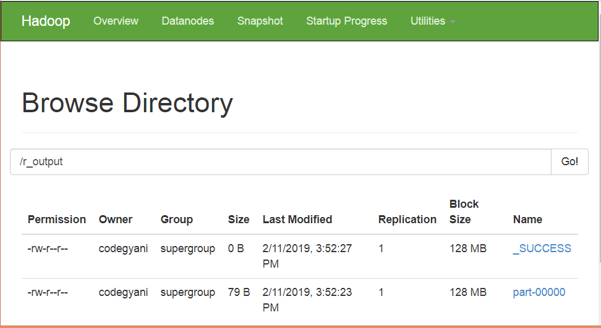

* Now execute the command to see the output.  
  hdfs dfs -cat /r\_output/part-00000

Result:

Thus the word count program is executed using Hadoop Mapreduce.

**Ex.No: 10 Docker installation**

**Date:**

Aim:

To install docker on ubuntu 16.0.4.

sudo apt-get install system

Step 1: Updating all your software

First off, let's make sure that we are using a clean system. Run the apt updater.

apt-get update

Step 2: Set up the repository

Install packages to allow apt to use a repository over HTTPS

apt-get install apt-transport-https ca-certificates curl software-properties-common

Add Docker’s official GPG key

curl -fsSL https://download.docker.com/linux/ubuntu/gpg | apt-key add -

Use the following command to set up the stable repository.

add-apt-repository "deb [arch=amd64] https://download.docker.com/linux/ubuntu $(lsb\_release -cs) stable"

Step 3: Install Docker CE

apt-get update

apt-get install docker-ce

Step 4: Create a user

If you decide not to run Docker as the root user, you will need to create a non-root user.

Warning: The docker group grants privileges equivalent to the root user.

adduser user

usermod -aG docker user

Restart the Docker service.

systemctl restart docker

Step 5: Test Docker

Run the Docker hello-world container to test if the installation completed successfully.

docker run hello-world

You will see the following output.

Hello from Docker!

This message shows that your installation appears to be working correctly.

Step 6: Configure Docker to start on boot

Lastly, enable Docker to run when your system boots.

systemctl enable docker

## Creating your first Docker container

Docker creates virtual containers. Docker's container system is very efficient because it works with commits. This saves space, and allows you to see changes to the container. For example, if you install Apache in a container, you can create a commit with the name "Installed Apache" so you know exactly what happened.

The first thing we'll do is pull from a repository. Say that you want to install Ubuntu in a container, you can pull Ubuntu from the repository:

docker pull ubuntu

Be patient, as this can take a while. After everything has been downloaded, you can create a container with this OS:

docker run -i -t ubuntu /bin/bash

Or with Debian, for example:

docker run -i -t debian /bin/bash

If it can't find the OS (not pulled yet) it will automatically pull it from Docker Hub.

Effectively, you now have a container! You are running bash in the slimmed down container that is managed by Docker. Try running some common Linux commands to get a feel for the environment.

When you type exit to exit the container and return to your main OS, all of your changes will be gone. To save changes to a container, we use commits.

### **Commits**

When you create a Docker container, its hostname is automatically generated. For example, when I create a new Ubuntu container, I might get the hostname f7943e42aff0. This is the name that Docker has given to your container.

Install what you want on it, and make sure everything works. Then exit your Docker container:

exit

We now need to commit; otherwise, all of your changes will be lost.

docker commit -a "William E." -m "Installed Apache" f7943e42aff0 apachesnapshot

The -a switch can be used to properly determine who authored that commit (who made the changes in the container). -m is the commit message. The f7943e42aff0 is the hostname of my container. In your case it will differ, as Docker generates them randomly. apachesnapshot is the name of your image.

You can view a list with all of the images on your local machine. The newest ones are at the top.

docker images

In order to start your Docker container with the changes, run:

docker run -t -i apachesnapshot /bin/bash

## Using Dockerfiles

Dockerfiles can be used to make images with applications already installed. This makes it convenient to start a container without having to run a specific command. For example, if we want to create an image with the file ~/file.txt already created, we would use the following Dockerfile:

FROM ubuntu:14.04

MAINTAINER William E. <william@localhost>

RUN touch ~/file.txt

In order to create a Docker container with this Dockerfile, make a folder for your Dockerfile on your local machine (I used ~/files). Put the contents of your Dockerfile in a file called Dockerfile. You can now create an image with it by running:

docker build -t="test" .

This creates a Docker image from your Dockerfile script. You can now run your container. test is the same value as test in the docker build command.

docker run -t -i test /bin/bash

When the bash shell opens, you'll see that the ~/file.txt has already been created.

Result:

Thus the docker is installed on ubuntu 16.0.4.

**Ex.No: 11 INSTALLING SPARK**

**Date:**

**Aim:**

**To install apache spark on ubuntu 16.0.4.**

Install Dependencies

It is always best practice to ensure that all our system packages are up to date. To get started, run the following command.

root@ubuntu1804:~# apt update -y

Because Java is required to run Apache Spark, we must ensure that [Java is installed](https://www.liquidweb.com/kb/how-to-install-openjdk-11-on-centos-8/). To verify this, run the following command.

root@ubuntu1804:~# apt install default-jdk -y

Download Apache Spark

The next step is to download Apache Spark to the server. The Mirrors with the latest Apache Spark version can be found here on the [Apache Spark download page](https://spark.apache.org/downloads.html). As of the writing of this article, version 3.0.1 is the newest release. Download Apache Spark using the following command.

root@ubuntu1804:~# wget https://downloads.apache.org/spark/spark-3.0.1/spark-3.0.1-bin-hadoop2.7.tgz

--2020-09-09 22:18:41-- https://downloads.apache.org/spark/spark-3.0.1/spark-3.0.1-bin-hadoop2.7.tgz

Resolving downloads.apache.org (downloads.apache.org)... 88.99.95.219, 2a01:4f8:10a:201a::2

Connecting to downloads.apache.org (downloads.apache.org)|88.99.95.219|:443... connected.

HTTP request sent, awaiting response... 200 OK

Length: 219929956 (210M) [application/x-gzip]

Saving to: 'spark-3.0.1-bin-hadoop2.7.tgz'

spark-3.0.1-bin-hadoop2.7.tgz 100%[=========================================================================>] 209.74M 24.1MB/s in 9.4s

2020-09-09 22:18:51 (22.3 MB/s) - 'spark-3.0.1-bin-hadoop2.7.tgz' saved [219929956/219929956]

Once the program has finished downloading, extract the Apache Spark tar file using this command.

root@ubuntu1804:~# tar -xvzf spark-\*

Finally, move the extracted directory to /opt:

root@ubuntu1804:~# mv spark-3.0.1-bin-hadoop2.7/ /opt/spark

root@ubuntu1804:~#

Configure the Environment

Before starting the Spark master server, there are a few [environmental variables](https://www.liquidweb.com/kb/how-do-i-set-system-variable-path-for-python-on-windows/) that need to be configured. First, set the environment variables in the *.profile* file by running the following commands:

root@ubuntu1804:~# echo "export SPARK\_HOME=/opt/spark" >> ~/.profile

root@ubuntu1804:~# echo "export PATH=$PATH:/opt/spark/bin:/opt/spark/sbin" >> ~/.profile

root@ubuntu1804:~# echo "export PYSPARK\_PYTHON=/usr/bin/python3" >> ~/.profile

To ensure that these new environment variables are accessible within the shell and available to Apache Spark, it is also necessary to run the following command.

root@ubuntu1804:~# source ~/.profile

root@ubuntu1804:~#

Start Apache Spark

With the [environment configured](https://www.liquidweb.com/kb/install-pip-windows/), next up is to start the Spark master server. The previous command added the necessary directory to the system PATH variable, so it should be possible to run this command from any directory:

root@ubuntu1804:~# start-master.sh

starting org.apache.spark.deploy.master.Master, logging to /opt/spark/logs/spark-root-org.apache.spark.deploy.master.Master-1-ubuntu1804.awesome.com.out

In this case, the Apache Spark user interface is being run locally on a remote server. To view the web interface, it is necessary to use SSH tunneling to forward a port from the local machine to the server. Logout of the server and then run the following command replacing the hostname for your server’s hostname or IP:

ssh -L 8080:localhost:8080 root@ubuntu1804.awesome.com

It should now be possible to view the web interface from a browser on your local machine by visiting **http://localhost:8080/**. Once the web interface loads, copy the URL as it will be needed in the next step.

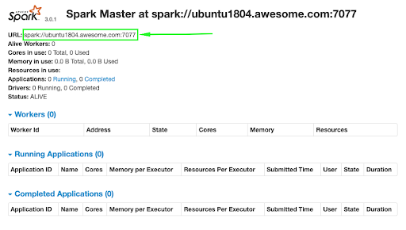

Start Spark Worker Process

In this case, the installation of Apache Spark is on a single machine. For this reason, the worker process will also be started on this server. Back in the terminal to start up the worker, run the following command, pasting in the Spark URL from the [web interface](https://www.liquidweb.com/kb/how-to-setup-openvpn-on-windows-server-2019/).

root@ubuntu1804:~# start-slave.sh spark://ubuntu1804.awesome.com:7077

starting org.apache.spark.deploy.worker.Worker, logging to /opt/spark/logs/spark-root-org.apache.spark.deploy.worker.Worker-1-ubuntu1804.awesome.com.out

root@ubuntu1804:~#

Now that the worker is running, it should be visible back in the web interface.

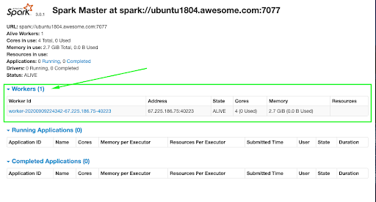

Verify Spark Shell

The web interface is handy, but it will also be necessary to ensure that Spark’s command-line environment works as expected. In the terminal, run the following command to open the Spark Shell.

root@ubuntu1804:~# spark-shell

WARNING: An illegal reflective access operation has occurred

WARNING: Illegal reflective access by org.apache.spark.unsafe.Platform (file:/opt/spark/jars/spark-unsafe\_2.12-3.0.1.jar) to constructor java.nio.DirectByteBuffer(long,int)

WARNING: Please consider reporting this to the maintainers of org.apache.spark.unsafe.Platform

WARNING: Use --illegal-access=warn to enable warnings of further illegal reflective access operations

WARNING: All illegal access operations will be denied in a future release

20/09/09 22:48:09 WARN NativeCodeLoader: Unable to load native-hadoop library for your platform... using builtin-java classes where applicable

Using Spark's default log4j profile: org/apache/spark/log4j-defaults.properties

Setting default log level to "WARN".

To adjust logging level use sc.setLogLevel(newLevel). For SparkR, use setLogLevel(newLevel).

Spark context Web UI available at http://ubuntu1804.awesome.com:4040

Spark context available as 'sc' (master = local[\*], app id = local-1599706095232).

Spark session available as 'spark'.

Welcome to

\_\_\_\_ \_\_

/ \_\_/\_\_ \_\_\_ \_\_\_\_\_/ /\_\_

\_\ \/ \_ \/ \_ `/ \_\_/ '\_/

/\_\_\_/ .\_\_/\\_,\_/\_/ /\_/\\_\ version 3.0.1

/\_/

Using Scala version 2.12.10 (OpenJDK 64-Bit Server VM, Java 11.0.8)

Type in expressions to have them evaluated.

Type :help for more information.

scala> println("Welcome to Spark!")

Welcome to Spark!

scala>

The Spark Shell is not only available in Scala but also Python! Exit the current Spark Shell by holding the CTRL key + D. To test out pyspark run the following command.

root@ubuntu1804:~# pyspark

Python 3.6.9 (default, Jul 17 2020, 12:50:27)

[GCC 8.4.0] on linux

Type "help", "copyright", "credits" or "license" for more information.

WARNING: An illegal reflective access operation has occurred

WARNING: Illegal reflective access by org.apache.spark.unsafe.Platform (file:/opt/spark/jars/spark-unsafe\_2.12-3.0.1.jar) to constructor java.nio.DirectByteBuffer(long,int)

WARNING: Please consider reporting this to the maintainers of org.apache.spark.unsafe.Platform

WARNING: Use --illegal-access=warn to enable warnings of further illegal reflective access operations

WARNING: All illegal access operations will be denied in a future release

20/09/09 22:52:46 WARN NativeCodeLoader: Unable to load native-hadoop library for your platform... using builtin-java classes where applicable

Using Spark's default log4j profile: org/apache/spark/log4j-defaults.properties

Setting default log level to "WARN".

To adjust logging level use sc.setLogLevel(newLevel). For SparkR, use setLogLevel(newLevel).

Welcome to

\_\_\_\_ \_\_

/ \_\_/\_\_ \_\_\_ \_\_\_\_\_/ /\_\_

\_\ \/ \_ \/ \_ `/ \_\_/ '\_/

/\_\_ / .\_\_/\\_,\_/\_/ /\_/\\_\ version 3.0.1

/\_/

Using Python version 3.6.9 (default, Jul 17 2020 12:50:27)

SparkSession available as 'spark'.

>>> print('Hello pyspark!')

Hello pyspark!

**Note:**

The warnings above usually occur if one of the newer versions of the Java JDK is installed. Java 8 evidently does not incur this error. According to https://github.com/apache/spark/pull/24825, and https://issues.apache.org/jira/browse/HADOOP-10848, this issue has been addressed.

Shut Down Apache Spark

If it becomes necessary for any reason to turn off the main and worker Spark processes, run the following commands:

root@ubuntu1804:~# stop-slave.sh

stopping org.apache.spark.deploy.worker.Worker

root@ubuntu1804:~# stop-master.sh

stopping org.apache.spark.deploy.master.Master

1. First check openssh-server installed in that system.
2. check the status of ssh service, make ssh service start.
3. sudo service ssh status
4. sudo service ssh start
5. Check iptables in that system that port 22 is blocked. Just allow port in iptables and then check.

sudo iptables -A INPUT -p tcp --dport ssh -j ACCEPT

Result:

Thus the spark framework is installed on ubuntu 16.0.4.